Kindergarten Supply List
2 boxes of sharpened pencils-(Ticonderoga preferred)
3 boxes of Crayola crayons
1 box of Crayola markers
One pair of blunt/round Fiskars scissors
5 large or 10 small glue sticks
1 plastic pencil box
1 composition book
2 kindergarten writing journals (this is the “primary” journal)
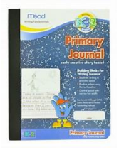

1 package of dry erase markers
1 pair of headphones
2 boxes of tissues
Boys: 1 box of gallon Ziploc bags
Girls: 1 box of quart Ziploc bags
1 package of Clorox wipes
1 package of baby wipes

