Classroom Celebrations
Order Form
updated 7/27/22
We are here to help you celebrate any occasion in your child’s classroom in a safe way.
- Select treat(s) from the list below. Please make sure funds are available the day of the celebration
- Treats will be picked up by your child’s teacher
- Submit the order form to Maribel.Hicks@cobbk12.org three weeks before day of event.
Item | Price Per Item | Flavor Choice(s) | Number of Treats Needed
Ice Cream Cones  Ice Cream sandwiches  Menchie’s  Ice cream bars | $1.75each  $1.75each  $2.00each  $1.50each
Fruit snacks/roll-ups | $.75 each
Chocolate Chip Cookies  Celebration Cookies  Double Chocolate Chip Cookies | $.70 each
Chips-  Scooby Grahams, Goldfish, Animal Crackers | $1.00each $.60 each
Fresh Baked Brownies | $1.50 each
Rice Krispies Treat  Chocolate Chip Rice Krispies Treat  Chips | $1.50 each
16 oz. Bottled Water | $1.00 each
Switch Sparkling 100% Juice | $1.90 each
Capri Sun | $1.25 each

Name of Student: ____________________________ Teacher’s Name/Class: ___________________________
Date to be Delivered: ___________________ Total Due: _________________________________________
Method of payment (Circle one): Child’s Lunch Account Check
Parent/Guardian’s Name: _______________________________ Phone Number: ________________________
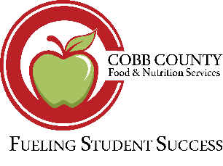
Cafeteria Manager: Maribel Hicks Phone Number: 770-578-7201 Email: Maribel.Hicks@cobbk12.org

