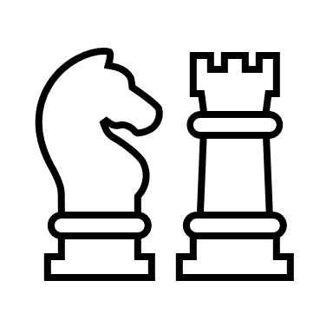 PICKETT’S MILL CHESS CLUB
We’re excited to announce that Chess Club is back! There will be 3 different sessions throughout the school year (beginner, intermediate, & advanced). ***The first session will be for BEGINNERS only!***
Who: Kindergarten through 5th grade students with no chess experience
Where: Pickett’s Mill Learning Commons
When: Mondays 2:10 – 3:30 (August 29th, September 12th & 19th, October 3rd, 10th, 24th, & 31st, November 7th & 14th)
Cost: $50 (includes: t-shirt, chess board, & pizza party) ***Payments accepted through MyPaymentsPlus, check, or cash. ***All students will need to be registered for ASP as well.

E-mail Mr. Kagan (russ.kagan@cobbk12.org) or Coach Gresham (chris.gresham@cobbk12.org) with any questions or concerns.
----------------------------------------------------------------------------------------------
Student Name: __________________________ T-shirt Size: _________
Teacher: _______________ Grade: ____ After chess (circle one): Car or ASP
Parent Name: ___________________ Parent Phone Number: _______________
Parent e-mail address: _____________________________________________
Medical or Health Problems we need to know: ____________________________
_______________________________________________________________
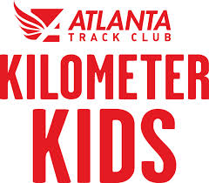
Parent Signature: _____________________ Date: _______________________

