Cooper Middle School

2022-2023

School Supply List

6th Grade

Loose-leaf Paper (check supply often)
(4) – Pocket paper folders or regular tab dividers for their general binder
(5) – ink pens (blue, black or red)
(12) - #2 Black Lead Pencils -Check student supply weekly
(1) - One pack of Colored Pencils
(2) - Glue Sticks
(1) - Handheld Pencil Sharpener (unless they use mechanical pencils)
(3) - 2-Pocket Folders with Prongs (plastic preferred for durability).
2-for ELA & 1 for math
(1) - Zipper Binder with Shoulder Straps (see illustration examples)
(1)- Composition notebook for ELA
(1)-5 subject notebook for Social Studies
(1)- Scissors
(1) Basic four function calculator-any brand (see example photo)
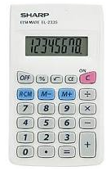
(2) - Hand sanitizer & wipes for personal use (check supply often)
(1) - Pack of Dry Erase Markers

Optional (Very useful items):
(1) - Pack of Highlighters (Blue, Pink, Green)
(1) - Pack of 8 X 11 copy paper (white or colored). Deliver to Homeroom.
(1) - Transparent Tape
(1) - Set of earbuds (inexpensive type to use with school technology)
(1) - Box of Kleenex, Clorox wipes, and Hand Sanitizer. Deliver to Homeroom.

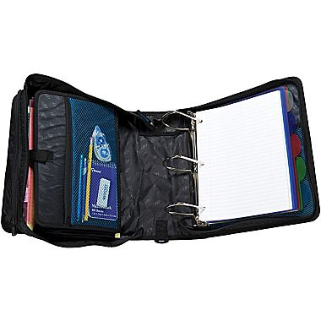
Two compartment Zipper Binder
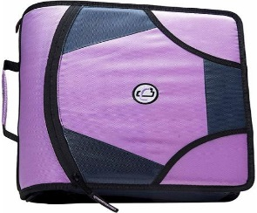

OR

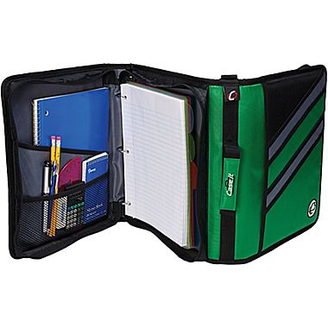
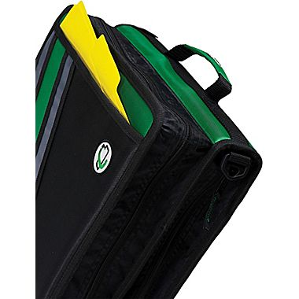
3” or 4” Inch Zipper binder

