Cooper Middle School
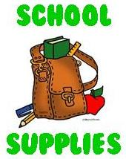

2022-2023 School Supply List
7th Grade

General List (multiple classes, replenish throughout the year)

Lined Notebook Paper
Blue/Black Ink Pens
Pencils
Highlighters
Dividers (3 packs)
Ruler
Markers
Pencil Pouch
Pencil Sharpener with Shaver Catcher
Extra Pencil Erasers
4-pack Dry Erase Markers
Dry Erase Board Erasers
Colored Pencils
Earbuds with Microphone
*Please review our uniform policy.

Content Specific Supplies (To be used specifically in these classes)
Science
1 Inch Binder
Pocket Folder
Index Cards (2 packs)

Language Arts
Composition Notebook
Pocket Folder
1.5 Inch Binder

Social Studies
1 Inch Binder (filler paper)
Pocket Folder

Mathematics
Graphing Paper
3 Orange Pocket Folders (7th Grade Math Only)
1/2 Inch Binder (Math 7/8 Only)
Composition Notebooks (2-3 - 7th Grade Math Only)
TI 30Xa Calculator
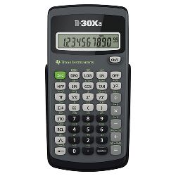

Homeroom Teacher (used for all classes)
3 Boxes of Tissue
Hand Sanitizer
Gallon Size Ziploc bags
Cleaning Wipes

STEAM Academy
Composition Notebook

