Cooper Middle School
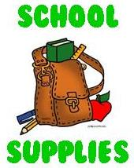

8th Grade School Supply List
2022-2023

General List (multiple classes, replenish throughout the year)

Blue/Black Ink Pens
Pencils
Highlighters
Pencil Sharpener with Shaver Catcher
Extra Pencil Erasers
Colored Pencils
Post It Notes
Earbuds with Microphone

Content Specific Supplies (To be used specifically in these classes)
Social Studies
Composition Book

Language Arts
Composition Notebook
pen/pencils
personal reading selection
earbud/headphones (suggested)
calendar/organizer (suggested)

Algebra I
TI -36x Pro

Science
5-Subject-Spiral Notebook
Composition Book

Mathematics
MATH Composition Notebook, Spiral Notebook, or 3-Ring Binder with Paper
Dry Erase Markers
Pencil
Graph Paper
TI-30XA Calculator
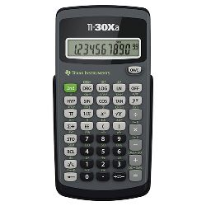
STEM Academy
Composition Book
Please Note: Additional household and recycled materials needed will vary with each project. Project materials lists will be provided throughout the year.

