Principal Advisory Council Agenda & Minutes

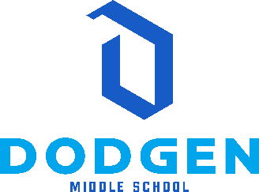

Mission: One Team, One Goal: Student Success
Vision: A school of excellence where all students succeed.
August 25, 2022

Dodgen Middle School Principal Advisory Council Norms
- Begin and end on time.
- Be positive.
- Keep conversation on topic and relevant to all Dodgen students, not individuals.
- Receive a meeting reminder along with the agenda the day before each meeting.

In attendance at the meeting:
Precious James and Chick-fil-a Intern, Dr. Alford, Maggie Carlock, David Gabel, Kelly O’Brien, and David Scott (arrived later in the meeting)
- Welcome/Introductions/Orientation/Purpose of the Council
  - Review/Revise Norms
    - Called the meeting to order @ 8:15 AM.
    - Norms were agreed upon, reviewed, and no revision was needed.

- Report of the Principal
  - Start of the year
    - Discussed a smooth opening to the school year and new programs that began at Dodgen this year.
  - Celebrations – STEM, Laptops, Directional Signage, Awards, etc…
    - Shared that our PTSA Received “National PTA of Excellence” award, STEM certification was received last spring, new signage is in process of installation funded by our Foundation, all Dodgen students have access to personal laptops, etc.
  - Local School Initiatives: STEM Night, LLC Certification, Clubs, Trips, etc….
    - We discussed the work we are doing around RTI, Dodgen’s New Teacher Academy and the rationale behind that, our theme “Be Brilliant at the Basics” to help students and staff focus on strong instructional practices, and ideas were shared around Student/Staff Recognition and how we can enhance this program further at Dodgen.
  - SPLOST Updates for Summer 2023
    - Plans being created, already approved by SPLOST and architects hired to renovate Learning Commons and instructional spaces in summer ’23.
  - Health & Safety Updates
    - Centegix is fully operational and all staff have been trained.
  - SSP Goals
    - A draft of our SSP as well as the rationale for the specific goals was shared with the team and feedback was shared by team members.

- Communication feedback
    - Families/staff are happy with the level of communication

- Partnership Opportunities & Needs
    - Considering ways to involve our business partnership with Chick-fila-a
      - Coupons for Students of the Week
      - Recognition banquet at the end of the year
      - Assistance with STEM Night

- Open Agenda topics
    - None this time – we wrapped up just after 9 AM.

Next Meeting Date / Time / Location:
Thursday, October 13, 2022 / 8:15 AM – 9:00 AM / Theater Conference Room

