Parents must have a ParentVUE account.
Parents should contact Marleny.Mendez@cobbk12.org
if they need an account.

ParentVUE Information for Student Devices
- Log in to ParentVUE:
parentvue.cobbk12.org
- Click on Student Device Liability Agreement

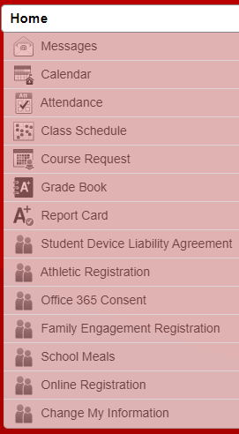

- Click on Student Device Liability Agreement
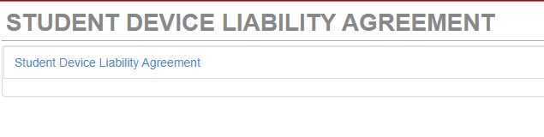
- Click on Read Agreement
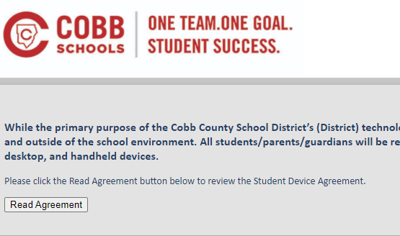
- Click in the box next to I agree to the conditions listed above.
Then click Submit agreement
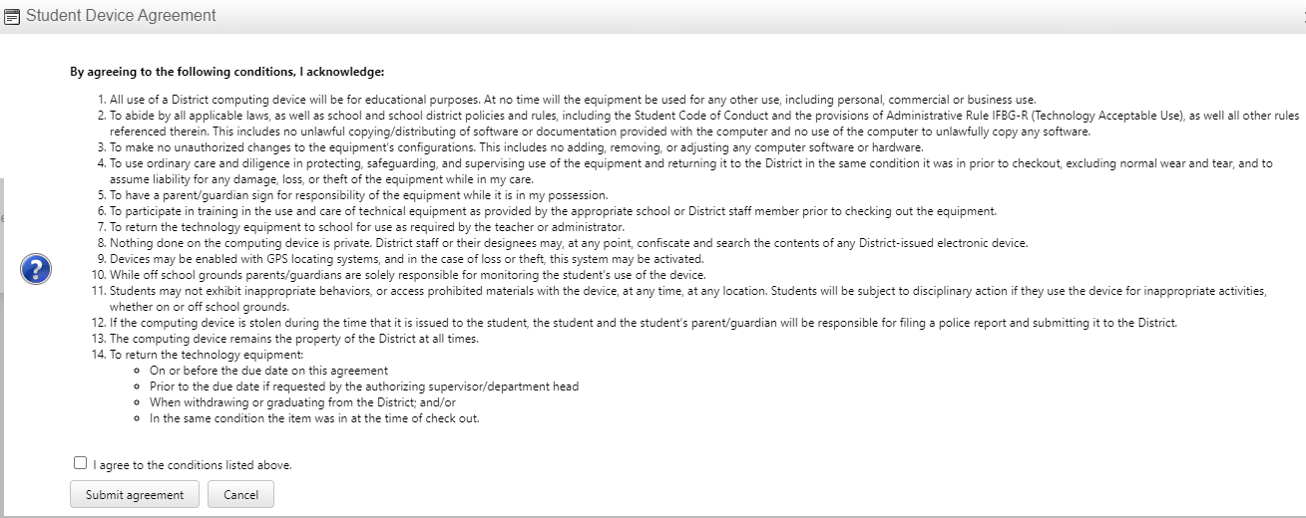

- Click the box next to Opt-in

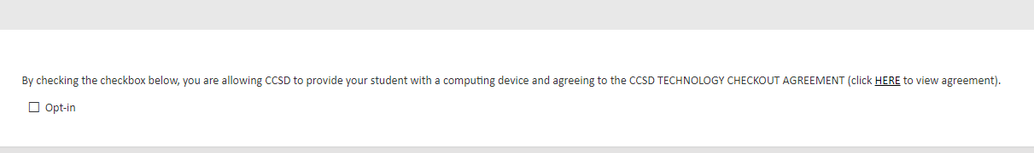

- You should see the green message that You have successfully opted-in this student.
