

#### What is a School-Parent Compact?

#### Building Partnerships

# First Grade

# School-Parent Compact for Achievement 2021-2022

Revised May 17, 2021

As a Title I school, Brumby Elementary School and their families agree that this compact outlines how the parents, the entire school staff, and the students will share the responsibility for improved student academic achievement as well as describes how the school and parents will build and develop a partnership that will help children achieve the state’s high standards.

**Jointly Developed**  
Jointly the parents and staff of Brumby Elementary School developed this School-Parent Compact for Achievement. Teachers suggested home learning strategies, administration identified school and district goals, and parents added suggested items for the student role. Meetings are held each year in April to review the compact and make changes based and student needs. We look forward to having parent input on how we can better meet the needs of our students and families.

**Parents are welcome to contribute comments at any time.**

Please contact Luz Landaverde at luz.landaverde@cobbk12.org

Throughout the year parents will have opportunities to partner with the staff at Brumby to enhance their understanding of the standards as well as the curriculum. Some events to look forward to:

* Online/In-person activities
* Digital resources to help parents support their learners
* Curriculum nights

*More details will be sent home and made available on the school’s website as we draw closer to these events.*

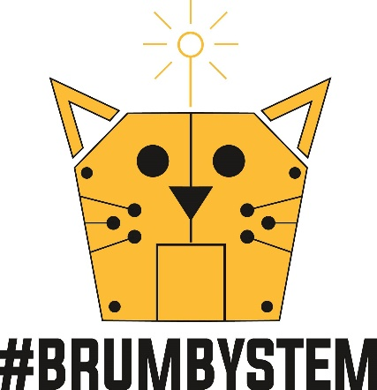

Brumby Elementary School is committed to frequent two-way communication with families about student learning. Some of the ways you can expect us to reach you are:

* CTLS Parent Portal
* Report Cards per county timeline for distribution.
* Updates on the school website
* Parent/teacher collaboration/conferences on student progress.
* Email and phone
* Social Media
* ParentVue

Do you have a question about your child’s progress? Contact your child’s teacher to make an appointment by phone at 770-916-7070 or via email through links on the school website at [www.cobbk12.org/brumby](http://www.cobbk12.org/brumby)

#### Communication

815 Terrell Mill Rd.  
Marietta, GA 30067

Phone: 770-916-7070

www.cobbk12.org/brumby

One Team, One Goal, Student Success

Inspiring personal success through collaboration and respect.



1. Increase percentage of 1st graders moving from FRA to RI by 5%

**In 1st grade our school will focus on decoding, fluency, comprehension, and sight words.**

1. Increase quantile scores from one band to the next by 5% on the MI from Fall administration 2021 to Spring administration 2022.

**In the 1st grade our school will focus on number sense, place value, and problem-solving strategies.**

Brumby students can succeed in school and meet our school goals in both Math and Reading. As a student, I can:

1. Use a variety of mathematical strategies to solve math problems both in and out of school and use a variety of reading strategies to read and understand what I am reading both in and out of school.
2. Read at least 20 minute each night
3. Log in to Dreambox and practice math facts and concepts.

#### Brumby Students

Families can support student’s math and Reading understanding by:

1. Utilize strategies provided by school in both reading and math to explore books and literacy skills as well as mathematical concepts with your child.

Also use this QR  
code to access   
Cobb’s 1st grade   
standards.

1. Help your child develop a love of reading by reading the materials provided with them at home.
2. Ensure your child frequently logs into Dreambox software to build conceptual understanding and procedural fluency.

#### At Home

Increase student performance in all core content areas by 2% annually as measured by achievement data.

CCSD will increase the participation rate of families and communities engaging in services/programs by 10% as measured by CTLS Parent data, survey results & web view module.

By 2023, we will reorganize the PL framework to meet the needs of all schools to ensure alignment with Superintendent Priorities as measured by PL opportunities, surveys, and student achievement.

By the end of 2025 school year every school will have identified practices and resources that support student success as measured by student academic, perception or discipline data.

#### School Goals

#### District Goals

#### In the 1st Grade Classroom

The *first-grade teachers, specialists and support staff* will work students and their families to develop students’ *Mathematical and Reading competency according to grade level standards*. The focus of our key connections with families will be:

1. Provide parents with a variety of math and reading strategies that meet the Georgia Standards of Excellence. Examples of each will be provided through CTLS Parent, classroom parent meetings or conferences.
2. Provide individualized and personalized mathematics support using Dreambox Learning software.
3. Provide individualized and adaptive reading support using Headsprout online reading program.

#### Teachers, Parents, Students- Working together for Success

#### Goals for Achievement