Strategic Plan
2022-2023 School Year

School Name: Campbell Middle School
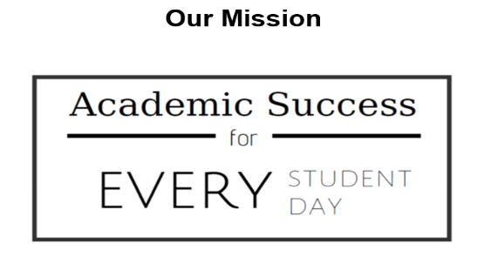 | 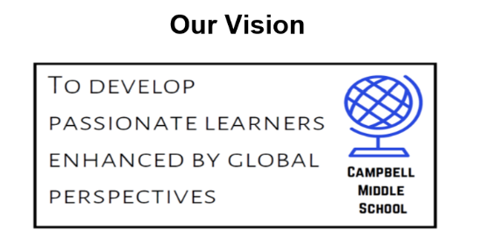

CCC Goal: To hold productive collaborative meetings based on the 4 CCC Questions

Utilize your local CCC implementation plan to complete chart below:
 | 2019-2020 |  | 2020-2021 |  | 2021-2022 |  | 2022-2023
Focus on Learning | Promote the newly adopted mission, vision, and establish collective commitments for student success.  Implement the prioritizing standards process for greater student achievement. |  | Continue to promote the collective commitments for student success.  Ensure that the prioritizing standards process allows for subject teams to adequately address what and how students are assessed. |  | Establish and promote common subject goals across grade levels.  Ensure that prioritizing standards allows for vertical transition that contributes to student success. |  | Focus on Tier 1 and quality instruction for all students.  Daily intervention block to address well-being, PBIS and behavior, IB traits, and academic support.
Collaboration | Ensure that all teacher collaboratives have norms and processes in place for full engagement in the CCC process.  Utilization of common team meeting agendas, and IB unit plans. |  | Develop interdisciplinary meeting agendas and IB unit plans that integrate constructed and extended writing activities. |  | Promote processes that vary the learning experiences for students via cross team / subject area collaboration outside of the weekly meetings. |  | Thursday CCC continues to prioritize standards and LQs are displayed and referred to in the lesson.  Tuesday grade level meetings address our students’ needs.
Results Oriented | Establish common formative and summative assessment data to identify standards needing remediation or enrichment. |  | Utilizing CTLS Assess consistently to assess and plan for student learning.  Develop common standards-based gradebooks. |  | Strengthen the common standards-based gradebooks with a direct link to CTLS Assess that allows teachers to address the remediation / enrichment in the portal. |  | The CCC focuses on data from CTLS Assess, RI and MI, and common summative assessments to drive instruction.
Academic Goal: Increase percentage of students performing at grade level in ELA and Math.

 |  | 2019-2020 |  | 2020-2021 |  | 2021-2022 | 2022-2023
Initiatives, programs, or strategies supporting goal: |  | Utilize RI and MI data to identify struggling students and provide support during Spartan Academy, Quarterly Grade Repair, and Milestones Prep Constructed / Extended Responses in February and March. |  | Provide AC (Advanced Content) students reading above grade level with a middle schools gifted resource class in lieu of a content reading class.  Continue to strengthen our math support classes with targeted assistance for struggling students as identified through MI. |  | Provide every student with academic incentives to improve proficiency.  Provide DLI (Dual Language Immersion) students with a Spanish Language class and a Social Studies class taught in Spanish, and grouping them together for ELA instruction.

Goal 3 (if needed):
Area of Focus: Social Emotional Learning
 | 2019-2020 | 2020-2021 | 2021-2022 | 2022-2023
Initiatives, programs or strategies supporting goal: | Adopt daily restorative circles to be used to proactively develop relationships and build our IB community or to reactively respond to conflicts or other potential issues that is prevalent with the middle school child.  Introduce the restorative conferencing process to students in order to deescalate ongoing conflict. | Ensure that we continue to grow with the usage of daily restorative circles beyond the designated morning routine to reinforce IB community and PBIS expectations.  Implement with fidelity, restorative conferences among students to deal with the consequences of wrongdoing and decide how best to repair the harm in order to exist without further incidents. | Integrate social emotional learning via school wide lesson that support academic achievement in the content classes.  Continue to create compassionate classes for all students through restorative practices.

