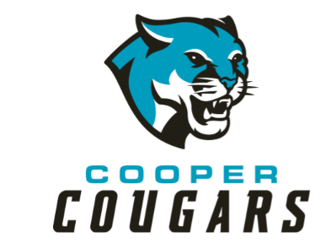

**Cooper Middle School**

***Family-School Engagement Policy***

***for Shared Student Success***

*2022–2023 School Year*

*Mr. James Rawls, Principal*

*Cobb County School District*

*4605 Ewing Road*

*(770) 819- 2438*

*http://www.cobbk12.org/cooper/*

*Revised (pending)*

**Cooper Middle School**

**Academic Goals**

**Goal #1:** The percentage of students scoring proficient/advanced will increase by 10% as measured by the 2022-2023 Georgia Milestones English/Language Arts assessment.

**Goal #2:** The percentage of students scoring proficient/advanced will increase by 10% as measured by the 2022-2023 Georgia Milestones Mathematics assessment.

**Goal #3:** The percentage of students scoring proficient/advanced will increase by 10% as measured by the 2022-2023 Georgia Milestones Social Studies assessment.

**Goal #4**: The percentage of students scoring proficient/advanced will increase by 10% as measured by the 2022-2023 Georgia Milestones Science assessment

**Goal #5**: The number of students receiving office discipline referrals will decrease from 1300 to less than 1000 as measured by the office discipline referrals during the 2022-2023 school year.

School Plan for Shared Student Achievement

**What is it?**

This is a plan that describes how Cooper Middle School will provide

opportunities to improve family engagement to support student learning.

Cooper Middle School values the contributions and involvement of families to

establish an equal partnership for the common goal of improving student

achievement. This plan describes the different ways that Cooper Middle School

will support family engagement and how parents can help plan and participate

in activities and events to promote student learning at school and at home.

**Jointly Developed**

Cooper Middle School invites all parents to complete the Fall school improvement input survey/evaluation to provide suggestions on the school’s Title I program. All parents are also invited to attend the Spring school improvement input meeting to revise this parental involvement policy, our school-parent compact, building staff capacity professional learning topics, and the parental involvement budget. Additionally, parent input and comments regarding this plan are welcome during the school year. The plan is posted on our school Web site for parents to view and submit feedback throughout the year. All parent feedback received during the year will be used to revise the plan for the next school year. We also distribute an annual survey that is posted online to ask parents for their suggestions on the plan and the use of the 1% reservation of funds for parental involvement. Parents can also give feedback during any parent meetings and activities during the school year.

**Who is it for?**

All students participating in the Title I, Part A program, and their parents and families, are encouraged and invited to fully participate in the opportunities described in this policy.  Cooper Middle School will provide full opportunity for the participation of Neglected and Delinquent proxy parents, parents and families with limited English, parents with disabilities, and parents of migratory children.

**Where is it available?**

Every family will receive the plan during Parent-Teacher Conference week. It is also available on the school website and a copy is in the front office binder. Parents can also retrieve a copy of the plan in the Parent Resource Center. We will gladly mail the plan to you upon request.

**What is Title I?**

Cooper Middle School is identified as a school having a Schoolwide Title I program as part of Every Student Succeeds Act (ESSA). Title I is designed to support State and local school reform efforts tied to challenging state academic standards which reinforce and enhance efforts to improve teaching and learning for students. Title I program must be based on effective means of improving student achievement and include strategies to support parental involvement. All Title I schools must jointly develop with all parents a written parental involvement policy.



**Let’s Get Together!**

Cooper Middle School will host the following events to build the capacity for strong parental involvement to support a partnership among the school, parents, and community to improve student academic achievement. Family and Community Engagement (FACE) activities will be held at various times to provide opportunities for all families to participate. If you are unable to attend and would like meeting information, please contact **Japonika Francis or Natosha Miller.**

**State of the School Meeting/Open House**

**August 30th 5:30 – 6:00 p.m.**

We invite you to an evening of learning about our Title I program, including the parent and family engagement policy, school-parent compacts, parents rights under Title I, highlights of the school improvement plan and the 1% reservation of funds for family engagement. Additionally, you’ll receive a description about our school’s curriculum and the assessments used to monitor student progress.

Planning A Way to Success (P.A.W.S)

Virtual and Face-to-Face – October 10, 2022 @ 6:30 pm – 8:00 pm

Meet your child’s teacher and our friendly and helpful school staff for the year and create S.M.A.R.T. goals based on your child’s Reading Inventory & Math Inventory data.

**Fall School Improvement Input Survey**

**Monday, October 10, 2022-5:30 -6:30 p.m.**

Cooper Middle School will send home the Title I Survey / Evaluation through CTLS Parent. Parents are asked to provide valuable feedback regarding the school, current and future family and community engagement activities and programs.

**Parent-Teacher Conferences – October 18, 2022 - October 21, 2022**

Receive updates on your child’s progress in class and on assessments during Conference Week.

Parents may always request conferences with their child’s teacher, as needed.

**Read 180 meeting**

**Monday, November 7, 2022, 5:30 – 6:30**Gain an understanding of your child’s reading inventory score and ways to help them at home to improve their grades and performance at school.

**ESOL meeting**

**March 6, 2023, 5:30 – 6: 30p.m** Gain understanding of how the ESOL classes work and how your student can exit the class

**Rising 6th Grade Parent Meeting- Thursday, March 23, 2022; 6:30 – 8:00 pm**

Rising 6th grade families are introduced to expectations and learning opportunities offered in Cooper Middle School.

**Spring School Improvement Input Forum**

**Wednesday, April 19, 2023, 5:30 -6:30**

Parents and educators review and discuss Cooper Middle School’s Title I program, future parent activities, school-family compact and policy, family engagement budget and staff trainings.

**2022-2023**

**Cobb County Schools**

**District Goals**

* Increase student performance in all core content areas by 2% annually as measured by achievement data.
* CCSD will increase the participation rate of families and communities engaging in services/programs by 10% as measured by CTLS Parent data, survey results & web view module.
* By 2023, we will reorganize the PL framework to meet the needs of all schools to ensure alignment with Superintendent Priorities as measured by PL opportunities, surveys, and student achievement.
* By the end of 2025 school year every school will have identified practices and resources that support student success as measured by student academic, perception or discipline data.

Family-School Compacts

As part of this plan, Cooper Middle School and our families will develop a family-school compact, which is an agreement that parents, teachers, and students will develop that explains how parents and teachers will work together to make sure all our students reach grade-level standards. The compacts will be reviewed and updated annually based on feedback from parents, students, and teachers during the School Improvement forum. The family-school compacts are distributed during Parent-Teacher Conference week **October 18-21, 2022**. Copies are also available throughout the year with each child’s teacher.

8

**Parental Involvement Matters**

Cooper Middle School is committed to helping our parents and families attend the family activities listed in this policy. Please call or email us if you need assistance with childcare or transportation to participate in our programs.

Japonika Francis and Natosha Miller

770- 819- 2438 or   
[Japonika.francis@cobbk12.org](mailto:Japonika.francis@cobbk12.org)

Natosha.miller@cobbk12.org

**Parent Resource Center Front Office**

**Hours: Mon.-Fri.; 9:30am - 4:00pm**

Visit the Parent Resource Center (PRC) to check out books, study materials, and activities to use at home with your child. Computers are available for parents to explore CTLS Learn, CTLS Parent and educational resources.

Parental Involvement

Cooper Middle School believes that parental involvement means the participation of parents in regular two-way, and meaningful communication involving student academic learning and other school activities, including ensuring:

* That parents play an integral role in assisting their child’s learning.
* That parents are encouraged to be actively involved in their child’s education at school.
* That parents are full partners in their child’s education and are included, as appropriate, in decision-making and on advisory committees to assist in the education of their child.

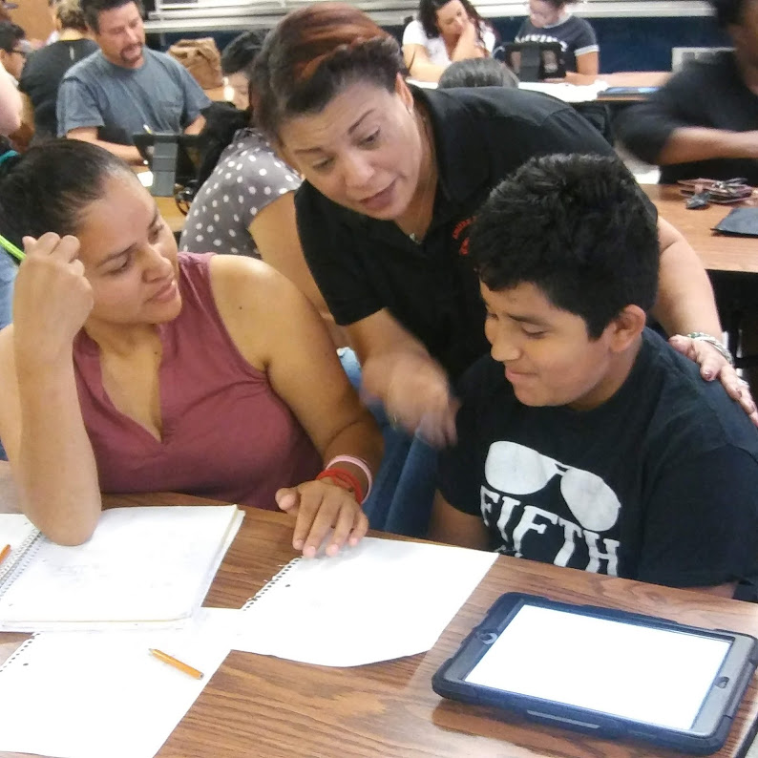

**One Team, One Goal, Student Success**

Cooper Middle School will take the following measures to promote and support parents as an important foundation of the school in order to strengthen student academic performance and reach our school goals. We will:

* Ensure that all information related to school and parent programs, meetings, and other activities is published in both English and Spanish, posted on the school website, and included in the weekly Wednesday message for all parents.
* Provide two trainings each semester for staff during their planning periods on strategies to improve communication with parents and ideas to increase family engagement.
* Partner with our feeder schools by conducting joint meetings and events for parents and sending school information about parent engagement activities to help prepare parents and their child for school transitions.
* Share information in English and Spanish on the school blog and in the school newsletter for parents to understand the school’s academic standards and assessments as well as the ways parents can monitor their child’s progress and work with educators.
* Communicate with all families and the community on a regular basis regarding schoolwide events and activities, through CTLS Parent, school website, social media, campus signpost and flyers, etc.
* Work with our parents to develop relevant trainings and helpful presentations to educate our staff on the importance of parental involvement.
* Provide necessary materials and handouts for parents at conferences, meetings, and activities to help parents work with their child to improve their child’s achievement.
* Use our Parent Facilitators and Education Partners to improve awareness of the activities and events listed in the school parental involvement policy
* Collect feedback from parents at all events and offer a variety of surveys throughout the school year to respond to parents’ input regarding parental involvement activities and requested meetings.

Principal Advisory Council

The purpose of the Principal Advisory Council is to bring together parents, community members, and school staff to create a better understanding of and mutual respect for each other’s concerns and share ideas for school improvement.

The Principal Advisory Council meets three times per school year. Along with the principal, council members include:

1. Two staff members (one being the current Teacher of the Year).

2. Two parents (one being the current PTSA president).

3. Two members of the community (one being a Partner in Education representative).

4. High Schools *only* should include the president of the student government association or the senior class president.

If you would like to share your ideas and perspective with the Principal Advisory Council please contact James Rawls, school principal, [James.Rawls @cobbk12.org](mailto:Vanessa.Watkins@cobbk12.org)

**Parent Involvement Opportunities**

I am interested in participating on the Principal Advisory Council.

I am interested in volunteering in the front office.

I am interested in volunteering in the media center.

I am interested in other volunteer opportunities, please contact me as needed.

|  |  |  |  |  |
| --- | --- | --- | --- | --- |
| Name: |  | | | |
| Child’s Name and Grade: | | |  | |
| Phone Number: | | | |  |
| Email Address: | |  | | |

To return this form via email to [Japonika.francis@cobbk12.org](mailto:Japonika.francis@cobbk12.org)

[Natosha.miller@cobbk12.org](mailto:Natosha.miller@cobbk12.org)

or deliver form to the school’s Main Office.

**Share Your Thoughts**

We want to hear from you. If you have any suggestions or if there is any part of this plan that you feel is not satisfactory with the students’ and the school’s goals for academic achievement, please provide us with your comments in the space provided and leave this form in the Main Office:

|  |  |  |  |
| --- | --- | --- | --- |
| Name (Optional): |  | | |
| Phone Number (Optional): | | |  |
| Email Address (Optional): | |  | |

Suggestions, Compliments, Concerns:

Parental Involvement Standards

Cooper Middle School and our parents have adopted the National PTA Standards for Family-School Partnerships as the school’s model in engaging parents, students, and the community. These standards are:

1. Welcoming All Families
2. Communicating Effectively
3. Supporting Student Success
4. Speaking Up for Every Child
5. Sharing Power
6. Collaborating with Community