Campbell High School
2022-23 Advanced Placement Exam Registration

Fall 2022
Students and guardians should complete this registration/enrollment together. This is a two-step process, and both steps MUST be completed to successfully order AP Exams. The entire process can be completed in a single sitting in approximately 15 minutes.

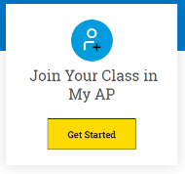
REGISTRATION
2
1
JOIN AP CLASSROOM  https://apstudents.collegeboard.org/access-your-ap-resources/join-your-class-online | Students should sign up for the AP Class using the JOIN CODE provided by their teacher. All students are automatically enrolled to take AP exams upon joining AP Classroom in their AP classes. Students who choose NOT to test must REQUEST a registration change through their teacher prior to the Nov.13th deadline.
PAY EXAM FEES  https://user.totalregistration.net/AP/112745 | Complete all electronic payments through the Total Registration website.  FIRST SEMESTER exam registrations must be completed before Nov. 13, 2022. You must pay by November 14  *** Exams will be ordered on November 15

IMPORTANT UPDATES FROM COLLEGEBOARD
Please visit www.collegeboard.org for updates on testing.

EXAM FEES
Exam fees for on-time exam orders (by November 13, 2022) for full-year and first-semester courses  **Spring exam payment/registration will take place starting in January | - $15 one-time testing fee for all students  - $97 per exam  - $145 per exam for AP Capstone Exams (AP Seminar and Research)  - Students who qualify for free/reduced lunch are eligible for fee assistance. Requests are made through Total Registration.  - One STEM exam is free for all students (Calculus, Physics, Computer Science, Chemistry, Statistics, Biology)

REFUND POLICY
- Students who cancel a first semester exam by November 14, 2022 are entitled to a full refund of the exam fee.
- Late fees are nonrefundable. Late fees for exams ordered after November 15 are $40.

REQUESTS FOR ACCOMMODATIONS
All requests for accommodations and, when required, complete documentation must be submitted through SSD Online by January 17, 2023 Requests for accommodations are not submitted through AP Registration and Ordering. SSD Online is a separate system.
Questions or concerns regarding Accommodations can be sent to Dr. Lisa Eaton at Lisa.Eaton@cobbk12.org

CONTACTS
Ms. Jessica Tibbetts
Jessica.Tibbetts@cobbk12.org

Dr. Lisa Moore Sparks
Lisa.MooreSparks@cobbk12.org
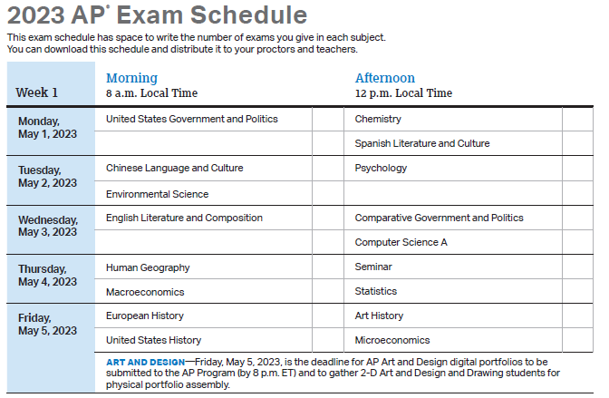
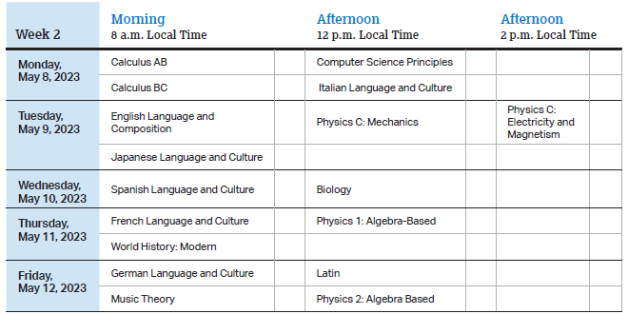

- AP Seminar and AP Research students must submit final performance tasks and their presentations must be scored by their AP Seminar or AP Research teachers by 11:59 p.m. ET on May 1, 2023.
- On their AP Digital Portfolio, students participating in AP Computer Science Principles must submit their Create performance task as final by 11:59 p.m. ET on May 1, 2023.

