J.J. Daniell’s Sixth Grade Supply List 

Unlike elementary school, middle school supplies are not collected by the teacher and then distributed to students. Students will keep up with their own supplies (with the exception of homeroom donations). Many supplies will need to be refreshed throughout the school year as students use them.

**Homeroom Donations:**

* Boxes of tissue
* Paper towels
* Hand sanitizer
* Disinfecting wipes
* Band-Aids
* Ream of paper

**For Academic Classes:**

* Flash-drive required
* Large zippered pencil pouch

**\*\*Following items should be placed into the pencil pouch\*\***

~Colored pencils, thin markers, or crayons

~Highlighters

~Hand-held pencil sharpener (not motorized)

~Pencils

~Black or blue pens

~Ruler with standard and metric measurements

~Two or more large glue sticks/scotch tape

~Dry erase markers

~Safety scissors

~Ear Buds

* 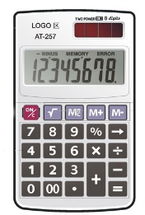Multiple packs of loose leaf notebook paper
* 1 package 3x5 index cards
* (4) 1 ½’’ binders for Language Arts, Math, SS and Science
* 3 sets of 8 tab dividers for Language Arts, Science and Math
* Sticky notes
* 3 composition books
* Calculator with buttons similar to the one above. You may not have a TAX button on the calculator for Math.

**Some additional supply requests may be made by teachers after school begins.**