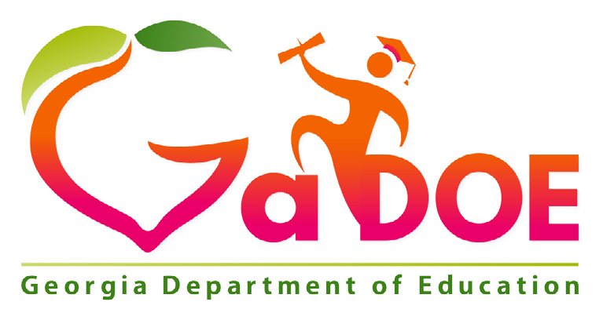

School Improvement Plan
2021-2022
Comprehensive Needs Assessment

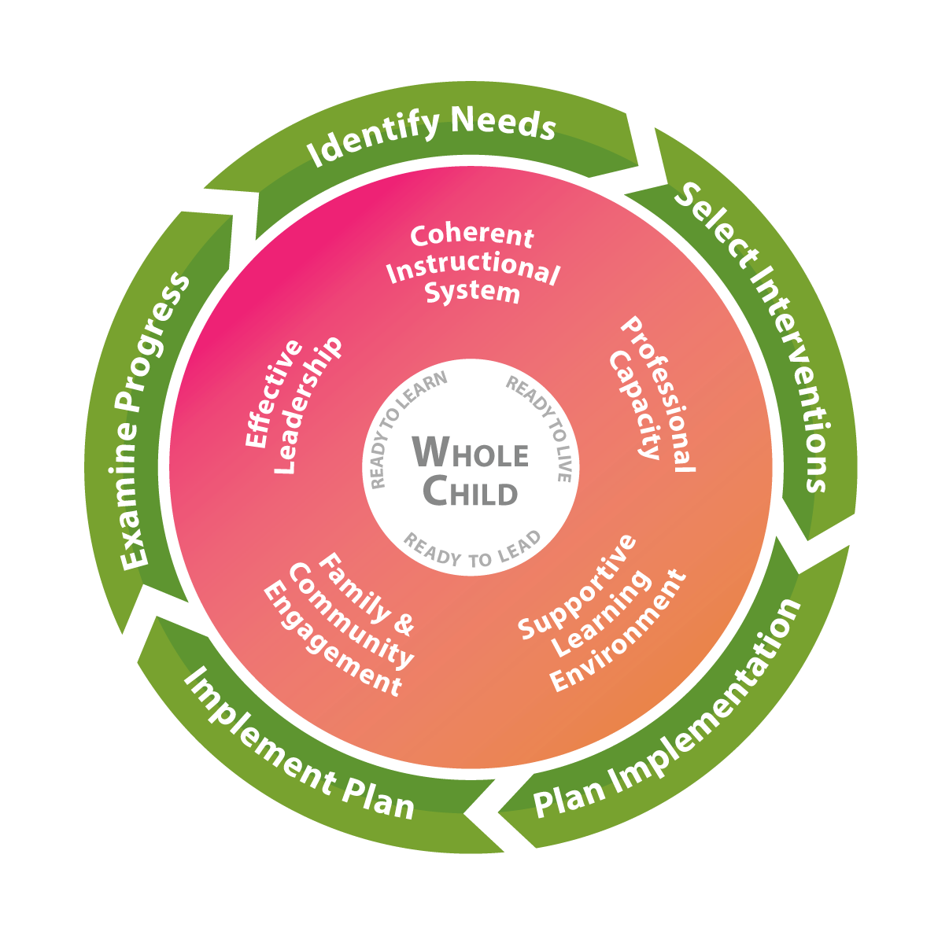

SCHOOL NAME: Argyle Elementary
DATE SUBMITTED
6/30/2021
DATE REVISED
8/20/2021

1

GEORGIA’S SYSTEMS OF CONTINUOUS IMPROVEMENT
The Georgia Department of Education’s strategic plan emphasizes transforming the agency into one that provides meaningful support to schools and districts. The agency has developed a common, continuous improvement framework to ensure that these efforts are aligned across all agency divisions, departments, and programs. Georgia’s Systems of Continuous Improvement focuses on the systems and structures (the “what”) that must be in place for sustained improvement in student outcomes. It also utilizes a problem-solving model (the “how”) to provide a clear process for identifying improvement needs, planning for improvement, and implementing, monitoring, and evaluating the improvement efforts.
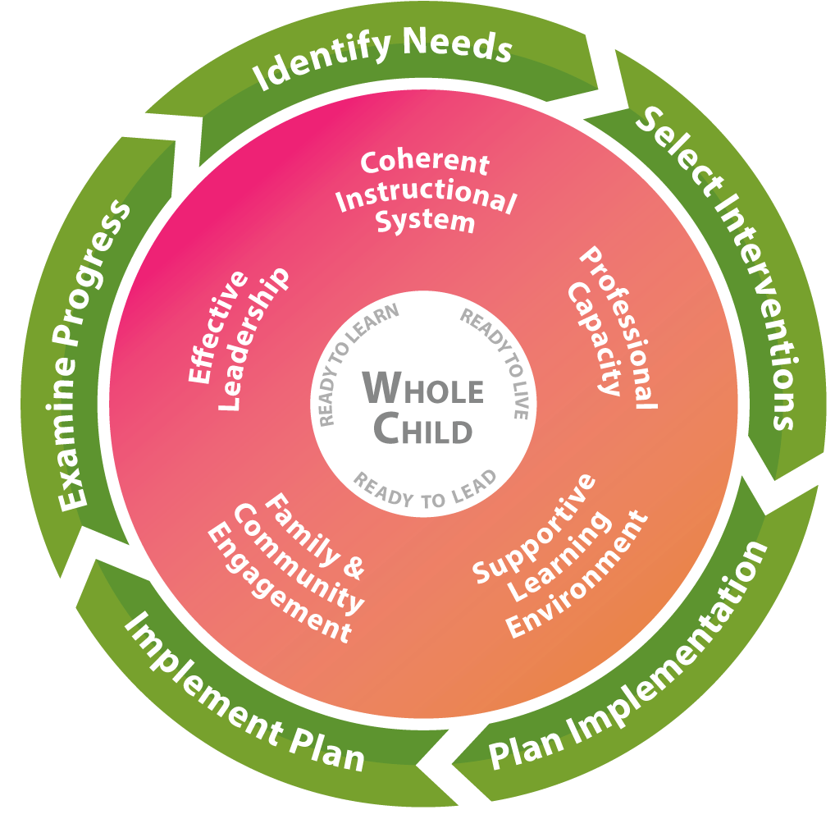
Systems to Improve (What to Improve)
Coherent Instructional System: The major system of the complex school organization that articulates and guides the “what” and “how” of instruction. This comprehensive system includes the processes related to:
- Planning for quality instruction - The structure of the instructional system in which the district defines what the students should “know” and “do”, and determine how their students will show they “know” the content and can “do” a skill or performance task
- Delivering quality instruction - The structure of the instructional system that guides teachers in how they introduce content, practice its use along with the students, and then allow students to use the content on their own while providing students regular standards-based feedback to gain mastery of the content
- Monitoring student progress - The structure of the instructional system that methodically discovers if the students are getting the content, and what to do about it when they are getting it or are not getting it
- Refining the instructional system - The structure of the instructional system that examines how to improve the planning for quality instruction, delivering quality instruction, and monitoring student progress

Georgia’s Systems of Continuous Improvement
Effective Leadership: A major system of the complex school organization that sets the direction for the school, ensures that the school staff and the school leaders are capable of meeting that direction, and makes sure the organization functions according to its mission. This system includes the processes related to:
- Creating and maintaining a climate and culture conducive to learning - the structure of the leadership system that ensures that the school allows both adults and children to put learning at the center of their daily activities
- Cultivating and distributing leadership - the structure of the leadership system that develops others to accomplish the group’s purpose and encourages the development of leadership across the organization
- Ensuring high quality instruction in all classrooms - the structure of the leadership system that reduces the variability in the quality of instruction across all schools and all classrooms
- Managing the district and its resources - the structure of the leadership system that ensures leaders effectively use all the resources at hand so that the district functions according to its mission
- Driving improvement efforts - the structure of the leadership systems that methodically, intentionally, and effectively improves the district’s major systems, structures, and processes
Professional Capacity: A major system of the complex school organization that develops a quality staff to reduce the variance of quality in instruction throughout the school. This system includes the processes related to:
- Attracting staff - the structure of the professional capacity system that is intentional in locating the teachers and leaders that are the best fit for the district and its schools to achieve its mission
- Developing staff - the structure of the professional capacity system that ensures the increasing quality of the school staff’s knowledge and skills
- Retaining staff - the structure of the professional capacity system that ensures the quality staff is working in the context/ position that is most beneficial to student achievement
- Ensuring staff collaboration - the structure of the professional capacity system that reinforces the effective practice of constant collaboration to improve instructional quality in all schools and in all classrooms
Family and Community Engagement: A major system of the complex school organization that develops quality links between school professionals and the parents and community the school is intended to serve. This system includes the processes related to:
- Welcoming all families and the community - The structure of the family and community engagement system that ensures families and the community are active participants in the life of the school, and feel welcomed, valued, and connected to each other, to school staff, and to what students are learning and doing in the school
- Communicating effectively with all families and the community - The structure of the family and community engagement system that ensures families/the community and school staff engage in regular, two-way, meaningful communication about student learning
- Supporting student success - the structure of the family and community engagement system that ensures families, communities, and school staff, continuously collaborate to support students’ learning and healthy development both at home and at school, and have regular opportunities to strengthen their knowledge and skills to do so effectively
- Empowering families - the structure of the family and community engagement system that ensures families are empowered to be advocates for their own and other children, to ensure that students are treated fairly and have access to learning opportunities that will support their success
- Sharing leadership with families and the community - the structure of the family and community engagement system that ensures families/the community and school staff are equal partners in decisions that affect children and families and together inform, influence, and create policies, practices, and programs
- Collaborating with the community - the structure of the family and community engagement system that ensures families and school staff collaborate with community members to connect students, families, and staff to expanded learning opportunities, community services, and civic participation
Georgia’s Systems of Continuous Improvement
Supportive Learning Environment: A major system of the complex school organization that ensures students’ school participation and willingness to expend major effort on classroom learning. This system includes the processes related to:
- Maintaining order and safety - the structure of the supportive learning environment system that ensures that the basic needs of orderliness and safety are met
- Developing and monitoring a system of supports - the structure of the supportive learning environment system that provides comprehensive services to students to meet their unique, whole-child needs
- Ensuring a student learning community - the structure of the supportive learning environment system that ensures compliance with positive and healthy behavioral and academic norms
Process to Improve (How to Improve)
Step 1: Identify Needs: Consult many sources to determine what in the district needs improvement.
- Plan and prepare for the process
- Collect and analyze data
- Identify needs and conduct a root cause analysis
Step 2: Select Interventions: Research many sources to determine the solutions that have a good chance of meeting the identified district needs.
- Consider all the evidence for needed improvements
- Research possible interventions
- Determine if staff has the capacity to implement possible interventions
Step 3: Plan Implementation: Develop a team and plan to implement the solutions that are most promising and can be carried out at the school.
- Identify roles and responsibilities of those implementing the intervention
- Develop a team that will deeply understand the intervention and of best ways to implement it
- Develop the implementation timeline
- Identify resources and supports needed for the implementation of the intervention
- Develop a set of information to be reviewed to track the implementation
Step 4: Implement Plan: Carry out the plan to implement the promising solutions, making real-time adjustments where/ when needed.
- Collect information to monitor the quality of supports being provided for the intervention
- Consider what additional information is needed to determine if intervention is working
- Assess the degree to which the implementation plan is being followed
- Identify ways to break down any barriers
- Build capacity of others to facilitate the improvement process now and in the future
Step 5: Examine Progress: Determine whether the implementation of the promising solutions is meeting the originally identified needs of the school.
- Determine if the staff can formally study the effects of the intervention to share with others in the field
- Monitor implementation and progress against defined goals
- Define reasonable expectations for success
- Identify and track progress and performance
- Develop a plan for how knowledge about the intervention will be shared with others
- Use the evidence to determine whether the intervention should continue as is, be modified, or be discontinued

Georgia’s Systems of Continuous Improvement
Georgia Department of Education
School Improvement Plan
1. GENERAL IMPROVEMENT PLAN INFORMATION
District Name |  |  | Cobb County School District
School Name |  |  | Argyle Elementary School
Team Lead
Position
Email
Phone
Federal Funding Options to Be Employed (SWP Schools) in This Plan
(Select all that apply)
 | X | Traditional funding (all Federal funds budgeted separately)
 |  | Consolidated funds (state/local and federal funds consolidated) - Pilot systems ONLY
 |  | “Fund 400” - Consolidation of Federal funds only
Factor(s) Used by District to Identify Students in Poverty
(Select all that apply)
 | X | Free/Reduced meal applications
 |  | Community Eligibility Program (CEP) - Direct Certification ONLY
 |  | Other (if selected, please describe below)
1. General Improvement Plan Information

2. SCHOOL IMPROVEMENT GOALS

2.1 CREATING IMPROVEMENT GOALS
Effective goals assist schools in attaining collective agreement about what work needs to occur for improvement to take place. Goals should focus and prioritize the efforts and resources of the district/school to the previously identified needs and create a focus for improvement. Setting goals should be a strategic process which aligns the goals within one of the five systems: Coherent Instruction, Effective Leadership, Professional Capacity, Family and Community Engagement, or Supportive Learning Environment.
There are several categories of goals which may be used in school improvement but the one type which focuses on improving results and not just enhancing processes is a SMART goal. SMART is an acronym for:
Specific Measurable Attainable Relevant Time-bound
An example of a SMART goal is:
By the end of the school year 2017-2018, all teachers will have training and be included in a PLC for their content-specific area.

2.1.1 Completing the Improvement Goals Tables
Enter the school’s two to four overarching needs and related root causes, as identified in the Comprehensive Needs Assessment 2017-2018 School Report, into the tables on pages 8, 14, 20, and 26. Determine a goal for each overarching need and include the goal in the last row of each corresponding table. For each overarching need, complete the planning tables covering the five systems from Georgia’s Systems of Continuous Improvement. Use the codes below to list the structures addressed through the goal within each system. For each system, identify one to six action steps that will be taken to address the root causes that have created the overarching need. Finally, identify any supplemental action steps necessary to ensure the necessary supports are in place for the listed subgroups.

Coherent Instructional System
CIS-1 Planning for quality instruction
CIS-2 Delivering quality instruction
CIS-3 Monitoring student progress
CIS-4 Refining the instructional system
Effective Leadership
EL-1 Creating and maintaining a climate and culture conducive to learning
EL-2 Cultivating and distributing leadership
EL-3 Ensuring high quality instruction in all classrooms
EL-4 Managing the district and its resources
EL-5 Driving improvement efforts
Professional Capacity
PC-1 Attracting staff
PC-2 Developing staff
PC-3 Retaining staff
PC-4 Ensuring staff collaboration

2. School Improvement Goals
Family and Community Engagement
FCE-1 Welcoming all families and the community FCE-2 Communicating effectively with all families and
the community
FCE-3 Supporting student success
FCE-4 Empowering families
FCE-5 Sharing leadership with families and the
community
FCE-6 Collaborating with the community
Supportive Learning Environment
SLE-1 Maintaining order and safety
SLE-2 Developing and monitoring a system of supports
SLE-3 Ensuring a student learning community

PLANNING and PREPARATION
Date(s)__________________________________________________________________________
  - IDENTIFICATION of STAKEHOLDERS

Stakeholders are those individuals with valuable experiences and perspective who will provide the team with important input, feedback, and guidance. Stakeholders must be engaged in the process in order to meet requirements of participating federal programs. Documentation of stakeholder involvement must be maintained by the school

Position/Role | Name
Title I Supervisor | Lou Ferretti
Academic Coach (District)
Academic Coach (Local School) | Balisha Johnson
Parent (Non CCSD Employee)
Business Partner
Counselor | Mark Baker
Parent Facilitator | Zoila Hill
Health Care Providers
Social Workers
IHE Leaders
Faith-based Community Leaders
Technology Experts (TIS) | Starla Townsend
Media Specialists/Librarians | Roshanda Wilson
Police/Public or School Safety Officers

Meeting Date(s): _______4/27/2021_____________________________________________________________

IDENTIFICATION OF TEAM
The comprehensive needs assessment (CNA) and school improvement team (SIP) team consist of people who are responsible for working collaboratively throughout the needs assessment and plan development process. Ideal team members possess knowledge of programs, the capacity to plan and implement the needs assessment, and the ability to ensure stakeholder involvement. Documentation of team member involvement must be maintained by school.
Position/Role | Printed Name | Signature
Principal | Georgette Clinton
Assistant Principal | LeShon Graham
Academic Coach/Curriculum Coor. | Balisha Johnson
Parent Facilitator | Zoila Hill
Student Support/RTI/504/EIP | Joseph Wang
7

IDENTIFICATION of STAKEHOLDERS
References: Schoolwide Checklist 3.b.

Stakeholders are those individuals with valuable experiences and perspective who will provide the team with important input, feedback, and guidance. Stakeholders must be engaged in the process to meet federal program requirements of participating federal programs. Documentation of stakeholder involvement must be maintained by the school

In developing this plan, briefly describe how the school sought and included advice from individuals (teachers, staff, other school leaders, paraprofessionals, specialized instructional support personnel, parents, community partners, and other stakeholders).
References: Schoolwide Checklist 3.b.[Sec. 2103(b)(2)]
7/26/2020; 12/2/2020; 2/23/2021

Throughout the 2020-2021 school year, we work to develop goals and monitor our progress toward meeting academic and parent engagement goals. To do so, we began the school year by sharing the plan that was developed as a team, we shared end of year data and our action plan for meeting growth and engagement goals.

We met with families to share the state of the school data and met with them throughout the school year for Title I input meetings and as a Principal Advisory Team. During these sessions, we reviewed current data, methods for student support, and opportunities for families to be engaged. Families and staff we able to share their input, feedback, and thoughts.

At the end of the school year, we had our final family and staff meetings to look at the end of the year data from RI, MI, Write Score, and Istation. We determined our progress and shortcomings as well as began to plan for the 2021-2022 school year.

During the 2021-2022 pre-planning days, we will review all the final data including Milestones and Access as well RI, MI, Write Score, Istation, and Next Steps for reading. Our action plan will be discussed to ensure shared understanding and commitment. We will have a similar meeting with families during our Title I State of the School meeting to share the data and determine how families can support our efforts toward meeting school-wide goals.

8

Comprehensive Needs Assessment (References: Schoolwide Checklist 1.a.)
Comprehensive Needs Assessment Evaluation of Goal(s)
9
Collaborate with your team to complete the questions below regarding the progress the school has made toward each goal in the FY22 School Improvement Plan (SIP).
For the School Year: FY22

Goal 1: Seventy percent of students in Second through Fifth grade will show 100 points in Lexile growth as measured by the end of year Reading Inventory for the 2020-2021 school year.
- Was the goal met?
We did not meet our Lexile growth goal. Forty-two percent of Second graders were eligible to take the RI, therefore it wasn’t possible to attain the goal. 40% of Third graders, 29% of Fourth graders, and 34% of Fifth graders grew 100+ points in Lexile growth.
- What data supports the outcome of the goal?
We used our March Reading Inventory Growth Report to determine if we met our Lexile growth goal.
- What process/action step/Intervention contributed to the outcome of the goal?
Many students entered this school year with greater deficits due to loss of learning from the previous school year. To provide support for our students, our teachers provided targeted small groups and/or one-on-one instruction and used evidence-based practices to close noted gaps. Tutors and ESOL teachers provided students with supplementary literacy support. Students were also given the opportunity to participate in extended day tutoring and other students in danger of not meeting grade-level expectations received interventions through Response-To-Intervention or RTI. Additionally, we offered quarterly trainings for the parents, hosted a Literacy Night, and gave families literacy resources to use at home.
- Reflecting on outcomes:
  - If the goal was not met, what actionable strategies could be implemented to address the area of need?
Kindergarten-first grade teachers will focus on consistent phonics instruction and reading strategy instruction with ability-based word work and/or reading groups.
Second through fifth grade teachers will focus on consistent reading strategy instruction with ability-based reading groups.
All teachers will give ongoing feedback to students through conferencing. During conferences, teachers will share reading levels, along with literacy strengths, areas to strengthen, and grade level learning targets. Students will track their reading levels and progress so they will be able to share in the ownership of their learning and growth.
To further address the area of need, we will begin the school year by establishing a baseline for each student. We will then work as a CCC to determine interventions and extensions based on assessment results. We will establish a data cycle for progress monitoring so that scaffolding is student specific and flexible to meet student’s changing needs. We will also implement a yearlong professional learning plan to strength instructional practices for all teachers.
  - If the goal was met, what strategies will be implemented to sustain the progress that was made and go to the next level?
  - If the outcomes exceeded the goal, what are the next steps?

Goal 2: Seventy percent of all students will show 100 points in Quantile growth as measured by the end of the year Math Inventory during the 2020-2021 school year.
- Was the goal met?
We did not meet our math goal. The results were: 32% of kindergarteners, 23% of first graders, 33% of second graders, 30% of third graders, 45% of fourth graders, and 21% of fifth graders grew 100+ Quantiles points.
- What data supports the outcome of the goal?
We used the Spring Math Inventory Growth Report to determine if we met our Quantile math goal.
- What process/action step/Intervention contributed to the outcome of the goal?
Similar to reading, many students entered this school year with multiple gaps in mathematics due to a shortened school year in 2019-2020. To improve instruction and to efficiently and effectively close existing gaps, teachers received quarterly strategic math trainings throughout the 2020-2021 school year. To improve consistency between virtual and face-to-face students, math manipulatives and other materials were purchased and provided to students and teachers. Teachers utilized their data in CCC Meetings to improve the process of teaching and learning.
To support students, they received small group instruction and worked with a tutor for math support. Students participated in extended day tutoring and received interventions through RTI. Quarterly trainings were offered to parents which included an overview of grade specific math standards and resources for students.
- Reflecting on outcomes:
  - If the goal was not met, what actionable strategies could be implemented to address the area of need?
To address the area of need, we will begin the school year by establishing a baseline for each student. We will then work as a CCC to determine interventions and extensions based on assessment results. We will establish a data cycle for progress monitoring so that scaffolding is student specific and flexible to meet student’s changing needs. We will also implement a yearlong professional learning plan to strength instructional practices for all teachers.
All grade levels will continue working on fluency and automaticity. Primary grades will use making tens, adding doubles, adding near doubles, and counting on strategies to improve math accuracy and automaticity.
Third grade will focus on multiplication and division. They will use skip counting, repeated addition, making groups, making arrays, area model, repeated subtraction, equal groups, fact families, bar model to aid them in learning their facts.
Fourth & Fifth grades will use the area model, partial products, distributive property, partial quotients, and the area model to shore up their multiplication and division facts.
  - If the goal was met, what strategies will be implemented to sustain the progress that was made and go to the next level?
  - If the outcomes exceeded the goal, what are the next steps?
Goal 3: Thirty percent of all students in Kindergarten through Fifth grade will score proficient on the Spring Write Score writing assessment.
- Was the goal met?
Second grade students met our writing goal. Thirty-five percent of second graders scored at the proficient level on the Spring Write Score assessment. One percent of third and fifth graders were proficient, and 15% of fourth graders were proficient on Write Score’s Spring writing assessment. As of 4/28/2021, we have not received the kindergarten and first grade spring writing scores.
- What data supports the outcome of the goal?
We used the Write Score Spring Narrative Assessment to determine if we met our writing proficiency goal.
- What process/action step/Intervention contributed to the outcome of the goal?
Many students entered this school year with learning gaps due to a shortened school year in 2019-2020. To support student learning, teachers implemented Write Score lessons that included each genre of writing and strategies to address the differences in composing each type. Teachers identified students for EIP not only for reading and math, but for writing as well. Some teachers started to use dictation as a strategy to support students in their writing. We also offered an after-school Writing Club.
- Reflecting on outcomes:
  - If the goal was not met, what actionable strategies could be implemented to address the area of need?
To address the areas of need, our teachers will teach Write Score lessons more explicitly, teach with consistency and fidelity. Additionally, they will, implement dictation, analyze data, and make necessary changes in instruction to give adequate support to students. Teachers will confer with students regularly and use a focused writing organizer such as the Hamburger Paragraph Writing Organizer.
To further address the area of need, we will begin the school year by establishing a baseline for each student. We will then work as a CCC to determine interventions and extensions based on assessment results. We will establish a data cycle for progress monitoring so that scaffolding is student specific and flexible to meet student’s changing needs. We will also implement a yearlong professional learning plan to strength instructional practices for all teachers.

  - If the goal was met, what strategies will be implemented to sustain the progress that was made and go to the next level?
If the outcomes exceeded the goal, what are the next steps?

Comprehensive Needs Assessment (References: Schoolwide Checklist 1.a.)
Comprehensive Needs Assessment Summary of Findings
9
Data Types | Identified Strengths | Identified Challenges | Multiple Data Sources Used
 |  | (Highlight 2-3 as Priority)
Student Achievement Data
ELA |  | 1.Lack of idea development in writing  2. Lack of organization and coherence in extended writing  3. Students’ Lexile levels continue to be below grade level targets | -ELA Touchstones Data  -Reading Inventory  -Next Steps Reading Level Data  -IStation  -Write Score  -Writing Rubrics
Math |  | 1.Lack of fact fluency related to addition/subtraction and multiplication/division.  2.Problem Solving- (Reading, Solving, and Sharing mathematical thinking using written constructed responses) | -Math Touchstones Data  -Math Inventory  -Math Fluency Initiative Data
Science
Social Studies
Other
Discipline / School Climate Data
Perception Data
Process Data

Prioritized Need #1
A high percentage of students in each grade level consistently perform below proficiency in ELA. Many students are not on grade level for their reading targets.
Root Cause #1 | Inconsistent implementation of balanced literacy within the reading workshop model.
Root Cause #2 | Need for additional training in reading strategies for instruction and interventions.
Root Cause #3 | Inconsistent implementation of academic interventions especially related to small group instruction for reading.

Root Cause #4

Root Cause #5
GOAL | Seventy percent of students in Second through Fifth grade will show 100 points in Lexile growth as measured by the end of year Reading Inventory for the 2021-2022 school year.

10

Prioritized Need #2

A high percentage of students are not performing on grade level in math.

Root Cause #1 | Student’s lack of stamina in constructing written responses in math
Root Cause #2 | Inconsistent teacher knowledge of math standards and instructional best practices in math.
Root Cause #3 | Student’s lack of math fluency.

Root Cause #4

Root Cause #5
GOAL | Seventy percent of all students will show 100 points in Quantile growth as measured by the end of the year Math Inventory during the 2021-2022 school year.

11

Prioritized Need #3

More than half of our students are not proficient writers.
Root Cause #1 | Inconsistent implementation of balanced literacy within the writing workshop model.
Root Cause #2 | Need for additional training in reading and writing strategies for instruction and interventions for writing.
Root Cause #3 | Inconsistent implementation of academic interventions especially related to small group instruction and conferencing.
Root Cause #4 | Students did not master writing skills should have acquired during the previous grade level.

Root Cause #5
GOAL | Thirty percent of all students in Kindergarten through Fifth grade will score proficient on the Spring Write Score writing assessment.

12

