Classroom Celebrations
Order Form updated 7/27/22
We are here to help you celebrate any occasion in your child’s classroom in a safe way.
- Select treat(s) from the list below. Please make sure funds are available the day of the celebration
- Treats will be picked up by your child’s teacher
- Submit the order form to kimberly.lofstrand@cobbk12.org three weeks before day of event.
Item | Price Per Item | Flavor Choice(s) | Number of Treats Needed
Ice Cream Cones  Ice Cream sandwiches  Ice Cream bars  Menchies-various flavors | $1.75  $1.75  $1.75  $2.00
Whole Pizza- Cheese 10 slices  Whole Pizza- Pep. 10 slices | $20.00
Chocolate Chip Cookies  Celebration Cookies  Double Chocolate Chip Cookies | $.70 each
Chips-various flavors  Scooby Grahams, Goldfish, Animal Crackers | $1.00 $.60
Fresh Baked Brownies  Fruit snacks/roll-ups  Frozen Fruit cups- Straw or peach | $1.50  $.75  $.75
Rice Krispies Treat  Chocolate Chip Rice Krispies Treat | $1.50
8 oz. Bottled Water | $.75
Switch Sparkling 100% Juice  Capri Suns | $1.90  $1.25
Cream filled Van. Cupcake  Cream filled Choc. Cupcake | $1.25  $1.25

Name of Student: ____________________________ Teacher’s Name/Class: ___________________________
Date to be Delivered: ___________________ Total Due: _________________________________________
Parent/Guardian’s Name: _______________________________ Phone Number: ________________________
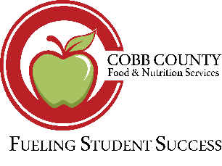
Cafeteria Manager: _____________________ Phone Number: __________________ Email: _______________
Thank you for your support,
Kim

