2023 AP Seminar Summer Preparation Assignments
- As a requirement for the class next year, please purchase the APA Style Manual Made Easy, 7th edition, a text you will use in AP Seminar, AP Research, and in college. It is available new on Amazon.com for $9.95.

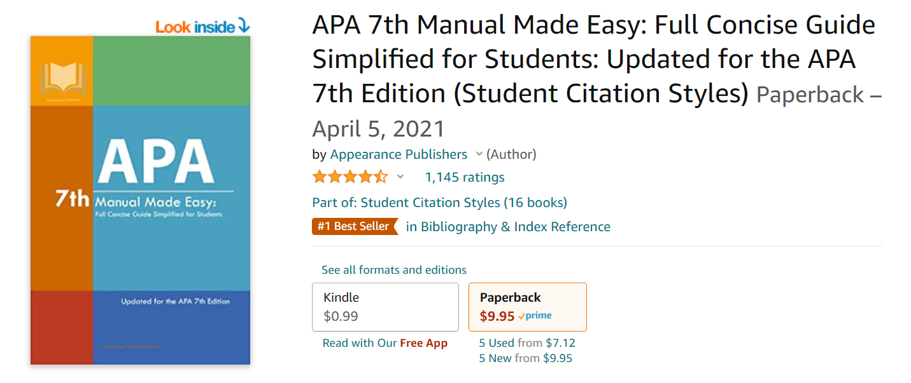

- Over the summer, please choose 3 of the 6 stimulus texts from performance task 2 on the 2017 exam, excluding “We Can Do It” (Rosie the Riveter), as this is an image rather than a text. The assignment (also included below) and link to the texts will be available on the LHS website Summer Assignments page. Texts are found using the following link: https://apcentral.collegeboard.org/pdf/ap-seminar-pt2-directions-stimulus-packet-2017.pdf. These stimulus texts will give you an idea of what is involved in performance task 2, one of the three components that will comprise your AP score.
Please print and physically annotate each text (highlight and take notes in the margins). Additionally, for each text, complete the response form below (you will complete 3 total). Feel free to copy/ paste this format to use as you type your reflections in MS Word. Please type all responses. ** The format below may not be an accurate indication of space needed for responses. Since you will be providing a citation in APA style, you may want to reference the following helpful webpage: https://owl.english.purdue.edu/owl/resource/560/01/.

If you have any questions or issues regarding the assignment, please email me over the summer at hilary.minich@cobbk12.org. Assignments are due the first week of school.

Title of Text:
Author:
Date of Publication:

- Identify the argument or thesis evident in the text (1-2 sentences):

- What claims or main points does the author make in order to arrive at a conclusion? (approx. 1 paragraph)

- Evaluate the author’s use of evidence in the article: (determine if the evidence provided was substantive and credible; provide a few examples of strong evidence in your evaluation) (approx. 1 paragraph)

- Using easybib or citationmachine.net, provide an APA citation of the article:

