**Birney Elementary School**

***Family-School Engagement Policy***

***for Shared Student Success***

*2022–2023 School Year*

*William C. Dills, Principal*

*Cobb County School District*

*776 Smyrna Powder Springs Rd*

*Marietta, GA 30060*

*678.842.6824*

*Cobbk12.org/Birney*

*Revised 8/9/22*

**Birney Elementary School**

**Academic Goals**

**Goal #1**:  The number of students reading on and above grade level will increase by at least 25% (177 of 710 students) during the 2022-2023 school year as measured using the Next Step Guided Reading Assessment tool that will be administered in August 2022 and May 2023.

**Goal #2:**  The percentage of students performing at proficient or higher on the Math Inventory (MI) will increase by at least 25% (177 of 710 students) at each grade level from August 2022 to May 2023.

**Goal #3:** The number of discipline referrals for the 2022-2023 school year will decrease by 10% as reported at the end of the year Comprehensive Discipline Summary.

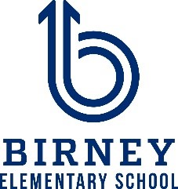

School Plan for Shared Student Achievement

**What is it?**

This is a plan that describes how Birney Elementary will provide

opportunities to improve family engagement to support student learning.

Birney Elementary values the contributions and involvement of families to

establish an equal partnership for the common goal of improving student

achievement. This plan describes the different ways that Birney Elementary

will support family engagement and how parents can help plan and participate

in activities and events to promote student learning at school and at home.

**Jointly Developed**

Birney Elementary invites all parents to complete the Fall school improvement input survey/evaluation to provide suggestions on the school’s Title I program. All parents are also invited to attend the Spring school improvement input meeting to revise this parental involvement policy, our school-parent compact, building staff capacity professional learning topics, and the parental involvement budget. Additionally, parent input and comments regarding this plan are welcome during the school year. The plan is posted on our school Web site for parents to view and submit feedback throughout the year. All parent feedback received during the year will be used to revise the plan for the next school year. We also distribute an annual survey that is posted online to ask parents for their suggestions on the plan and the use of the 1% reservation of funds for parental involvement. Parents can also give feedback during any parent meetings and activities during the school year.

**Who is it for?**

All students participating in the Title I, Part A program, and their parents and families, are encouraged and invited to fully participate in the opportunities described in this policy.  Birney Elementary will provide full opportunity for the participation of Neglected and Delinquent proxy parents, parents and families with limited English, parents with disabilities, and parents of migratory children.

**Where is it available?**

Every family will receive the plan during Parent-Teacher Conference week. It is also available on the school website and a copy is in the front office binder. Parents can also retrieve a copy of the plan in the Parent Resource Center. We will gladly mail the plan to you upon request.

**What is Title I?**

Birney Elementary is identified as a school having a Schoolwide Title I program as part of the Every Student Succeeds Act (ESSA). Title I is designed to support State and local school reform efforts tied to challenging state academic standards which reinforce and enhance efforts to improve teaching and learning for students. Title I programs must be based on effective means of improving student achievement and include strategies to support parental involvement. All Title I schools must jointly develop with all parents a written parental involvement policy.

**Let’s Get Together!**

Birney Elementary will host the following events to build the capacity for strong parental involvement to support a partnership among the school, parents, and community to improve student academic achievement. Family and Community Engagement (FACE) activities will be held at various times to provide opportunities for all families to participate. If you are unable to attend and would like meeting information, please contact Birney Elementary.

**State of the School Meeting- September 8, 2022**

We invite you to an evening of learning about our Title I program, including the parent and family engagement policy, school-parent compacts, parents rights under Title I, highlights of the school improvement plan and the 1% reservation of funds for family engagement. Additionally, you’ll receive a description about our school’s curriculum and the assessments used to monitor student progress.

**Parent-Teacher Conferences – October 17-21, 2022**

Receive updates on your child’s progress in class and on assessments during Conference Week.

Parents may always request conferences with their child’s teacher, as needed.

**Fall School Improvement Input Survey- October 18, 2022**

Birney Elementary will send home the Title I Survey / Evaluation through CTLS Parent. Parents are asked to provide valuable feedback regarding the school, current and future family and community engagement activities and programs.

**Spring School Improvement Input Forum- March 6, 2022**

Parents and educators review and discuss Birney Elementary’s Title I program, future parent activities, school-family compact and policy, family engagement budget and staff trainings.

**Incoming Kindergarten Parent Meeting- April 19, 2023**

Rising Kindergarten families are introduced to expectations and learning opportunities offered in elementary school.

**Rising 6th Grade Information Meeting- April 13, 2023**

Rising 6th grade families are introduced to expectations and learning opportunities offered in middle school.

**Other Parent Activities Provided by the School–**

**Literatura and Hispanic Heritage Program- October 6, 2022**

Families will come to grade-level sessions that provide strategies and materials to support reading at home. Students will present a Hispanic Heritage program.

**Family Hands-on Math Night- December 1, 2022**

Families will come to grade-level sessions that provide strategies and materials to support math at home.

**Literatura and Black History Program- February 2, 2023**

Families will come to grade-level sessions that provide strategies and ideas to support reading at home.

Students will present a Black History Month program.

**Connecting Reading to Math Night- March 2, 2023**

Families will come to sessions that provide strategies and materials to connect reading and math at home.

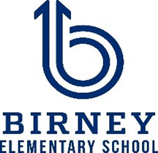

**2022-2023**

**Cobb County Schools**

**District Goals**

* Increase student performance in all core content areas by 2% annually as measured by achievement data.
* CCSD will increase the participation rate of families and communities engaging in services/programs by 10% as measured by CTLS Parent data, survey results & web view module.
* By 2023, we will reorganize the PL framework to meet the needs of all schools to ensure alignment with Superintendent Priorities as measured by PL opportunities, surveys, and student achievement.
* By the end of 2025 school year every school will have identified practices and resources that support student success as measured by student academic, perception or discipline data.

Family-School Compacts

As part of this plan, Birney Elementary and our families will develop a family-school compact, which is an agreement that parents, teachers, and students will develop that explains how parents and teachers will work together to make sure all our students reach grade-level standards. The compacts will be reviewed and updated annually based on feedback from parents, students, and teachers during the School Improvement forum. The family-school compacts are distributed during Parent-Teacher Conference week October 17-21, 2022. Copies are also available throughout the year with each child’s teacher.

8

**Parent Resource Center (Rm. 102)**

**Hours: Mon.-Fri.; 8:00am - 2:00pm**

Visit the Parent Resource Center (PRC) to check out books, study materials, and activities to use at home with your child. Computers are available for parents to explore CTLS Learn, CTLS Parent and educational resources.

Parental Involvement

Birney Elementary believes that parental involvement means the participation of parents in regular two-way, and meaningful communication involving student academic learning and other school activities, including ensuring:

* That parents play an integral role in assisting their child’s learning.
* That parents are encouraged to be actively involved in their child’s education at school.
* That parents are full partners in their child’s education and are included, as appropriate, in decision-making and on advisory committees to assist in the education of their child.

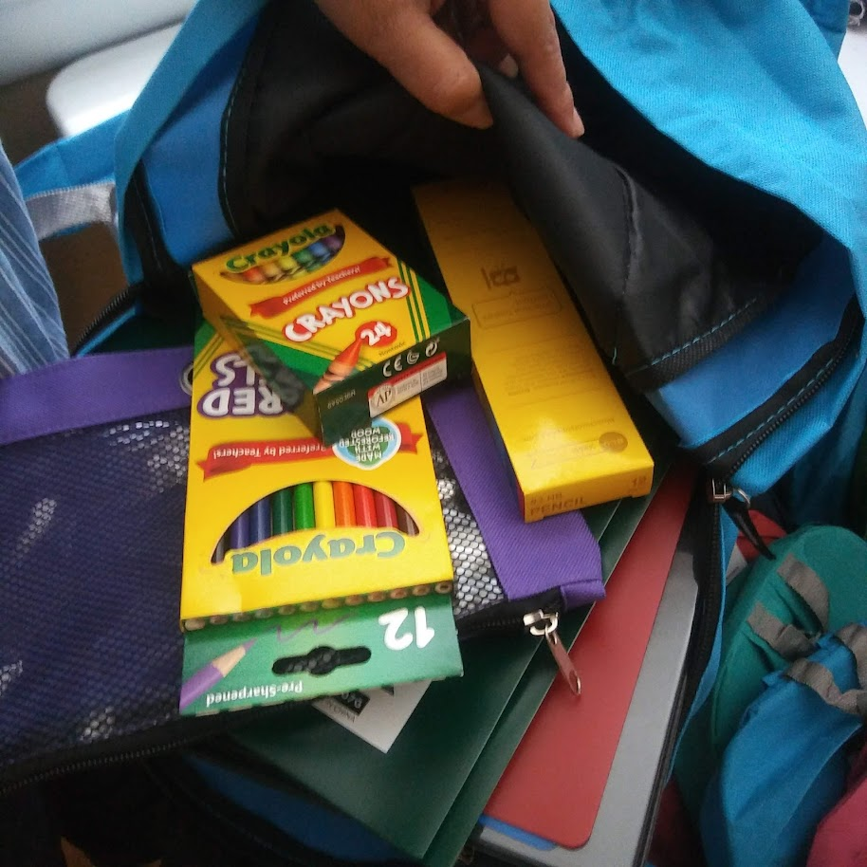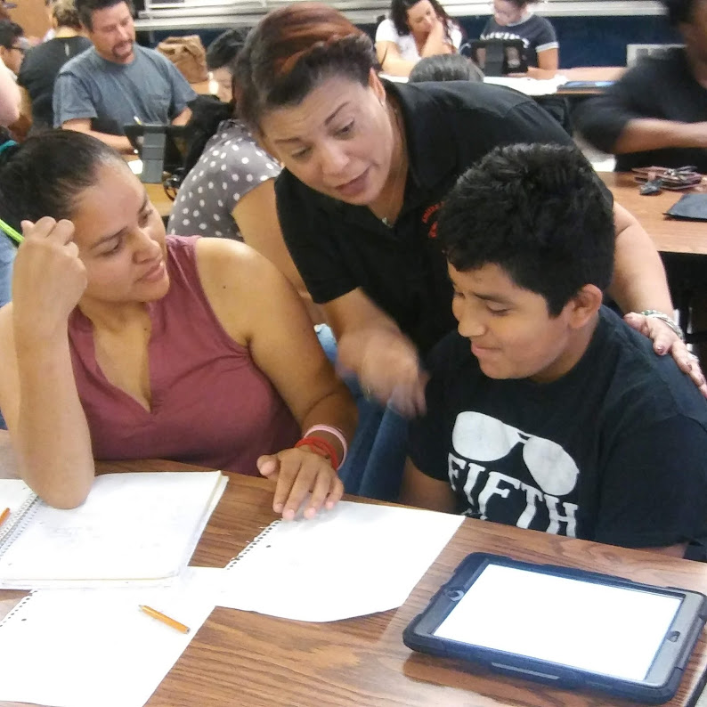

**One Team, One Goal, Student Success**

Birney Elementary will take the following measures to promote and support parents as an important foundation of the school in order to strengthen student academic performance and reach our school goals. We will:

* Ensure that all information related to school and parent programs, meetings, and other activities is published in both English and Spanish, posted on the school website, and included in the monthly Birney Bulletin for all parents.
* Provide two trainings each semester for staff during their planning periods on strategies to improve communication with parents and ideas to increase family engagement.
* Partner with our feeder schools by conducting joint meetings and events for parents and sending school information about parent engagement activities to help prepare parents and their child for school transitions.
* Share information in English and Spanish on the school blog and in the school newsletter for parents to understand the school’s academic standards and assessments as well as the ways parents can monitor their child’s progress and work with educators.
* Communicate with all families and the community on a regular basis regarding schoolwide events and activities, through CTLS Parent, school website, social media, campus signpost and flyers, etc.
* Work with our parents to develop relevant trainings and helpful presentations to educate our staff on the importance of parental involvement.
* Provide necessary materials and handouts for parents at conferences, meetings, and activities to help parents work with their child to improve their child’s achievement.
* Use our Parent Facilitators and Education Partners to improve awareness of the activities and events listed in the school parental involvement policy
* Collect feedback from parents at all events and offer a variety of surveys throughout the school year to respond to parents’ input regarding parental involvement activities and requested meetings.

**Parental Involvement Matters**

Birney Elementary is committed to helping our parents and families attend the family activities listed in this policy. Please call or email us if you need assistance with childcare or transportation to participate in our programs.

Lina Capellan-Genao

678.842.6824 Ext. 032 or   
Lina.Capellan-Genao@cobbk12.org

Principal Advisory Council

The purpose of the Principal Advisory Council is to bring together parents, community members, and school staff to create a better understanding of and mutual respect for each other’s concerns and share ideas for school improvement.

The Principal Advisory Council meets three times per school year. Along with the principal, council members include:

1. Two staff members (one being the current Teacher of the Year).

2. Two parents (one being the current PTSA president).

3. Two members of the community (one being a Partner in Education representative).

4. High Schools *only* should include the president of the student government association or the senior class president.

If you would like to share your ideas and perspective with the Principal Advisory Council please contact William C. Dills, school principal, William.Dills@cobbk12.org

**Share Your Thoughts**

We want to hear from you. If you have any suggestions or if there is any part of this plan that you feel is not satisfactory with the students’ and the school’s goals for academic achievement, please provide us with your comments in the space provided and leave this form in the Main Office:

|  |  |  |  |
| --- | --- | --- | --- |
| Name (Optional): |  | | |
| Phone Number (Optional): | | |  |
| Email Address (Optional): | |  | |

Suggestions, Compliments, Concerns:

Parental Involvement Standards

Birney Elementary and our parents have adopted the National PTA Standards for Family-School Partnerships as the school’s model in engaging parents, students, and the community. These standards are:

1. Welcoming All Families
2. Communicating Effectively
3. Supporting Student Success
4. Speaking Up for Every Child
5. Sharing Power
6. Collaborating with Community

**Parent Involvement Opportunities**

I am interested in participating on the Principal Advisory Council.

I am interested in volunteering in the front office.

I am interested in volunteering in the media center.

I am interested in other volunteer opportunities, please contact me as needed.

|  |  |  |  |  |
| --- | --- | --- | --- | --- |
| Name: |  | | | |
| Child’s Name and Grade: | | |  | |
| Phone Number: | | | |  |
| Email Address: | |  | | |

To return this form via email to [Lina.Capellan-Genao@cobbk12.org](mailto:Lina.Capellan-Genao@cobbk12.org)

or deliver form to the school’s Main Office.