Classroom Celebrations
Order Form
We are here to help you celebrate any occasion in your child’s classroom in a safe way.
- Select celebration treat(s) from the list below.
- Treat(s) will be distributed to the class as they walk through the serving line.
- Submit the order form and payment to the Cafeteria Manager preferably three (3) weeks before day of event.
- Cafeteria manager: Julie Crawford email: julie.crawford@cobbk12.org
Item | Price Per Item | Flavor Choice(s) | Number of Treats Needed
Fresh Baked Cookies  *Cookies are produced in a nut free facility | $0.70 | Chocolate Chip – dairy, soy, egg, wheat  Double Chocolate Chip – dairy, soy, egg, wheat  Sugar - dairy, egg, wheat
Frosted Cookies  Wheat, soy, eggs, milk  *Cookies are produced in a nut free facility | $1.25 | Birthday Frosted
Rice Krispies Treat  Traditional, Chocolate Chip  dairy, soy, soybean oil | $1.50
Fresh Baked Brownies  egg, soy, wheat | $1.50
Novelty Ice Cream | $1.90 | Contact the FNS Manager for available option and allergens
Switch Sparkling 100% Juice | $2.00 | Assorted Flavors

Name of Student: ____________________________ Teacher’s Name/Class: ___________________________
Date of celebration: ___________________ Total Due: _________________________________________
Method of payment (Circle one): Child’s Lunch Account Check
Parent/Guardian’s Name: _______________________________ Phone Number: ________________________
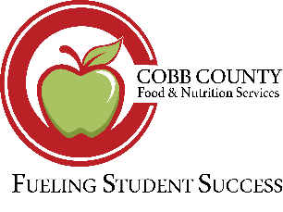
Cafeteria Manager: _____________________ Phone Number: __________________ Email: _______________

