Lassiter High School College Prep 9th Grade Literature and Composition Summer Reading 2023
Over the summer, rising College Prep 9th grade students are encouraged to read the novel The House of the Scorpion by Nancy Farmer and complete the assignment below. This is not required, but students will able to earn extra credit by reading the book and completing the assignment.

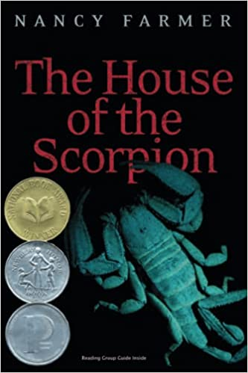
Matteo Alacrán was not born; he was harvested.
His DNA came from El Patrón, lord of a country called Opium--a strip of poppy fields lying between the United States and what was once called Mexico. Matt's first cell split and divided inside a petri dish. Then he was placed in the womb of a cow, where he continued the miraculous journey from embryo to fetus to baby. He is a boy now, but most consider him a monster--except for El Patrón. El Patrón loves Matt as he loves himself, because Matt is himself.
As Matt struggles to understand his existence, he is threatened by a sinister cast of characters, including El Patrón's power-hungry family, and he is surrounded by a dangerous army of bodyguards. Escape is the only chance Matt has to survive. But escape from the Alacrán Estate is no guarantee of freedom, because Matt is marked by his difference in ways he doesn't even suspect.

https://www.amazon.com/House-Scorpion-Nancy-Farmer/dp/0689852231

Students who choose to read the novel should complete the accompanying Major Works Data Sheet. Be as thorough and detailed as possible while filling out the Major Works Data Sheet.

If you have questions about the book or the assignment, please contact Kris Lodde (Kristine.lodde@cobbk12.org) or Jonathan Waters (Jonathan.waters@cobbk12.org)

