**Cooper Middle School Activities to Build Partnerships**

Please consider joining us through some of the events listed below. Volunteer opportunities may be virtual or face to face.

**Volunteer Opportunities:**

* Classroom Readers (In person or virtual)
* Media Center
* Title I Planning Committee

**Partnership Meetings:**

Annual Title I Parent Informational Meeting

Open House

Meet and greet

Title I Parent Input Meetings

Parent Teacher Conference Week

**Family Engagement Opportunities:**

P.A.W.S Night

Strategy Training to Assist Students at Home

Parent Resource Room

**What is a School-Parent Compact?**

Congue nihil imperdiet doming id quod mazim placerat facer minim veni am ut wisi enim ad minimeniam, quis erat nostr uexe

rci tation ullamcorper nostru exerci tation ullam corper et iusto odio dig nissim qui blandit praesent lupta. Tummer delenit

augue duis dolore te feugait nulla facilisi. Con erattis sectetuer adip iscing elit, sed erat diam nonummy nibh magna erat.

If you would like more information, please contact:

**Japonika Francis and Natosha Miller**

(770) 819- 2438 or

[Japonika.francis@cobbk12.org](mailto:Japonika.francis@cobbk12.org) and [Natosha.miller@cobbk12.org](mailto:Natosha.miller@cobbk12.org)

**Jointly Developed**

The parents, students, and staff of Cooper Middle School worked together and shared ideas to develop the school-parent compact for achievement. Teachers suggested home learning strategies, parents added ideas to make them more specific, and students told us what would help them learn. Parents are encouraged to participate in the annual review process of the compact and make changes based on students’ needs. Parents are welcome to contribute comments at any time. Please contact Japonika Francis and Natosha Miller at (770) – 819-2438 or [japonika.francis@cobbk12.org](mailto:japonika.francis@cobbk12.org) and [natosha.miller@cobbk12.org](mailto:natosha.miller@cobbk12.org) to provide feedback.

**Mr. James Rawsl, Principal**

[**James.Rawls@cobbk12.org**](mailto:James.Rawls@cobbk12.org)

**4605 Ewing Road**

**Austell, 30106**

**(770) 819-2438**

[**www.Cobbk12.org/cooper**](http://www.Cobbk12.org/cooper)

*2022-2023*

*Cooper Middle School*

*School-Parent Compact for Achievement*

Grades 6th, 7th and 8th

*Revised Month Day, Year*

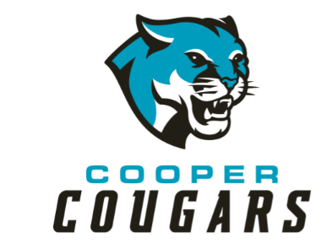

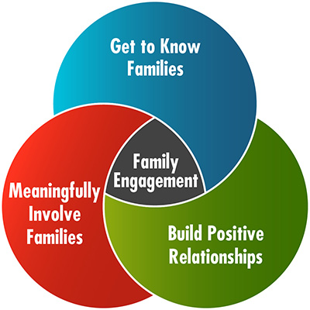

* CTLS Parent
* ParentVUE
* Weekly Folders
* School Website
* Monthly Newsletters
* Email
* Parent/Teacher Conferences
* Facebook &Twitter
* Flyers
* District Website
* School Marquee

**Some communications may be provided virtually**

*A School-Parent Compact is an agreement that parents, students, and teachers, develop together. It explains how parents and teachers will work together to make sure all of our students succeed. This compact includes strategies to help connect learning at school to learning at home.*

**Cooper Middle School Activities to Build Communication**

**Cooper Middle School Students**

**Strategy #1:**

* Students will monitor their classroom performance, assignments and resources via Student Vue/CTLS.

**Strategy #2:**

* Students will continue to use classroom strategies to complete all assignments.

**Cooper Middle School Families**

**Strategy #1:**

* Families will check ParentVue for student assignments, grades, and classroom information.

**Strategy #2:**

* Families will check CTLS announcements provided by classroom teachers to remain current on provided resources and classroom progression.

**Visit Our Website:**

[**www.cobbk12.org/cooper**](http://www.cobbk12.org/cooper)

**Cooper Middle School’s Goal(s) for Student Achievement**

**Goal #1:** The percentage of students scoring proficient/advanced will increase by 10% as measured by the 2022-2023 Georgia Milestones English/Language Arts assessment.

**Goal #2:** The percentage of students scoring proficient/advanced will increase by 10% as measured by the 2022-2023 Georgia Milestones Mathematics assessment.

**District Goals for Student Achievement**

* Increase student performance in all core content areas by 2% annually as measured by achievement data.
* CCSD will increase the participation rate of families and communities engaging in services/programs by 10% as measured by CLTS Parent data, survey results & web view module.
* By 2023, we will reorganize the professional learning framework to meet the needs of all students to ensure alignment with the superintendent priorities as measured by professional learning opportunities, surveys, and student achievement.
* By the end of the 2025 school year, every school will have identified practices and resources that support student success as measured by student achievement, perception and discipline data.

*One Team, One Goal, Student Success!*

**Cooper Middle School Teachers**

**Strategy #1:**

* Pre-teach vocabulary prior to introducing new reading material.

**Strategy#2:**

* In math, implement new or review concepts using scaffolding.

*Teachers, Parents, and Students-Together for Success*