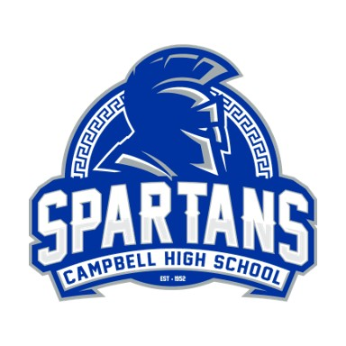

Honor Insignia: Fine Arts Pathway
Cord/Stole Color: Pink

Sponsor(s): Dr. Chantae D. Pittman (chair)
Sponsor Email Address: chantae.pittman@cobbk12.org

Criteria:
Visual Arts & Theatre – These students have completed the pathway by successfully completing 3 or more sequential visual arts courses by their senior year.

Music – These students have completed the performing arts pathway by successfully completing 6 or more sequential performing arts courses by their senior year. (This is due to expected year-long enrollment in these programs).

Students will need to reach out to their fine arts teacher for course verification and purchase their cord on mypaymentsplus.com ($5). Students will receive their cord from their discipline teacher once approved.

One School, One Team, One Goal: Student Success
Every Student, Every Day

