Form JGC-2

STANDARD HEALTH CARE PRECAUTIONS

All blood and body fluids should be treated as if they contain blood and/or respiratory borne pathogens, such as human immunodeficiency virus (HIV), hepatitis B or C, influenza, and COVID-19.

Procedures:
Questions should be directed to the Supervisor, School Health Services.

- Hand Hygiene:
Proper handwashing is the key component of standard precautions and infection control. Students and staff should be encouraged to wash hands as a routine.
- If soap and water are available:
  - Wet your hands with clean running water (warm or cold) and apply soap.
  - Lather your hands by rubbing them together with the soap. Lather the backs of your hands, between your fingers, and under your nails.
  - Scrub your hands for at least 20 seconds. Need a timer? Hum the “Happy Birthday” song from beginning to end twice.
  - Rinse your hands well under clean, running water.
  - Dry your hands using a clean towel or air dry them.
- If soap and water are unavailable, use hand sanitizer (60% to 90% alcohol based):
  - Apply the gel product to the palm of one hand (read the label to learn the correct amount).
  - Rub your hands together.
  - Rub the gel over all the surfaces of your hands and fingers until your hands are dry. This should take around 20 seconds.
- Key Times to Wash Hands
  - Before and after each clinic encounter and after each intervention
  - Before and after treating a cut or wound
  - Before and after caring for someone who is sick with vomiting or diarrhea
  - After blowing your nose, coughing, or sneezing or helping someone else
  - Before, during, and after preparing food
  - Before eating food
  - After using the toilet
  - After changing diapers or cleaning up a child who has used the toilet (https://www.cdc.gov/healthywater/hygiene/diapering/index.html)
  - After touching garbage
- During the COVID-19 pandemic, you should also clean your hands
  - After you have touched an item or surface that may be frequently touched by other people, such as door handles, tables, computers, etc.
  - Before touching your eyes, nose or mouth

- Respiratory Hygiene/Cough Etiquette:
  - Educate healthcare personnel on the importance of source control measures to contain respiratory secretions to prevent droplet and fomite transmission of respiratory pathogens, especially during seasonal outbreaks of viral respiratory tract infections (e.g., influenza, RSV, adenovirus, parainfluenza virus) in communities
  - Post signs at entrances and in strategic places with instructions for staff, students and other persons with symptoms of a respiratory infection to cover their mouths/noses when coughing or sneezing, use and dispose of tissues, and perform hand hygiene after hands have been in contact with respiratory secretions.
  - Provide tissues and no-touch receptacles (e.g., foot-pedal-operated lid or open, plastic-lined waste basket) for disposal of tissues
  - Cough Etiquette:
    - Cover your mouth and nose with a tissue when coughing or sneezing;
    - Use the nearest waste receptacle to dispose of the tissue after use;
    - Perform hand hygiene after having contact with respiratory secretions and contaminated objects/materials
    - Offer masks to persons who are coughing. Either procedure masks (i.e., with ear loops) or surgical masks (i.e., with ties) may be used to contain respiratory secretions (respirators such as N-95 or above are not necessary for this purpose).
    - When space and chair availability permit, encourage coughing persons to sit at least six feet away from others in common areas

- Gloves:
- Wear gloves when it can be reasonably anticipated that contact with blood or other potentially infectious materials, mucous membranes, nonintact skin, or potentially contaminated intact skin could occur
- Vinyl gloves should be used with students who have latex allergy or high potential for developing a latex allergy, such as students with spina bifida
- The use of gloves is intended to reduce the risk of contact with blood and body fluids for the caregiver as well as to control the spread of infectious agents.
- Gloves must be worn when:
  - Disposing of infectious waste/contaminated supplies as described in Section C:
  - Caring for nose bleeds
  - Changing a bandage or sanitary napkins
  - Cleaning up spills or garments soiled with body fluids
  - Disposing of supplies soiled with blood;
  - Any procedure where blood or body secretion is visible
  - Changing a diaper
  - Catheterizing a student
  - Providing mouth, nose or tracheal care or
  - Using a nebulizer treatment
- Change gloves if the hands will move from a contaminated body-site (e.g., perineal area) to a clean body-site (e.g., face).
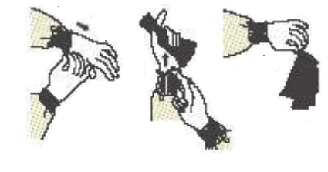
- Do not wear the same pair of gloves for the care of more than one patient.
- Gloves should be removed without touching the outside of the gloves and should be disposed of in a no touch lined waste container
- Gloves are never to be reused.

- Other PPE (Personal Protective Equipment):
  - Gowns:
    - Wear a gown when contact with blood, body fluids, secretions, or excretions is anticipated.
    - Wear a gown for direct contact if there are uncontained secretions or excretions
    - Remove gown and perform hand hygiene after each contact
    - Do not reuse gowns
  - Mouth, nose, eye protection:
    - Use PPE to protect the mucous membranes of the eyes, nose and mouth during procedures and care activities that are likely to generate splashes or sprays of blood, body fluids, secretions and excretions. Select masks, goggles, face shields, and combinations of each according to the need anticipated by the task performed
    - During aerosol-generating procedures (e.g., suctioning of the respiratory tract, nebulizer treatments) in patients who are not suspected of being infected with an agent for which respiratory protection is otherwise recommended, wear one of the following: a face shield that fully covers the front and sides of the face, a mask with attached shield, or a mask and goggles (in addition to gloves and gown)

- Patient Placement:
  - Take Precautions When Performing Aerosol Generating Procedures (AGP) (https://www.cdc.gov/coronavirus/2019-ncov/hcp/infection-control-faq.html) i.e. Nebulizer treatments. Some procedures performed on patients with known or suspected COVID-19 could generate infectious aerosols. Procedures that pose such risk should be performed cautiously and avoided if possible.
  - If performed, the following should occur:
    - Healthcare Personnel in the room should wear a KN95 fitted mask, eye protection, gloves, and a gown.
    - Limit the number of people in the room.
    - Clean and disinfect room surfaces promptly after performing AGP.

- Environmental Infection Control:
  - Clean-up:
    - Care should be exercised to prevent blood and body fluids from coming in contact with open skin lesions and mucous membranes by wearing proper protective clothing (PPE) such as gloves, lab coat and face protection (face mask, eye goggles or face shield).
    - Infectious waste and supplies contaminated by infectious waste should be disposed of as follows:
      - Body waste (i.e., urine, vomitus, and feces) should be disposed of in the toilet.
      - Blood and/or body fluid spills should routinely be covered with absorbent material such as paper towels (handled with disposable gloves) and disposed of in a plastic bag securely fastened, placed in plastic lined garbage receptacle, and disposed of in the regular school garbage dumpster.
      - Soiled surfaces should be cleaned promptly with District or EPA approved disinfectants.
      - Ensure that environmental cleaning and disinfection procedures are followed consistently and correctly.
      - Refer to List Nexternal icon on the EPA website (https://www.epa.gov/pesticide-registration/list-n-disinfectants-use-against-sars-cov-2) for EPA-registered disinfectants that have qualified under EPA’s emerging viral pathogens program for use against SARS-CoV-2.
  - Disposal:
    - Disposable towels or tissues shall be used whenever possible and all cleaning equipment shall be disinfected after use:
      - Cleaning equipment such as mop heads should be cleaned thoroughly after clearing a blood and/or body fluid spill.
      - Equipment should be cleaned with detergent in hot water of 160 F, rinsed, soaked in a school-approved disinfectant for ten (10) minutes and rinsed again.
      - Any used or contaminated supplies containing blood or body fluids (except syringes, needles, and other sharp equipment) should be placed in a plastic bag, securely fastened and disposed of in the regular school garbage dumpster.
      - Persons involved in the cleaning of facilities in which blood and/or body fluid spills (i.e. feces, urine vomitus) occur should wear gloves and follow routine hand washing procedures.
    - Used needles, syringes, lancets, glass ampules, and razor blades should be placed immediately after use in biohazard container approved for “sharps” disposal. Needles should not be recapped, bent, or removed from the syringe before disposal.

- Manikins:
Persons responsible for the cleaning and maintenance of CPR manikins and CPR instruction should follow the guidelines established by the American Heart Association, the American Red Cross or the Center for Disease Control (CDC).

- PPE:
This infographic gives a basic overview of how to safely don and doff PPE equipment such as masks, gowns, eye protection, and gloves in the proper order.

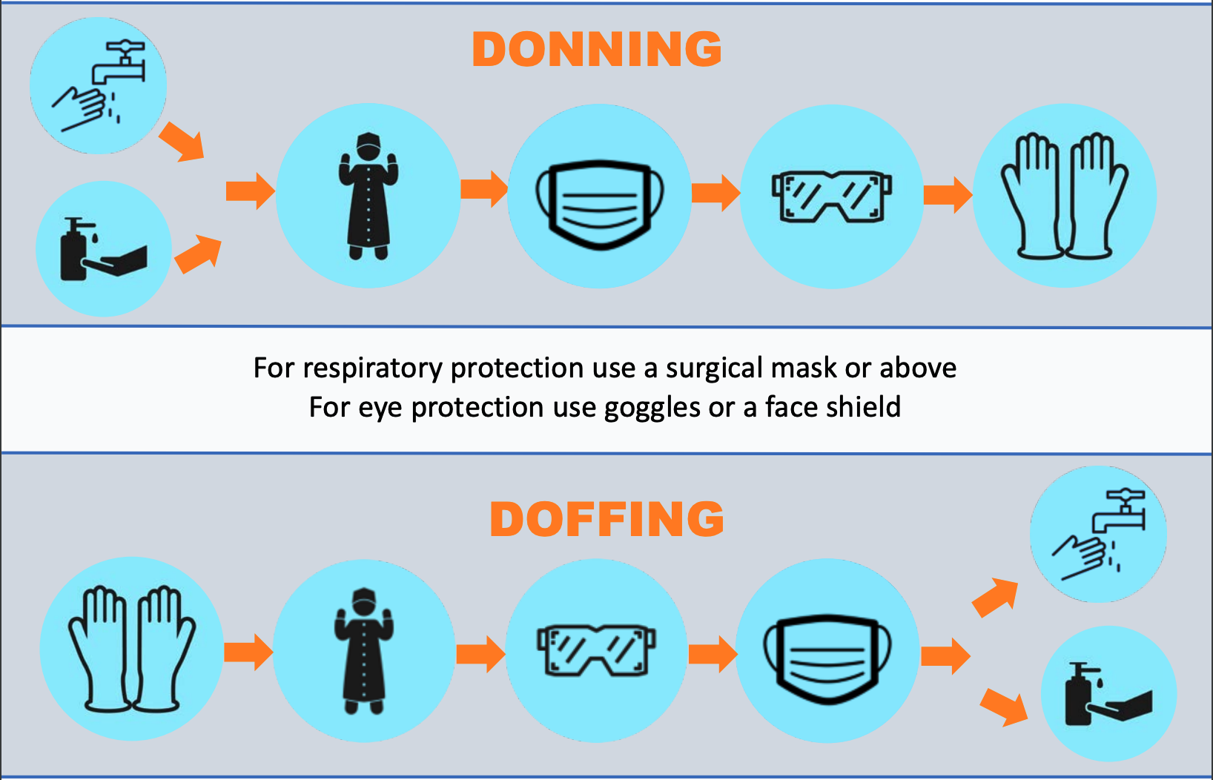

http://publichealth.lacounty.gov/acd/docs/CoVPPEPoster.pdf
https://youtu.be/cDcuU3KVpuo

