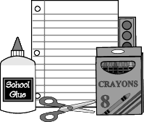
Kindergarten Supply List

1 pair of headphones (no earbuds)
1 red sturdy/poly (Plastic) 2 pocket folder with brads
1 sturdy/poly (Plastic) 2 pocket folder (any color/design)
1 - 12ct box of #2 Dixon Ticonderoga pencils
2 large pink erasers
1 plastic pencil box (5x8)
4 boxes of 24ct Crayola crayons
24 small Elmer’s glue sticks
1 - 4 pack thin, black Expo dry erase markers
1 pair of kids Fiskar scissors
1 box (12ct) of colored Crayola pencils
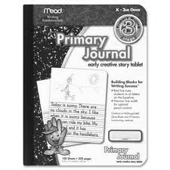
1 wide-ruled spiral bound notebook
2 boxes of tissues
2 boxes of sandwich size Ziploc baggies
1 box of snack size Ziploc baggies
2 boxes of gallon size Ziploc baggies
2 bottles of pump hand soap
1 bottle of hand sanitizer
2 containers of Clorox wipes
1 roll of paper towels
***1 Primary Composition book (Space for picture at the top and dotted lines on the bottom) **The Primary Journals have a space for drawing and lines for writing. MEAD is the supplier of the ones that are best for teaching handwriting. They have a blue solid line, a blue dashed middle line, and a red bottom line. Please do not purchase the regular composition notebooks; the lines are not correct for kindergarten writing. These Primary Journals are sometimes difficult to find. We suggest Staples, Office Max, or School Box. Please shop early.

