Name __________________________
Principles of Biomedical Science Summer Assignment 2023
lauren.jackson2@cobbk12.org
Background
This year in Principles of Biomedical Science we will be learning about a wide variety of topics including investigating crime scenes, clinical care practices, outbreaks, emergencies, as well as medical innovations such as regenerative medicine. Each of these topics share one common characteristic- they all involve the human body! The human body is a complex organism made up of various systems that work together to perform a variety of functions necessary for survival. At its most basic level, the human body is composed of cells, which are the building blocks of life. These cells are organized into tissues, which in turn form organs, and ultimately, organ systems. Some of the major organ systems in the human body include the respiratory system, which helps us breathe; the cardiovascular system, which pumps blood throughout the body; and the digestive system, which processes food and eliminates waste. In addition to these systems, the human body also has a nervous system, which helps us process information and control our movements, and an endocrine system, which produces hormones that regulate various bodily functions. Together, these systems help maintain the delicate balance necessary for the human body to function properly. This assignment will be electronically turned in on the first day of class.
Instructions Part I) Graphic Organizer
Use a search engine of your choice to complete the following graphic organizer of the human body. All your information should be listed with bullet points. Several body systems contain more than one organ and have many functions. The more detail the better! You may find a picture of the body system(s) online and place the picture(s) in the “Diagram” category. You may take up as much space as necessary!
Body System | Function | Diagram | Major Organs | Interactions Working with Other Body Systems
Digestive
Circulatory
Nervous
Excretory
Respiratory
Skeletal
Muscular
Endocrine
Immune
Integumentary
Lymphatic
Reproductive

Instructions Part 2) Labeling the Heart
You will be expected to know the anatomy and physiology of the human heart. In some instances, you will need to be able to label the heart from different angles. Research the anatomy of the heart, then label the heart as seen below using the provided word bank.
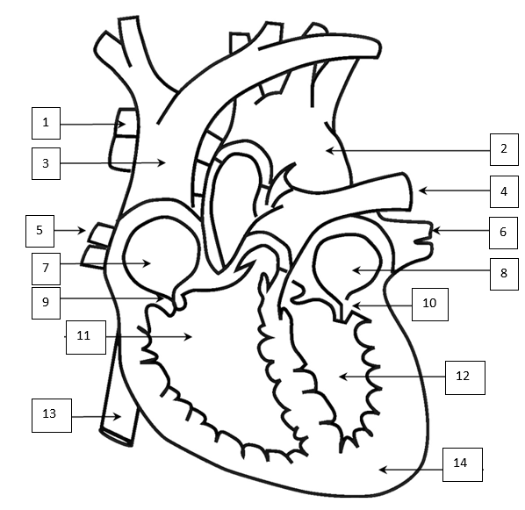
- ________________________________
- ________________________________
- ________________________________
- ________________________________
- ________________________________
- ________________________________
- ________________________________
- ________________________________
- ________________________________
- ________________________________
- ________________________________
- ________________________________
Word Bank
Apex
Left Pulmonary Vein
Right Atrium
Aorta
Right Pulmonary Vein
Left Pulmonary Artery
- ________________________________
Tricuspid Valve
Left Atrium
Right Pulmonary Artery
Right Ventricle
Superior Vena Cava
Left Ventricle
Inferior Vena Cava
Mitral Valve

- ________________________________

Instructions Part 3) Tracing the Pathway of Blood
Create a flowchart of blood flowing through the heart! Start your flow chart with deoxygenated blood going through the vena cava. You should use the computer to illustrate this design; use blue to identify deoxygenated blood and red for oxygenated blood. Use as much space as necessary!

Part 4) Engineering & Design: Constructing a 3D Model of the Heart
The human heart is an integral part of how the human body works. You are tasked with building a 3D model of the heart that is anatomically correct using simple materials and a diagram. The choice of appropriate material to build the model is up to you. Models made from papier-mache, Styrofoam, recycled materials, and modeling clay are all possible. Papier-mache, however, is the simplest of these building materials, and its use allows for accuracy. Get an accurate diagram of the human heart. Many diagrams are available from the Internet. Make a blueprint of the diagram you are going to create, include your materials, and labeled parts. Your blueprint can be designed on the computer or drawn on paper. Insert a picture of your blueprint below. Once you have finalized your blueprint begin making your 3D model. All parts of the heart must be colored and labeled. You will bring this model into class on the first day of school.
Your heart should include the following labeled structures:

- Right Atrium
- Left Atrium
- Left Ventricle
- Right Ventricle
- Ventricular Septum
- Aorta
- Pulmonary Veins
- Tricuspid Valve
- Bicuspid Valve
- Superior Vena Cava
- Inferior Vena Cava
- Apex

[Insert blueprint picture here]

