What is a School-Parent Compact?
A School-Parent Compact for Achievement is an agreement that parents and teachers develop together. It explains how parent and teachers will work together to make ensure all students reach grade-level standards.
Parents are welcome to contribute comments at any time. Please forward comments to
Elsa Alejandra Constantino
678-842-6966 or email, elsaalejandra.constantinototo@cobbk12.org
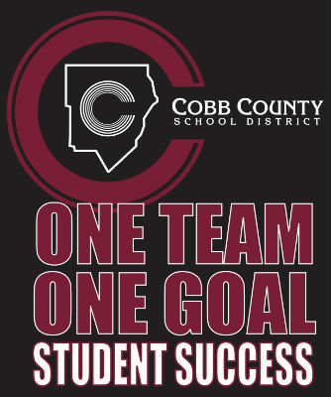

If you would like to volunteer at Milford Elementary School, please contact:
Elsa Alejandra Constantino
678-842-6966 or email, elsaalejandra.constantinototo@cobbk12.org

Building Partnerships
Milford builds partnerships with our families in the following ways:
- Providing educational materials and resources for check out from our Parent Resource Center
- Volunteering
- Joining PTA
- Attending academic workshops
- Conference Week October 19-22, 2021
Communication about Student Learning
Milford is committed to consistent communication in the following ways:
- CTLS Parent
- CTLS Student
- Zoom Meetings
- ParentVUE
- Maintaining a school website
- Meeting with families during parent –teacher conferences in October 2021
- Mid-Quarter Academic Progress Reports
- Curriculum Nights
- Response to Intervention (RTI) meetings
- Automated calls and text messages about school happenings

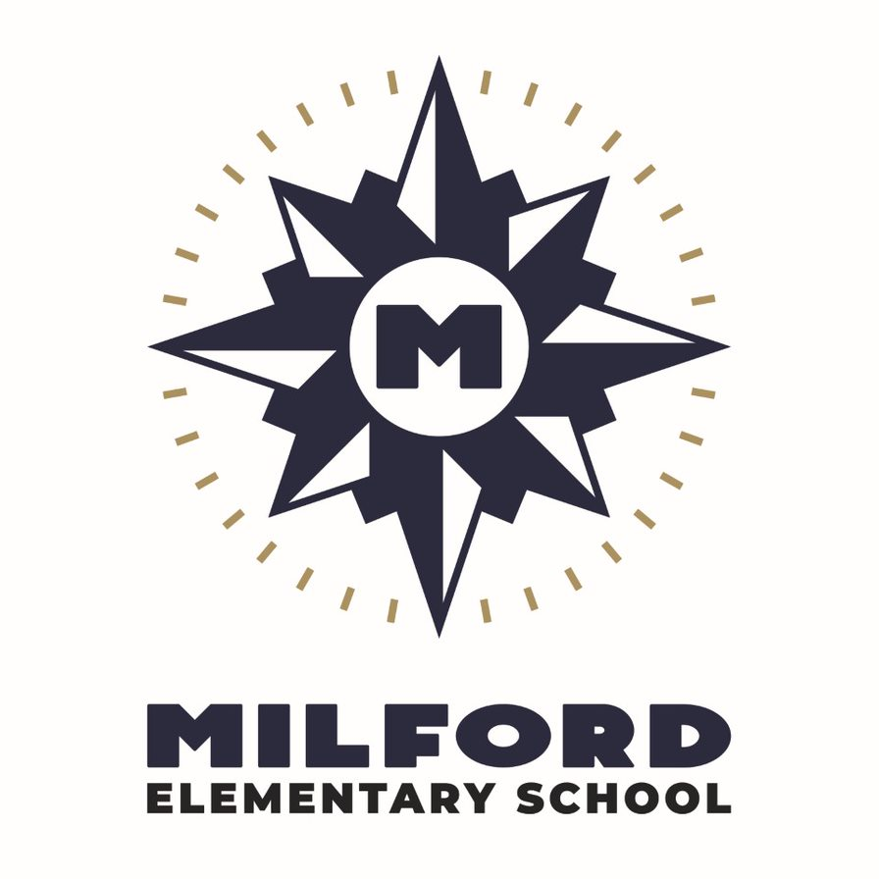
2021-2022
School-Parent Compact
For Achievement

Primary (K-2)

Dr. Hermia Simmons-Deveaux, Principal
http://www.cobbk12.org/Milford/
678-842-6966

Revision Date
08/13/2021

Our Goals for Student Achievement
Cobb County District Goals

- Increase student performance in all core content areas by 2% annually as measured by achievement data.
- CCSD will increase the participation rate of families and communities engaging in services/programs by 10% as measured by CTLS Parent data, survey results & web view module.
- By 2023, we will reorganize the PL framework to meet the needs of all schools to ensure alignment with Superintendent Priorities as measured by PL opportunities, surveys, and student achievement.
- By the end of 2025 school year every school will have identified practices and resources that support student success as measured by student academic, perception, or discipline data.

Milford Goal(s) and Focus Area(s)
- We will increase the number of students scoring proficient or advanced by a minimum of 10% as measured by the spring Reading Inventory assessment.
- We will increase the number of students scoring proficient or advanced by a minimum of 15% as measured by the spring Math Inventory assessment.
- Writing across the curriculum in all grade levels.

Milford Vision Statement
Empowering Students for Success
Milford Primary Teachers Will:
The primary teachers, specialists and support staff will work with your students to develop understanding of grade level standards. They will:

- Provide books for reading 20 minutes nightly on each child’s independent level; invite parents to an academic workshop to support the literacy standards.

- Provide Parent Road Maps that explain and show models of the Georgia Standards of Excellence Math Strategies; provide an online license for XtraMath and Splash Math for students to access at school and home; invite parents to an academic workshop to support the math standards.

- Provide writing activities to parents in all subject areas.
Milford Families Will:
- Read with their child nightly to support literacy standard; families will attend an academic literacy workshop.
- Review the Parent Roadmap’s to better understand math strategies; Access Xtra Math and Splash Math from website and review math assignments with their child; families will attend an academic math workshop.
- Provide time for students to write daily in all subjects.
Milford Students at Home Will:
- Read at school and at home daily.
- Access Fast Math and Splash Math at school and at home; practice math skills nightly.
- Students will write daily in all subjects.

