**South Cobb High School**



**South Cobb**

**High School**

Student Handbook

2023-2024

**Important Numbers**

Main Office: 770-819-2611

Fax: 770-819-2612

Attendance: 770-819-2621

<http://www.cobbk12.org/southcobb/>

|  |  |
| --- | --- |
| Table of Contents |  |
| **A** | Page |
| Absences | 22 - 23 |
| Advisement (Homeroom) | 17 |
| Athletic Activities | 25 |
| Attendance | 22 |
| **B** |  |
| Behavior Policies/Expectations of Behavior | 11-18 |
| Bell Schedules | 7-8 |
| Block Scheduling | 18 |
| Bus Dismissal | 32-33 |
| Bus Expectations | 26 |
| **C** |  |
| Cafeteria Procedures | 6 |
| Calendar | 25 |
| Cell Phones | 33 |
| Certificate of Attendance | 24-25 |
| Changing of the Chairs | 35 |
| Cheating | 33 |
| Co-Curricular Activities | 17 |
| College Visitations | 26 |
| Counseling | 19 |
| **D** |  |
| Deliveries | 26 |
| Detention | 10 |
| Discipline Procedures | 9-13 |
| Dress Code | 14 |
| **E** |  |
| Eagle Fly-By | 35 |
| Early Dismissal | 24 |
| Eligibility (see Co-Curricular) | 17 |
| Excused Absences | 22 |
| Extended Absences | 23 |
| Extracurricular Activities | 27 |
| **F** |  |
| Fees/Fines | 26 |
| Field Trips | 27 |
| Final Exams/Exam Exemptions | 17 |
| Fire/Tornado/Code Red Drills | 27 |
| Free/Reduced Lunch Program | 27 |
| **G** |  |
| GHSA Eligibility (see Co-Curricular) | 17 |
| Grades | 18 |
| Graduation Requirements | 16 |
| **H** |  |
| Hallway Procedures | 28 |
| Homework | 34 |
| Honors Night | 20 |
| Hope Grant | 19 |
| Hospital/Homebound | 20 |
| **I** |  |
| Information Changes | 31 |
| International Festival | 34 |
| ISS (In School Suspension) | 10 |
| **L** |  |
| Library Policies | 20-21 |
| Lockers | 28 |
| Lost and Found | 28 |
| **M** |  |
| Make-up Work | 23 |
| Medicine | 29 |
| Messages for Students | 30-31 |
| **O** |  |
| OSS (Out of school suspension) | 11 |
| **P** |  |
| Parking Fees and Policies | 29 |
| PBIS at SCHS | 35 |
| Phone Messages | 29 |
| **R** |  |
| Reassessment Policy | 33 |
| Registration | 21 |
| Report Cards | 21 |
| **S** |  |
| Schedule (Bell) | 8-9 |
| School Hours | 30 |
| School Insurance | 30 |
| School Property | 32 |
| Student Daily Expectations | 10 |
| Student Events | 30 |
| Student Lanyards | 34 |
| Student Personal Information Changes | 31 |
| Student Recognition | 22 |
| **T** |  |
| Tardies/Tardy Policy | 23-24 |
| Transportation Expectations | 32-33 |
| **V** |  |
| Valuables | 31 |
| Visitors | 27-28 |
| Volunteering | 26 |
| **W** |  |
| Who's Who | 35 |
| Withdrawal Policy | 31 |
| Work Permits | 31 |
| **Y** |  |
| Yearbook Sales | 31 |
|  |  |

**2023- 2024 SCHOOL CALENDAR**

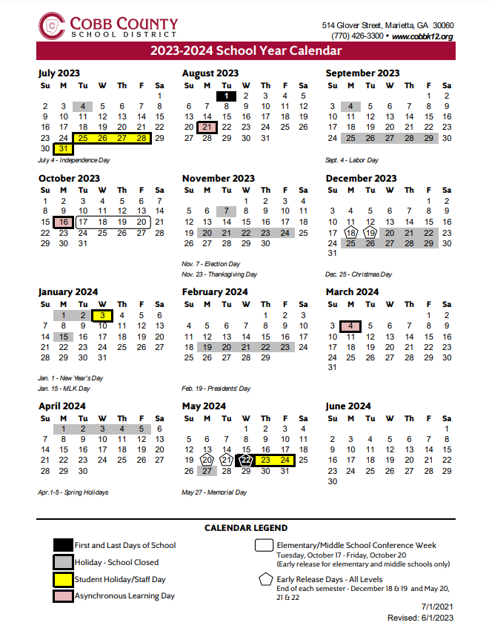

For all CCSD calendars visit <http://www.cobbk12.org/>

**Bell Schedule**

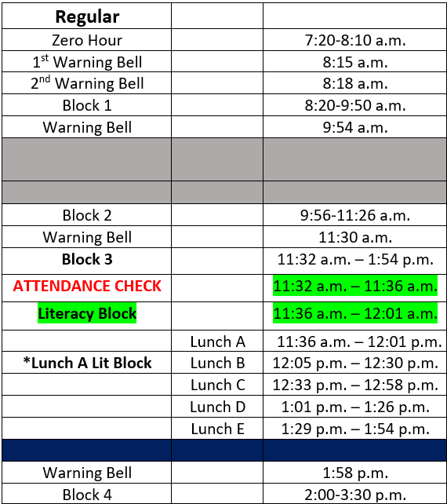

**Advisement Bell Schedule**

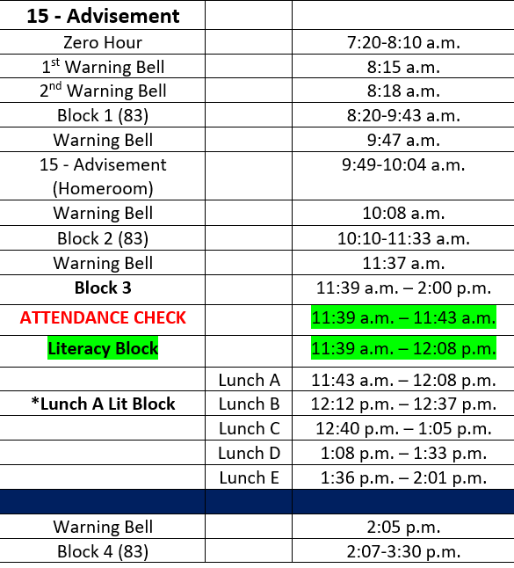

**DISCIPLINE PROCEDURES**

The Cobb County School District Code of Conduct and the Student handbook will be available to parents and students on the school website. Students will also review policies and procedures at the beginning of each semester, when they register, and throughout the year. Parents are encouraged to read this information carefully. Further information may be obtained at:

[www.cobbk12.org](http://www.cobbk12.org)

Our teachers communicate and maintain high standards for conduct in all classes. Students are informed of these standards and always know what is expected. A responsible student at South Cobb High School:

* Follows School Rules
* Is Respectful to Adults and Peers
* Is Prepared for Classes
* Is in dress code
* Sets Goals for Personal and Academic Development
* Completes Classwork and Homework Assignments
* Attends Tutoring and/or SOAR Saturday
* Strives to Reach Their Fullest Potential
* Is Involved in School Clubs/Athletic Activities

Whether in the classroom, elsewhere on campus, or representing the school at an off-campus event, our objective is to maintain a high standard of conduct and to create an atmosphere that is conducive to the growth of every student. Although actual classroom procedures may vary from classroom, students may expect fair treatment in response to disciplinary infractions. In addition to classroom behavior guidelines, there are school standards that apply to every part of our campus. All school policies and standards are designed to provide for the safety of students, protect property, and minimize interruptions to classroom instruction. School guidelines in the Student Agenda will be available on the school website. As a student at South Cobb High School, students are expected to adhere to these guidelines both on and off campus. Teachers review these rules with all students so that there is no confusion about the expectations that have been set.

**STUDENT DAILY EXPECTATIONS**

1. Students should be on time to class and lunch.
2. Students should leave the walkways clear for traffic so that all students can move comfortably throughout the building.
3. Students should have their lanyard when walking in the hallways and when entering the cafeteria.
4. Students are responsible for necessary repairs to any damaged property, or replacement of lost property. Therefore, care should be taken to avoid these damages.
5. Students should be respectful of adults, other students, and self. Inappropriate language, inappropriate displays of affection, and disruptive behavior are not acceptable behaviors on campus or during school activities.
6. Students are expected to remain in the classroom during instructional hours. However, should students need to leave the classroom for any reason, permission must be granted with a pass.
7. Hats and hoodies should be removed from heads upon entry into the building.

**DISCIPLINARY OPTIONS**

**TEACHER/DEPARTMENTAL DETENTION**

Teachers may assign detention for violations of class rules or tardies. Teacher/departmental detention are served before and/or after school. **It is the student's responsibility to know when and where to report for detention.** If the student does not serve the assigned detention(s), an administration referral will be submitted.

**IN-SCHOOL SUSPENSION (ISS)**

In- School Suspension (ISS) is a program designed to modify behavior while keeping the student in school with access to schoolwork. The program isolates the students from his/her peers in a controlled environment. Students may be removed from ISS for inappropriate behavior (i.e., tardy, insubordination, not working on assignments). Students who do not conduct themselves appropriately in ISS may be suspended. Since ISS is a form of suspension, ISS affects participation in extracurricular activities. Students who fail to report to ISS on the assigned date as instructed by an administrator will receive OSS. Students will receive OSS if they cannot follow ISS directions.

**OUT-OF-SCHOOL SUSPENSION (OSS)**

Suspension from school is an alternative to modify student behavior. A suspended student may not come on campus, attend any school function, or practice until the day he/she returns to school from suspension. Certain behaviors always result in suspension due to Cobb County School District policy or local school policy.



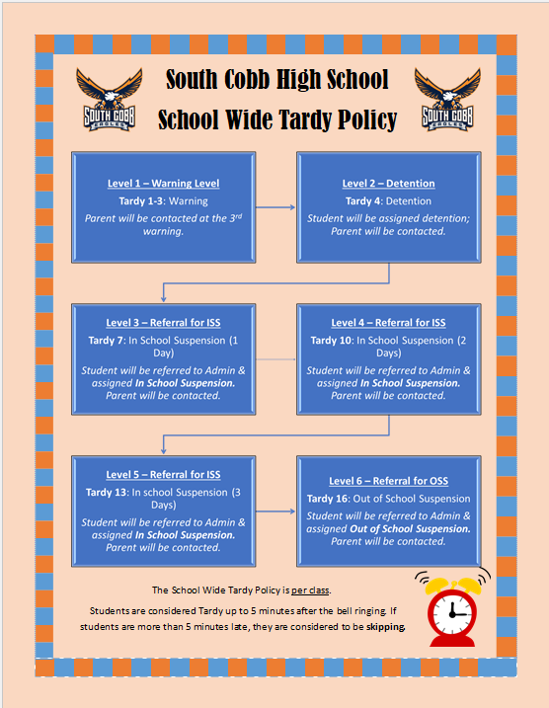

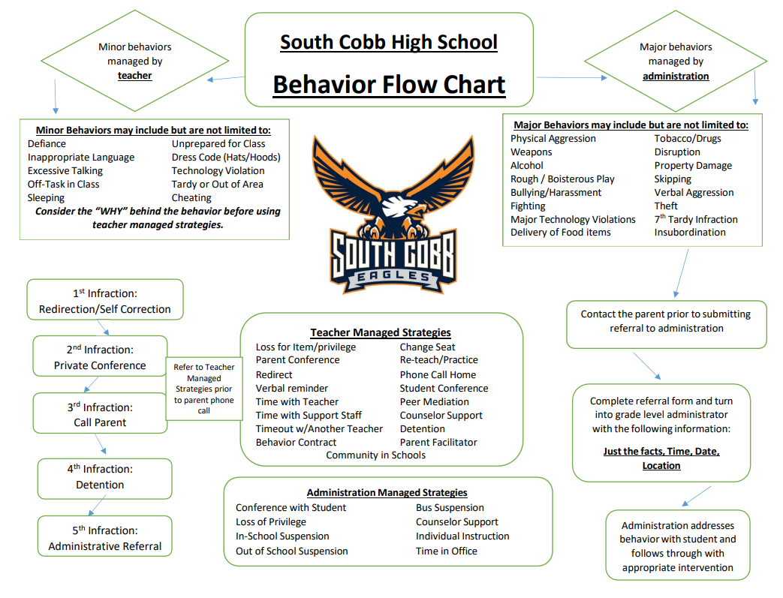

**DRESS CODE**

* Modesty and decency of dress are expectations at South Cobb High School.
* Students are expected to dress and groom themselves in a manner that demonstrates respect for fellow students, staff, and guests to our school.
* Clothing that is deemed disruptive to the learning environment is unacceptable and will not be permitted.
* Failure to adhere to the dress will result in school consequences.
* Dress code and consequences are subject to administrative approval.

School administration shall be the final judge as to the appropriateness of the apparel; and whether the apparel is disruptive, unsafe, or in violation of the dress code.

**MINIMUM STANDARD OF DRESS**

All students shall maintain the following minimum standard of dress:

1. Shoes must be worn at all times.
2. Midriffs must be covered.
3. Appropriate under-garments must be worn and may not be visible.
4. Strapless garments must be worn with a jacket.
5. Tank-tops must be worn with a jacket.
6. Appropriate shorts, as determined by the school administration, may be worn.
7. No caps, hats, bandanas, bonnets nor hoods covering the head are to be worn in the school buildings during the school day unless there is a special activity during which they are deemed appropriate by the school administration.
8. Shorts/Pants must always be at the waist.
9. Clothing or ornamentation that does any of the following is prohibited:
   1. Displays or advertises substances illegal for minors.
   2. Displays suggestive phrases, designs, markings, or profanities.
   3. Advocates, promotes, or suggests illegal activity.

**Where do I go to get what I need?**

|  |  |
| --- | --- |
| **ADAP** | Online - www.GA.gov |
| **Attendance Verification** | Attendance Office |
| **Change of Address** | Records Office |
| **Community Service Logs** | Magnet Office/SCHS Website |
| **Hospital/Homebound** | Counseling Office |
| **Laptops** | Media Center |
| **Late pass/Early Dismissals** | Attendance Office |
| **Locker Assignments** | Assistant Principal |
| **Lost and Found** | Main and FTA Office |
| **OSS Homework** | CTLS |
| **ParentVue Access** | Title 1 Parent Facilitator |
| **Parking Fines** | FTA Campus Police Officer |
| **Physical Forms** | Main Office |
| **Register for School** | CCSD Website olr.cobbk12.org |
| **Replacement Student ID** | Media Center |
| **Scheduling Issues** | School Counseling Office |
| **School Withdrawals** | Records Office |
| **Senior Class Information** | Senior Clerk Office |
| **Social Security Forms** | Attendance Office |
| **Student Computer Logins** | Media Center |
| **Student Parking Permits** | Main Building Office |
| **Transcripts** | Records Office |
| **Work Permits** | Attendance Office |

**GRADUATION REQUIREMENTS**



*Required Courses and/or Core Courses

Students planning to enter a 4-year University System of Georgia institution from high school MUST take at least 2 units of the same foreign language.

NOTE: Students should review specific college entrance, HOPE and NCAA requirements when planning their Individual Education Plan.

**STUDENT HANDBOOK**

**ADVISEMENT (HOMEROOM)**

All students are assigned to advisement groups which meet as needed for distribution of materials, information sharing and attendance record keeping. Students may receive registration information as well as other school communication through advisement.

**BLOCK SCHEDULING**

The school calendar and instructional time are based on a four-by-four block schedule. Each day is organized into four blocks, or four periods, of instructional time. Most students are enrolled in (4) classes per semester.

**CO-CURRICULAR ELIGIBILTY**

The District complies with the Rules and Regulations of the Georgia High School Association (GHSA), Georgia Music Educators Association (GMEA) and applicable Georgia Board of Education Rules, including 160-5-1-.18, Competitive Interscholastic Activities in Grades 9-12; No Pass, No Participate (www.ghsa.net). Principals and their designees will expect that all staff members adhere to applicable GHSA, GMEA, and State Board Rule requirements.

**FINAL EXAMS**

Comprehensive final exams are given in each class at the end of the semester. Students with an excused absence on an exam day are responsible for planning with the respective teacher(s) to complete any final exam(s). Students have ten (10) school days following the end of the semester to complete any outstanding final exams.

**Final exams may not be given in advance of the regularly scheduled test day.**

**Criteria for Exam Exemptions**

(None at this time.)

**GRADES**

**(Grading Scale)**

90-100...............A

80-89.................B

74-79.................C

70-73.................D

Below 70...........F

**GRADE CHANGES**

Any work not completed within the allotted time will receive a grade of zero. Students should resolve the incomplete within ten (10) school days after the end of the semester.

**GRADE CONCERNS**

Should parents have concerns about their student's grade or progress in a class, they may contact the appropriate teacher and/or counselor. Email addresses and phone extensions are available through the school website.

**GRADE-LEVEL PROMOTION**

In order for students to be promoted to the next grade level, the following credits must be earned in the appropriate categories (see your counselor):

5 or more credits Promoted to l0th Grade

10 or more credits Promoted to 11th Grade

16 or more credits Promoted to 12th Grade

Likewise, promotions also require that students receive credits in their annual Math, Science, and English Language/Arts courses prior to advancing to the next grade level. Students are promoted to the next grade level at the end of each academic year or at mid-year promotions.

**GRIEVANCES**

Should parents have concerns regarding administrative discipline matters, they should contact the appropriate administrator. Academic and classroom discipline concerns should first be directed to the teacher involved. **If the issue is not resolved after speaking with the teacher, further contact may be made through the appropriate office.**

**COUNSELING**

A complete range of counseling services is available to every student at South Cobb High School. Counselors are available to help with personal, educational, and career counseling. When access to additional resources is necessary, the counseling staff encourages and invites students, parents, and teachers to visit with the counselor to explore available resources and services. The Professional School Counselors maintain a student college and career center which has a collection of current information that includes college catalogs and applications, military and civilian career outlook materials, ACT/SAT information, financial aid forms, and scholarship information. Students and parents are also encouraged to visit the counseling website frequently for valuable and timely information.

The Professional School Counselors are available to share information and assist students involved in the following testing programs:

**9th Grade**: ACT Explore; End-of-Course Tests

**10th Grade**: PSAT; End-of-Course Tests

**11th Grade**: PSAT; SAT; ACT; ASVAB (Armed Services Vocational Aptitude Battery), ASSET (Technical College Entrance Exam); AP Exams, End-of-Course Tests

**12th Grade**: SAT; ACT; ASVAB; ASSET; AC Exams, End-of-Course Tests

Unless the situation is an emergency, students should plan to meet with a counselor in the college and career center during their lunch time. Appointments may be made by students and parents by contacting the counselor through email or phone.

HOPE SCHOLARSHIP: Georgia residents who graduate from high school and meet specific grade point average (G.P.A.) requirements and have completed additional rigorous academics are eligible for HOPE scholarships at a state public college, university, or state vocational/technical schools. Students should see their guidance counselor for additional information.

**HOPE GRANT PROGRAM**

Georgia's HOPE Grant (a separate program from the HOPE Scholarship) is available to Georgia residents who are working towards a certificate or diploma at an eligible college or university in Georgia.

Full-time enrollment is not required, and students are not required to graduate from high school with a specific GPA, however, they are required to have a post-secondary cumulative 2.0 GPA, at certain checkpoints, to maintain eligibility.

**HOMEWORK**

Students are encouraged to use a calendar to record homework assignments and then should refer to the that calendar each evening. Parents can emphasize the importance of homework by asking about daily homework and checking for completeness. Some assignments are long-range in nature and require planned study or library time. Parents can support students by helping them plan ahead and dividing tasks into manageable parts. This type of involvement can reduce stress and improve the quality of work a student produces. Homework assignments can be viewed on each teacher’s CTLS webpage. Additionally, students are encouraged to check CTLS every day.

**HOSPITAL/HOMEBOUND**

If any student has a medical emergency which requires hospital and/or homecare for ten (10) consecutive school days, the students or parent(s) should notify the appropriate counselor as soon as possible. Once the application for this service has been completed and the doctor has signed it, the Cobb County School District Homebound Office shall determine eligibility. Hospital/ Homebound students are counted present by exception and are required to maintain their studies to receive course credit. Upon returning to school, it is the responsibility of the Hospital/Homebound student to secure the remainder of the missed or make-up work and to arrange a timeline for its completion. Failure to fulfill this responsibility may result in a loss of grades and/or course credit.

**LIBRARY POLICIES**

Resources: The SCHS library offers students a dynamic array of multimedia learning for increased academic achievement. Included in the collection are a 20,000+ volume print collection and online resources. All SCHS library online resources are available for home use (ask the Media Staff for passwords). The Media Center houses a school store that provides basic supplies needed for most class assignments.

Book Checkout: Up to 3 books for 3 weeks may be checked out. Students may renew books only once. All books should be returned to the book drop at the circulation desk. Each student is responsible for their own library account. All library obligations should be taken care of in a timely manner. Should a student ignore notices, this may result in suspension of privileges. Overdue fines are 10 cents per day. Lost or destroyed material must be paid for by the student who borrowed them. Students with fines and/or overdue books lose the privilege to check out more materials. Removal of library materials, without following established checkout procedures, is considered stealing.

Computer Use in the Media Center: Library computers are available for academic use. The computers and all applications are for school-related activities only. Students may not install software, alter software, or change settings on the computers. Students who are in the library with their classroom teachers have priority for computer use. Please limit printing by taking notes from the computer, saving information to a USB flash memory data storage device and/or printing only selections that are necessary. There will be a small fee for printing in the media center; however, photocopies are free.

Time in the Media Center: Students who need support of the academic resources of the library or who would like to read periodicals or library books are welcome during study halls. However, students coming from a classroom MUST have an official Media Center pass signed by the classroom teacher. Students may come during lunch time and after school (Tuesday & Thursday) but must have a pass signed by the Media Staff and remain in the Media Center the entire period.

**REGISTRATION**

It is important that students register for electives on time. **Once courses have been selected, the electronically signed elective registration form, the electronic form will become a commitment to remain in the chosen classes.** Every effort will be made to accommodate the selections indicated; however, the following factors may affect the student's final schedule:

1. In the event a student has chosen a course and his/her final grade does not meet the prerequisite, the schedule must be adjusted accordingly.

2. In the event a course listed on the registration form is not requested by a sufficient number of students, that course will not be offered, and the student will be placed in an alternative choice.

3. A student who selects two courses that are only offered during the same period will be placed in an alternative choice.

**REPORT CARDS**

Report cards are posted every semester in ParentVue. At the six-week interval, students will also receive a progress report that indicates the student's class average in ParentVue. Grades are reported on the student academic transcript upon completion of the course. Report cards and progress reports are delivered in the following matter.

6th week of semester: Provided in ParentVue

12th week of semester: Provided in ParentVue

18th week of semester: Provided in ParentVue

**STUDENT RECOGNITION**

It is the goal of South Cobb High School to recognize outstanding students who excel academically and display exemplary character. Students will be honored through various programs, including Eagle of the Month, Honor’s Night, Positive Referrals, departmental recognition, and Principal's Honor Roll. The honors recognition ceremony is held during the spring semester.

Honor graduate status will be awarded to any student earning a cumulative grade point average of 3.5 or higher. Grades are computed through the second semester of the senior year.

**ATTENDANCE**

The Cobb County Board of Education considers regular school attendance to be essential for educational success. Students shall be in attendance in accordance with the requirements of the compulsory attendance law and for the number of full-length days prescribed by law.

1. Students must present a parent note to the attendance office within three (3) days of his/her return to school. If a student misses a consecutive number of days in a row, one note will be acceptable for all the days missed. The note must include the student's name, grade, and date of absence, reason of absence, parent signature, and phone number where a parent can be reached. Notes without all the above information will result in an unexcused absence.

2. No phone calls will be accepted to excuse a student's absence(s).

3. Parents/guardians may monitor student attendance through the ParentVUE.

***Please see Title I Parent Facilitator for access to ParentVUE.***

**EXCUSED ABSENCES**

State law governs excused absences. A student's absence may be excused for the following reasons:

1. Personal illness

2. Serious illness or death in the immediate family

3. Special and recognized religious holidays by his/her faith

4. Mandated by government agency

5. Serve as a Page for the Georgia General Assembly

6. Conditions rendering school attendance impossible or hazardous to his/her Health or safety.

7. Voter registration

**EXTENDED ABSENCES**

After a student has missed four (4) consecutive days of school due to illness, the parent may Work may be picked up 24 hours after making the request. Long-term absences may require a homebound teacher. (See Hospital/ Homebound). Requests for consideration for extended unexcused absences due to family trips/ activities must be submitted in writing to the grade level administrator prior to the absences. If approved, the absences will be considered "unexcused" but the opportunity for make-up work will be offered.

**MAKE-UP WORK**

Make-up work is a student's responsibility. No make-up is allowed for unexcused absences. A student may make-up all work missed for excused absences only if the student presents an excused attendance slip to the teacher within three (3) days of the date he/she returns to school. Cooperative arrangement between the student and teacher for the missed work must be made within four (4) days beginning with the date of the student's return. The teacher may require tests/ long- term assignments to be taken/ turned-in immediately upon a student's return. A student suspended out of school may make up work (see the appropriate administrator). Make-up work done outside of school must be returned on the day of the student's return to school.

Long-Term Projects: All long-term projects will have a date designated as the last day the project will be accepted by the teacher for full credit. Projects may be turned in any time prior to the designated day, but not after the assigned date.

**NOTIFICATION OF EXCESSIVE ABSENCES**

When a student has been absent three (3) days in a particular class, the classroom teacher will contact the parent/guardian. When a student has been absent for five (5), seven (7), ten (10) days of school, and again at fifteen (15) missed days of school, there will be a letter sent from the school regarding the absences. After ten (10) days of absences the student will be required to provide a doctor's note to excuse any further absences, including early dismissals and tardy to school. If no note is provided, the absences will be unexcused. The ten, fifteen, and twenty-day absence rule is cumulative for the school year. Excessive absences will impact student driving privileges and issuance of a driver license or permit. Students under 16 years of age may also be contacted by the school's Social Worker.

**TARDY POLICY**

Instructional time at South Cobb High School is valued. Therefore, the expectation is that all students arrive at school and class on time:

1. Excused tardies to school will require parent or doctor documentation of one of the following: doctor's or dentist's official appointment verification, a note regarding student illness, or a documentation for a court-order appearance. **Tardies due to missing the bus, oversleeping, car trouble, etc. are unexcused.**

2. Rather than reporting to 1st Block, any student checking into school after 8:20 a.m. must sign in at the Attendance Office.

**EARLY DISMISSAL POLICY**

In an effort to provide parents with access to their children during instructional time, the following guidelines are to be followed:

1. If a student is planning to check out for a prearranged reason (medical appointment that could only be scheduled during the school day, funeral, court appearance) he/she should bring a note in the morning to the attendance office so that the note can be verified, and a blue check-out slip written and delivered. Check-outs over the phone will only be done in extreme emergencies.

2. All notes from home must include the student's name, current date, a brief explanation identifying the reason for being checked out, the check-out time, phone number where a parent or guardian can be reached before the checkout time, and the parent's signature.

3. At the designated released time, the student will be released from class to report to the attendance office to sign-out.

4. Any student who leaves campus without properly checking out through the attendance office will receive disciplinary action and may lose his/her parking permit and driving privileges. South Cobb High School is a closed campus. Students must stay on the school grounds from the time they arrive, even if school (8:20) has not started, until school dismissal or until the bus picks them up. Any student leaving the school grounds must check out through the attendance office, or he/she will be subjected to discipline.

5. If a student becomes ill during the school day. he/she should notify the teacher and secure a pass to the clinic.

6. Students must keep early dismissal passes to present to teachers for excused absences.

7. The school reserves the right to require written requests or personal appearance of parent/guardian and proper identification before a student is dismissed.

**CERTIFICATE OF ATTENDANCE**

Students can apply for a Certificate of Attendance in the attendance office. Legislation requires that local school systems certify whether a student's attendance pattern and discipline record allow him or her to have a Georgia's driver's permit or license. Forms are available in the attendance office and cost $2.00 for processing. Forms turned in Monday through Wednesday will be available for pick up on Friday; those turned in Thursday or Friday will be available for pick up on the following Tuesday. No same-day forms will be processed.

For the purpose of reporting, a non-compliant student is one who:

1. Dropped out of school without graduating and has remained out of school for ten (10) consecutive school days.

2. Has been absent ten (10) or more school days (unexcused) in any semester. Students will not be allowed to turn in late notes.

3. Has been suspended from school for threatening, striking, or causing bodily harm to a teacher, or other school personnel; possession or sale of drugs or alcohol on school property; and/or possession or use of a weapon on school property.

**ATHLETIC/EXTRACURRICULAR ACTIVIES**

South Cobb High School has established a solid program of extracurricular activities for our students. Over the past years many clubs and teams have received local and state recognition for their achievement. Students involved in extracurricular activities enjoy high visibility and serve as role models for younger students in our school and in the community. Therefore, South Cobb High School expects its students to act in a manner appropriate and consistent with their positions as representatives of the school at all on-campus and off-campus activities. Student athletes participating in athletics must adhere to the Cobb County School District Code of Conduct as well as Board Policy IDF-R. In addition, the student may be excluded from future participation in extra-curricular activities. (See Student Eligibility Folder.) For specific coach and club sponsor contact information, please visit our school website.

**CAFETERIA PROCEDURES**

1. Students are expected to dispose of their trash properly and clean their eating area before leaving the cafeteria.

2. Students will go through the cafeteria line and pay for their choice of food.

3. Students are not to break or cut in line or hold a place for another student in line.

4. Students must be in one of the cafeterias or courtyards during their lunch periods and may not leave without a pass.

5. Students who are in an unauthorized area may receive disciplinary consequences.

6. Food is not to be delivered to the school or eaten in the cafeteria by outside sources. This includes parent deliveries as well as food service deliveries (i.e., UberEats, GrubHub, DoorDash, etc.)

7. Students may not check out of school and return during lunch periods except for excused reasons.

8. Students may NOT leave campus during lunch without permission other than for checkout.

The Food and Nutrition Staff at South Cobb High School serves several different entrees daily which may include pizza, sub sandwiches, salads, hamburgers, nachos, wraps, value meals (an entree, two (2) side items and milk), plus many a la carte items. You can find current menus and price lists at [www.cobbk12.org](http://www.cobbk12.org). Click on Lunch Menus.

**COLLEGE VISITATION**

Seniors who plan to visit colleges must make prior arrangements with their classroom teachers to receive make-up assignments.

**DELIVERIES**

We request that gifts of flowers or balloons not be delivered to the school. These items are distracting and disruptive to students in the classroom. **Lunch delivered to students at school is not allowed.**

**VOLUNTEERING**

While volunteering to help in different areas of the school is highly encouraged, for the safety of our students and staff, each volunteer is required to submit a volunteer packet (located in the main office) prior to participation.

See rules for Visiting. All volunteers must sign-in and have a visitor’s badge visible during their visit.

**BUS DISMISSAL**

In order to avoid missing the bus, students are encouraged to move directly to their bus at dismissal. Buses leave five (5) minutes after the dismissal bell and will not stop or wait for students who are tardy. Bus transportation is a privilege and, as with any privilege, may be taken away if abused or misused. Students are expected to respect all bus rules. Once the bus doors are closed and buses are moving students are not allowed to board the buses for safety purposes.

The bus lanes are closed to all traffic during arrival and dismissal.

**FEES/FINES**

All fees and fines must be paid prior to students withdrawing or graduating from South Cobb High School. This includes all books, athletic, booster club and extracurricular fines.

**FIELD TRIPS**

Any time a student leaves campus on an official school trip, signed parental consent must be given. If the trip causes a student to miss another class, it is the student's responsibility to secure that teacher's permission and arrange for any make-up assignments to be completed by the specific date. All students must abide by the Student Code of Conduct while on field trips.

**FIRE/TORNADO/CODE RED DRILLS**

A fire drill will be held at least once a month. Severe weather and code red drills will be conducted periodically. Plans have been designed to afford the greatest ease of evacuation and safety. It is imperative that each student cooperates completely when the alarm is sounded. Silence and immediate response to adults' directions is expected from each student. Students should be aware of each plan so that their reaction is appropriate when most needed.

**FREE AND REDUCED LUNCH**

Students need to apply to receive free breakfast and lunch at school. Students need to complete a lunch form for reduction in SAT/ACT testing or College applications. Talk to your counselor to determine the best course of action. <https://frapps.horizonsolana.com/COBC01>

**VISITORS**

Students may not bring guests with them to campus during the school day. Persons wishing to visit our campus must report to the Main Office to request a guest pass. Parents are always welcome; however, they should make appointments to see the teachers, administrators, or counselors. Instructional time will not be interrupted for conferences. Former students are welcome to visit campus after school hours and must be accompanied at all times by a South Cobb faculty member.

**Pursuant to the Cobb County School District Administrative Rule KM-R:**

B1. All Visitors:

Upon request, the Principal or designee may, at his/her discretion, grant permission for visits by the parents/guardians of current students, other family members of current students who are approved by the student’s parent/guardian, and those persons invited by the District for official business. To minimize disruption to the instructional program, visits to classrooms or programs or requests to meet with specific personnel must comply with the following guidelines:

a. All visitors must sign-in at the school office and obtain written permission to visit any part of the school.

b. Visits generally require notice at least 24 hours in advance.

c. Parents/guardians may observe for up to one hour during a classroom visitation. However, individuals who are invited by the District for official business may be granted extended time periods as necessary to perform their functions at the discretion of the District.

d. Classroom visitations are not a time for parent-teacher conferences, and parents/guardians should not expect teachers to conference with them at these times.

e. The regular school program must continue during such visits so parents/guardians must refrain from engaging the trespassing and may subject visitors to criminal prosecution under the laws of the State of Georgia.

B2. Limitations:

In addition to the limitations in Item B.1. above, parental visitation may be limited by means of a court order, including but not limited to a parenting plan.

**HALLWAY PROCEDURES**

Students in the halls or on campus during class time should have a lanyard with a pass insert written by a teacher. During lunch periods, students are expected to have their lanyard visible and to remain in the designated areas. Vending machines may not be used without a pass during class time. Failure to comply with this expectation may result in disciplinary consequences. Students may visit the College and Career Center during their lunch period without a pass.

**LOCKERS**

Locker space is provided free of charge to any student requesting a locker. Each student assigned a locker is responsible for any item in the locker, or any defacement to the interior or exterior of the locker. For security reasons, personal locks cannot be used on hallway lockers and will be removed immediately if found. Stickers and posters are not allowed on lockers. School insurance does not cover loss of books, materials, or personal possessions stored in lockers. Giving locker combination to friends or sharing a locker with any person other than the student(s) assigned to the locker is discouraged. Valuables should not be brought on campus and should never be left in lockers during the school day. During P.E. class, students should store items in an athletic locker with a lock provided from home. Locker problems should be reported to administration. Lockers are the property of Cob County School District and are subject to inspection and search by school officials.

**LOST AND FOUND**

Students who misplace personal belongings during the school day should see the clerk in the main office of the FTA or main building during non-instructional hours.

**MEDICINE**

1. With the permission from the student's parent/ guardian a school employee, or voluntary clinic worker will assist the student in taking medication. Only medications that have required dose during the school hours will be given.

2. Medications must be brought to the school clinic by parent/guardian in the original container; parent/guardian is responsible for completing the appropriate school clinic forms.

3. The school will not supply over-the-counter medications.

The school clinic is open from 8:00am-3:30pm each day. For additional information and medical forms, please call the school nurse or ***refer to the Cobb County School District Policy JGCD-R.***

**PARKING FEES AND POLICIES**

Students are authorized to park on South Cobb High School campus with the proper SCHS decal in the student parking lot located between the Performing Arts Center and the football field. Students are to be in good financial standing (owe no fees/fines). Students are also required to secure a parking pass prior to parking their vehicle. The South Cobb High School parking policy will be assigned by parent/guardian and students prior to issuing a decal.

Parking applications (Cobb County) can be found in Mrs. Crumley's office (Main Building) and will be made available during Eagle Fly By and the first week in school. Cost is $50.00 per semester. Only the authorized driver for the vehicle will be permitted to purchase a decal. Students are advised that vehicles on campus are subject to search as part of the overall campus security. Students are expected to follow proper driving techniques on campus. Students displaying reckless or dangerous driving will be subject to disciplinary action and revocation of parking privileges. Student may also purchase up to seven (7) Dollar-A-Day parking passes per semester. Passes can be purchased the day prior to the actual parking day in Mrs. Crumley's office.

**PHONE MESSAGES**

The school cannot take or deliver personal messages for students, except under specific circumstances. These circumstances will include only the following:

1) Notification of death, serious illness, or family emergency,

2) Medical appointments that have changed unexpectedly,

3) An unexpected change in work schedule for a student enrolled in work program.

Phones located in all administrative and faculty offices are accessible to students in extenuating circumstances and with administrative permission.

**SCHOOL HOURS**

Reasonable rules of student conduct shall apply at all times that students are on campus and in attendance at any school-related activity on this or another campus or any public or private property being used for a school-related function.

No students or outsiders will be allowed in the school building, including the gymnasium, after school hours without faculty supervision or proper adult supervision authorized by the school administration. Students may not loiter on school grounds before or after school hours. The principal or his designee reserves the right to take appropriate measures to ensure the safety and security of all students on school grounds at all times. Students that are not with a teacher or coach after 3:40 pm shall not be on campus and may receive consequences.

South Cobb High School has a tradition of offering a variety of after school activities for students such as: clubs, tutoring, competitive athletics, and events from the fine arts department. In order for students to stay after school, they must be under the direct supervision of an adult who sponsors a club, conducts a tutoring class, or coaches one of our athletic teams. All other students are to ride the bus home or be picked up by 3:40 pm each day. **If you are unable to pick up your child by 3:40 pm, it is your responsibility to make arrangements to ensure they depart from campus by 3:40 pm every day. If your child remains on our campus after 3:40 pm and is not under the direct supervision of a staff member, they will receive a discipline referral form.**

**SCHOOL INSURANCE**

School insurance is available to all students. A packet is available for each student on the first day of classes. Purchase of this program is optional. Students must have proof of insurance to participate in extracurricular activities.

**STUDENT EVENTS**

All South Cobb High School student events, which include extracurricular, athletic, or other events, must be approved by the administration. All events must be chaperoned by a South Cobb faculty member. Only enrolled students and their approved guests may attend. Appropriate school rules of conduct are in effect even though the event may be off-campus and after-hours. Admission to any event is at the discretion of school personnel. **Students are expected to be picked-up at the conclusion of the event. Failure to do so could result in students being denied the opportunity to participate in or attend future school events and criminal trespass warning. Bookbags are NOT allowed at athletic events.**

**STUDENT PERSONAL INFORMATION CHANGES**

All students are to keep the school informed of their current place of residence, change of residence and guardian information, and telephone number. In the event a change needs to be made to this information, the parent/guardian should update the appropriate documentation within ParentVue. Contact the Parent Facilitator with questions.

**VALUABLES**

The school cannot be responsible for students' personal property. Students should leave valuables and large amounts of money at home.

**WITHDRAWAL POLICY**

Students who withdraw from school must have a parent/guardian present to start the withdrawal process. All school property including but not limited to uniforms, instruments, laptops, and books must be returned and all money due for lost/damaged books, fines, and fees must be paid before records are released. If a student stops attending school without withdrawing or contacting the grade-level counselor, the student will receive no credit for any assignments missed during the unexcused absences.

Students seeking reenrollment at South Cobb High School: A student who withdraws, does not enroll at another school, and seeks to enroll at South Cobb High School must schedule a conference before readmission is considered. The conference will include the student, parent/guardian, and counselor. A student who has withdrawn to attend Cobb Horizon High School will not be considered for readmission during the same semester in which the student withdrew.

**WORK PERMITS**

Students who are of legal age and desire a work permit may obtain a work permit from the Attendance Office in the appropriate office.

**YEARBOOK SALES**

The Aquila Yearbook may be ordered from August to March. The prices for yearbooks vary from year to year but are generally around $70. There is usually a price break if ordered before the second semester. To reserve a yearbook, purchase personalized engraving on the cover, or order additional yearbooks, students must order and pay for the yearbook(s) during the fall ordering period. Additional information regarding yearbooks, order dates, senior pictures, senior credit, and senior advertisement information will be distributed to students at the beginning of the school year as well as posted on the school website throughout the year.

**SCHOOL PROPERTY**

All students are charged with the responsibility of caring for school property. Accidental damage when reported voluntarily will require restitution, but no further disciplinary action will be taken. Willful and thoughtless misuse or damage will result in disciplinary action. Vandalism is a violation of the law and may be treated as such.

**TRANSPORTATION/BUS EXPECTATIONS**

Behavior of students on school busses is considered an extension of classroom behavior. Students who fail to respond to directions of the bus driver shall be reported to administration who may deny the student bus transportation. Improper bus conduct may result in suspension from the bus and/or suspension from school.

Maintaining proper conduct while on the bus shall be the joint responsibility of the student, the parent, the bus driver, and school officials. Students shall observe the following code of conduct established by the Cobb County School District.

1. Students must show proper respect to the driver at all times and obey all driver instructions

2. Objectionable or dangerous objects are not permitted, including but not limited to large toys, balloons, insects, glass bottles, animals, plastic bags, straight or safety pins, skateboards.

3. Tobacco, illegal drugs, alcohol, and weapons or look-alikes are prohibited.

4. A student is expected to keep his/her arms, legs, and head inside the bus at all times.

5. Nothing

to be thrown in, out, or from the bus.

6. The use of obscene language or gestures is forbidden.

7. Destruction or defacing school bus is prohibited.

8. Fighting or physical play is prohibited.

9. Unnecessary noise is prohibited.

10. Food, gum, or drinks must not be consumed.

11. Drivers may assign students to specific seats.

12. Students must be seated at all times unless otherwise directed by the driver.

13. Students must be quiet at railroad crossings.

14. When crossing a street is necessary, students will wait for the driver to signal to cross the street in front of the bus in full view of the driver.

15. Students must transport band instruments on the bus if space is available.

16. The emergency door, windows and hatches are to be used only at the direction of the driver.

17. Students are to be at the bus stop five (5) minutes prior to the scheduled time and are to wait in an orderly manner.

18. Students may be allowed to ride a bus and to disembark at a bus stop other than the one designated by permanent address provided the parent/guardian submits the request in writing to the Principal approval. All requests should be submitted prior to 8:20 am to the appropriate office.

Bus drivers have a tremendous responsibility in transporting our students safely each day. As hard as we try to provide a timely service each day and every day, there are times when a driver is absent from work due to illness, inclement weather, mechanical breakdowns, or personal matters. When an unforeseen incident such as this happens routes may be run as a second load. Such variables may cause the bus to arrive late. Students should not leave their assigned stop. A bus will be by to pick them up as quickly as possible. Parents leaving their children at a stop before going to work are encouraged to have a contingency plan such as a neighbor or family member students can go to, a way to get back in their house, and a phone number for parents' work or another family member. Neighborhoods are encouraged to share this responsibility.

**CELL PHONES**

Students are permitted to use cell phones before 8:20 a.m., during lunches, and after 3:30 p.m. Cell phones may be used in classrooms, if the teacher has a lesson plan which requires students to use their cell phones to complete an assignment and the teacher has given the student(s) permission. Cell phones should not be visible otherwise in the classroom and during transition times. **If earbuds/airpods are worn while in the hall, only one is permitted so students can hear announcements and emergency alarms.** Earbuds/airpods should not be worn in the classroom unless deemed instructional by the Teacher. Students who are non-compliant are subject to school consequences.

**CHEATING**

Cheating occurs any time a student solicits, receives, or offers unauthorized help on any assignment. This includes class work, homework, projects, special assignments, and tests. Whenever a student is guilty of cheating, the teacher shall collect the student's paper, mark a zero for the work and notify the parent(s) and the appropriate administrator. When writing reports, presentations, essays, projects, etc., students must give credit to all sources used, including the internet. **If caught cheating, reassessment policy does not apply.**

**REASSESSMENT POLICY**

**Any student will be able to retake an assessment if they score less than an 80. Students must attend at least two tutoring sessions prior to reassessment. Once they reassess, the highest grade they can receive is an 80.**

**STUDENT IDENTIFICATION CARDS**

All students will be issued a student identification card, if they have their picture taken for the yearbook. Cards are issued to all new students; students returning to South Cobb are expected to retain their original card. Students must keep this card on their person at all times and as requested by a faculty member, the student must be able to produce his/her identification card. The purpose of the student identification card is to confirm the identity and grade-level of all students on our campus. Additionally, the student identification card will be required to conduct Media Center transactions such as checking out textbooks, acquiring lunch passes, purchasing food in the cafeteria, and gaining admittance to school activities/extracurricular events. Failure to present the identification card at the time of the request may result in a disciplinary referral. Lost identification cards are available through the Media Center, each Tuesday and Thursday, 3:00 p.m. to 3:45 p.m. for a fee of $5.00.

**STUDENT LANYARDS**

Students will be issued a student lanyard and colored schedule by SCHS. Students will have their lanyards visible to identify themselves as SCHS students and their location. Anytime a student leaves their classroom, they should have a pass. Students should produce identification when asked.

**EAGLE FLY BY**

Eagle Fly-By is a one-day summer event for current and new students and parents, to learn about vital information about the upcoming school year. Some of the events that parents, and students can expect to see at Eagle Fly-By include, the opportunity to peruse clubs and organizations, obtain parking information/passes, and complete online registration for free and reduced lunch. These are just a sampling of the opportunities offered during Eagle Fly-By.

**HONORS NIGHT**

Honors Night is a celebration in the Month of April or May for which we take time to recognize and honor our students' annual achievements.

**INTERNATIONAL FESTIVAL**

The International Festival is a celebration that is organized to honor and rejoice the various ethnic and cultural backgrounds of SCHS students. The celebration is student-led and held during the second semester. The students sing, dance, and bring traditional ethnic dishes as they teach others about their culture’s unique heritage.

**WHO’S WHO**

Who's Who Among Students is a prestigious award for high school seniors that recognizes students who have reached and maintained the pinnacle of both academic achievement, student leadership and volunteerism. Graduating seniors apply for the honor each fall, and accepted students are announced and recognized in a ceremony on campus.

**CHANGING OF THE CHAIRS**

The annual Changing of the Chairs Ceremony is a long-standing tradition at South Cobb which allows the achievements of our scholars to be acknowledged as leadership transitions from the current Senior Class to the rising Senior Class.  Professional business attire is required for all seniors to participate in this prestigious ceremony (no jeans, sneakers, or athletic wear will be permitted).

**PBIS AT SOUTH COBB HIGH SCHOOL**

**Positive Behavior Interventions and Supports** (**PBIS**) is a set of ideas and tools that schools use to improve students' behavior. PBIS uses evidence and data-based programs, practices, and strategies to frame behavioral improvement relating to student growth in academic performance, safety, behavior, and establishing and maintaining positive school culture.

What Are the PBIS EXPECTATIONS at South Cobb High School?

South Cobb Eagles will SOAR with P.R.I.D.E

**P**ersonal Responsibility

**R**espect

**I**ntegrity

**D**edication

**E**ngagement

All Students, Staff follow these expectations

