**Seventh Grade**

**2023-2024 Supply List**

**General Items**

Twistable colored pencils or regular-colored pencils with a pencil sharpener

#2 Pencils

Pens (Black and Blue)

Glue Sticks

Scissors

Loose Leaf notebook paper

Tissue

Disinfecting Wipes

4 highlighters (Multi color pack

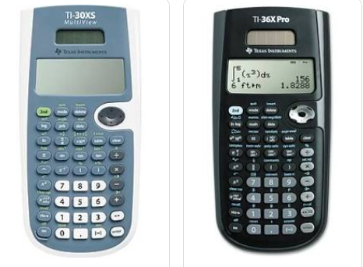Wired Earbuds/Headphones

**Math**

(1) 5 Subject spiral notebook with pocket dividers

(4) black dry erase markers

Calculator is required: Either a TI-30XS or a TI36X-Pro

**Social Studies**

(3) 2 pocket folders

**Science**

(2) Single Subject notebooks

**ELA/Reading**

(2) College ruled composition notebooks

(1) Spiral notebook with pocket dividers