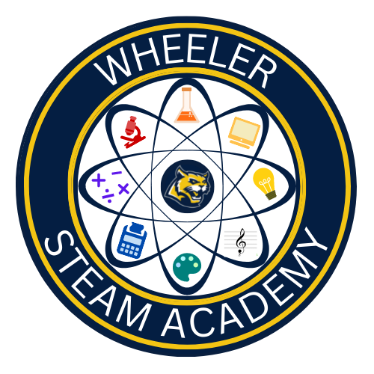

Wheeler STEAM Academy Program Description

The Wheeler STEAM Academy is a program offered to Wheeler High School students who are interested in pursuing advanced opportunities in any of the STEAM Fields (science, technology, engineering, arts, and mathematics), with an emphasis on Science and Math. The program is open to any student who is interested and able to complete Honors Literature, science courses at an Honors or AP Level. STEAM Academy students will be placed together in cohort classes for their STEAM Sciences and STEAM Literature. Students will have access to an accelerated, diverse, and innovative STEAM curriculum. The successful completion of the program will require that students complete all the curriculum requirements as outlined below. Students are intentionally given as much flexibility in their schedule as possible in order to pursue their own interests, whether in or out of the STEAM fields.

What is a STEAM Academy?
A STEAM Academy is a program within a school that allows students who are interested to do in-depth study in the STEAM fields. The curriculum for a STEAM Academy generally integrates STEAM throughout the curriculum.

How is the STEM Academy different than a traditional high school experience?
The Wheeler STEAM Academy is designed to give students the opportunity to pursue advanced opportunities in the STEAM fields while still in high school. By taking additional STEAM courses, students will be able to begin narrowing down their areas of interest for college and career before leaving high school. STEAM Academy students will be given the opportunity to double up in their science courses yearly, and the curriculum for the program will allow students to understand the interconnections between the five broad areas of STEAM – Science, Technology, Engineering, Arts, and Math.

How does the admissions process work?
Wheeler STEAM Academy will have a competitive admissions process. Criteria that will be evaluated will include the following:
- Standardized test scores, with emphasis on Math, English, Fine Arts, and Science scores
- Middle school grades, with emphasis on 7th and 8th grade
- Curriculum taken in middle school, with favor given to students taking Algebra I or higher in math and Physical Science.

Wheeler STEAM Academy Staffing
The Wheeler STEAM Academy has a STEAM Academy Coordinator, Dr. Joel Howell, who oversees all the program’s needs. There is also a Wheeler STEAM Academy Leadership Team to guide the program’s success.

STEAM Academy Curriculum
Subject Area | 9th Grade | 10th Grade | 11th Grade | 12th Grade
Science | Honors STEAM Biology | 1- Honors STEAM Chemistry  2-AP or Honors Physics | Science Elective
Math | 4 Math Credits (Including Algebra I and Geometry)
English | 9th Honors STEAM Literature | World Literature | American Literature or AP Language | British Literature or AP Literature or Dramatic Writing
Social Studies | Geography (optional) | World History | US History | Economics and Government
World Language | At least 2 World Language credits
STEAM | Above  1-H. STEAM Biology  2-H. STEAM Literature | H. STEAM Chemistry | 1-AP Computer Science Principals  2-AP Seminar | AP Research
Fine Art Elective | 1 Credit
Health/Personal Fitness | Health  Personal Fitness
STEAM Pathway | Pathway Course 1 | Pathway Course 2 | Pathway Course 3 | Pathway Course 4  (optional)

STEAM Academy Specific Requirement

Fine Arts Pathways
Music  Band  Chorus I-II  Orchestra | Theatre  Acting I-IV  Technical Theatre I-IV  Musical Theatre I-IV | Visual Arts  Visual Arts Comp (Intro Class)  Drawing & Painting I & II  Sculpture I & II  Ceramics I, II, & III  Photography I, II, & III  AP Art Studio, AP Art History
Career Tech Pathways
JROTC  JROTC I & II  JROTC III & IV  JROTC V & VI  JROTC VII & VIII | Audio Video Technology and Film* AVTF I  AVTF II  AVTF III  AVTF IV  *application required | Agricultural Science & Technology  Basic Ag. Science & Technology  General Horticulture & Plant Sci.  Nursery & Landscape*  Ag Leadership*  Agricultural Marketing*  *3rd course for each pathway
Culinary Arts  Introduction to Culinary Arts  Culinary Arts I  Culinary Arts II | Engineering Drafting and Design Pathway  Introduction to Drafting & Design  Survey of Engineering Graphics  3D Modeling & Design  Technical Manufacturing & Concepts | Computer Science Pathway  Intro to Digital Technology  Computer Science Principles  AP Computer Science A  AP Computer Science Principles
Architectural Drawing and Design Pathway  Introduction to Drafting & Design  Architectural Drawing & Design I  Architectural Drawing & Design II  Structural Detailing  Civil Engineering Drawing | Engineering and Technology Pathway  Foundations of Eng. & Tech.  Engineering Concepts  Engineering Applications  Research Design & Project Mgmt. | Healthcare Science Pathways  Intro to Healthcare Science  Essentials of Healthcare  Emergency Medical Responder*  Patient Care Fundamentals*  Applications of Public Health*  *3rd course for each pathway - EMR or CNA certification
Web and Digital Design  Introduction to Digital Technology  Digital Design  Web Design | Marketing  Marketing Principles  Introduction to Sports & Entertainment Marketing  Advanced Sports & Entertainment Marketing

Wheeler STEAM Academy Class of 2027 Admissions Timeline
- Online application available: December 2, 2022
- Rising 9th Grade Parent Night: February 1, 2023, 6:00-8:00
- Online application closes: February 18, 2023
- Admission Decisions: March 3, 2023
- Deadline for students to accept admission: March 24, 2023

