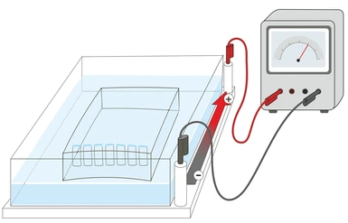
Exploring the Applications & Implications of Biotechnology
STEM Honor’s Biology Summer 2023
lauren.jackson2@cobbk12.org
Biotechnology Background
Biotechnology is a field of science that applies biological and biochemical processes to develop and improve products, services, and technologies for various industries. It involves the manipulation of living organisms, cells, and biological systems to develop new drugs, agricultural products, industrial chemicals, and energy sources. Biotechnology has a significant impact on human health, food production, and environmental sustainability. For instance, biotechnology has played a crucial role in developing vaccines, gene therapies, and biopharmaceuticals that have revolutionized the treatment of various diseases. In agriculture, biotechnology has enabled the development of genetically modified crops that are more resistant to pests, diseases, and harsh environmental conditions, thereby increasing crop yields and improving food security. Biotechnology also plays a critical role in environmental conservation, such as the development of biofuels and biodegradable materials that reduce the carbon footprint and waste generation.
The field of biotechnology is constantly evolving, and it has the potential to transform various industries and improve the quality of life. Biotechnology also presents new ethical and societal challenges, such as the safety and regulation of genetically modified organisms, the ownership and patenting of genetic material, and the impact of biotechnology on biodiversity and natural ecosystems. Therefore, it is essential to have a robust regulatory framework and ethical guidelines to ensure that biotechnology is used responsibly and for the benefit of humanity.
Purpose
In this project, students will explore the different applications of biotechnology and investigate the implications of these applications on society, the environment, and ethical considerations. The project will be broken down into the following components: Introduction, applications, past and present, implications, case study, debate, careers, and developing a prototype.
Instructions:
Read each section and their instructions carefully. Provide your source(s) on the works cited page.
You must cite your work; any form of plagiarism will result in a zero. You will turn in this assignment on the first day of school.
Introduction to Biotechnology
Research and provide an overview of biotechnology in eight sentences or more. Include who the “father of biotechnology” is, what his definition of technology was, and recent biotechnology advances.
[enter text here]

Biotechnology Applications:
Provide in-depth description on how each of the biotechnologies work, their benefits, and potential drawbacks; use as much space as necessary.
 | Medical | Agricultural | Industrial
How it works | [enter text here] | [enter text here] | [enter text here]
Benefits (Pros) | [enter text here] | [enter text here] | [enter text here]
Drawbacks  (Cons) | [enter text here] | [enter text here] | [enter text here]

 | Environmental | Marine | Forensic
How it works | [enter text here] | [enter text here] | [enter text here]
Benefits (Pros) | [enter text here] | [enter text here] | [enter text here]
Drawbacks  (Cons) | [enter text here] | [enter text here] | [enter text here]

Biotechnology Past and Present
Identify, in your opinion, the 4 discoveries in biotechnology that were most influential.
Discovery 1
- Explain the discovery (What was it? When was it? Where was it? Who made it?)
[enter text here]
- Explain how the discovery was made (People involved, important preceding events, process to get results, etc.)
[enter text here]
- Explain the lasting impacts of the discovery (important succeeding events, how we see/use this discovery today)
[enter text here]
Discovery 2
- Explain the discovery (What was it? When was it? Where was it? Who made it?)
[enter text here]
- Explain how the discovery was made (People involved, important preceding events, process to get results, etc.)
[enter text here]
- Explain the lasting impacts of the discovery (important succeeding events, how we see/use this discovery today)
[enter text here]
Discovery 3
- Explain the discovery (What was it? When was it? Where was it? Who made it?)
[enter text here]
- Explain how the discovery was made (People involved, important preceding events, process to get results, etc.)
[enter text here]
- Explain the lasting impacts of the discovery (important succeeding events, how we see/use this discovery today)
[enter text here]

Identify 1 new or future discovery in biotechnology that will be influential in the years to come.
- Explain the discovery (What is it? When was it/will it be?)
[enter text here]
- Explain how the discovery started (Who made it? Important preceding discoveries?)
[enter text here]
- Explain the impact this discovery would have (How would it help? Where would it be used?)
[enter text here]
*Note* This discovery may have occurred within the past year (after August 2022) or will be expected to come in the future.
*Note* For your future discovery, it may be helpful to explore recent news articles, news reports, magazines, etc. for this section

Implications of Biotechnology:
Analyze the ethical, environmental, and societal implications of THREE biotechnology applications listed above. Consider the potential risks and benefits of each application and discuss how they should be regulated.
#1 Technology: _______[enter text here]___________________
- Ethical: [enter text here]
- Environmental: [enter text here]
- Societal: [enter text here]
- How they should be regulated: [enter text here]
#2 Technology: _______[enter text here]___________________
- Ethical: [enter text here]
- Environmental: [enter text here]
- Societal: [enter text here]
- How they should be regulated: [enter text here]

#3 Technology: _______[enter text here]___________________
- Ethical: [enter text here]
- Environmental: [enter text here]
- Societal: [enter text here]
- How they should be regulated: [enter text here]

Biotechnology Case Study(s):
Research the following case studies that highlight biotechnology application and its implications. Include a background/summary, key players, and the outcome of each.
- CRISPR-Cas9: [enter text here]
- Golden Rice: [enter text here]
- Human Genome Project: [enter text here]
- Gene Therapy: [enter text here]
- Cloning of Dolly (sheep): [enter text here]
- Penicillin: [enter text here]
Biotechnology Debate:
Debate on ONE controversial biotechnology issue, such as the use of genetically modified organisms in food production or the ethics of cloning. You will present your arguments and counterarguments the first week of school. (You should be picking whether you are “for” a specific type of biotechnology or “against” it!) Remember, your argument should be persuasive!
[enter text here]

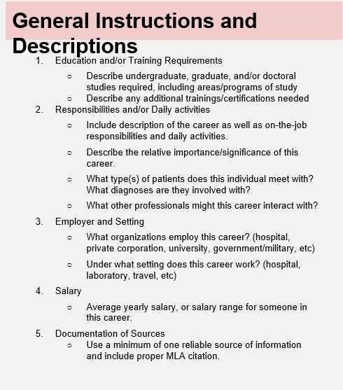
Careers in Biotechnology:
Those who pursue biotechnology careers can explore a plethora of thrilling options in fields like medical, environmental, and industrial sciences. Research and identify THREE careers in the field of “biotechnology” and answer provided questions. Use the information below to the right to help you answer these questions.
Career #1 _[enter text here]______________________
a) Education and/or Training Requirements
[enter text here]
b) Responsibilities and/or daily activities
[enter text here]
c) Employer and Setting
[enter text here]
d) Average Salary
[enter text here]
Career #2 _[enter text here]______________________
a) Education and/or Training Requirements
[enter text here]
b) Responsibilities and/or daily activities
[enter text here]
c) Employer and Setting
[enter text here]
d) Average Salary
[enter text here]
Career #3 _[enter text here]______________________
a) Education and/or Training Requirements
[enter text here]
b) Responsibilities and/or daily activities
[enter text here]
c) Employer and Setting
[enter text here]
d) Average Salary
[enter text here]

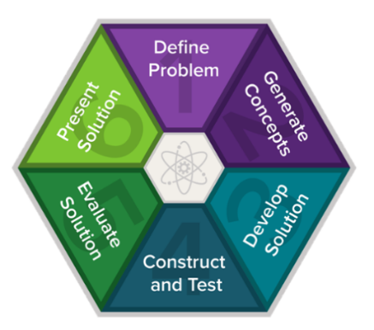
Engineering and Design Process:
Brainstorm and come up with a problem or challenge that people or living organisms are facing today that could be solved or helped by the creation of a biotechnological device/prototype. Create a detailed sketch of your prototype. You can create this prototype by using any online source such a Google Draw, Tinkercad, or you may draw a picture and insert it below.
- What is the problem your prototype is trying to solve?
[enter text here]
- Who is going to benefit from your device?
[enter text here]
- What will you have to take into consideration when developing your device?
[enter text here]
- Insert the sketch of your prototype below.

Works Cited Page
Number each citation, each citation should be in APA format. You may use the following website to help generate your citations. https://www.citationmachine.net/apa/cite-a-website

