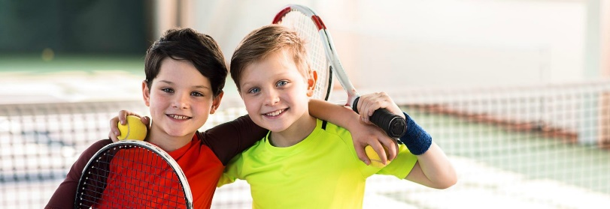
STRIKE TENNIS CLUB IS HERE! Starts Aug 31st
- Tennis Racquets Provided for Every Student
- Tennis is Never Cancelled Due to Weather
- Convenient Lessons Right at Your School
- Fraction of the Price of Private Lessons
- Students Get to Hit A Lot of Balls
- Learn a Life Sport, Fun with Friends
- We Bring the Tennis Courts to Your School
- For Beginner-Advanced 1st-5th Grade
Students just need to wear shoes that they can move in and be prepared to have FUN, we provide Everything else! Our Coaches are Positive and Energetic. We are Partnered with USTA’s NET Generation PTR & Yonex.

STILL FALL SEMESTER 2023
When: Thursdays 2:20-3:25
Where: STILL School Gym (12 wks)
Fee: $264 All Semester Classes
$92 Payment Plan Available
Register Here:

http://www.striketennis.com/still-elementary-enroll.html
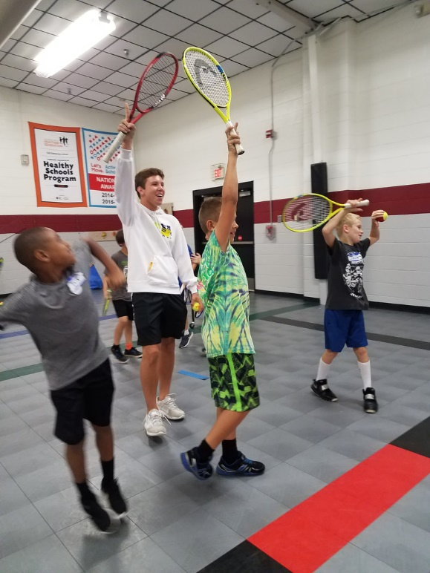
www.StrikeTennis.com
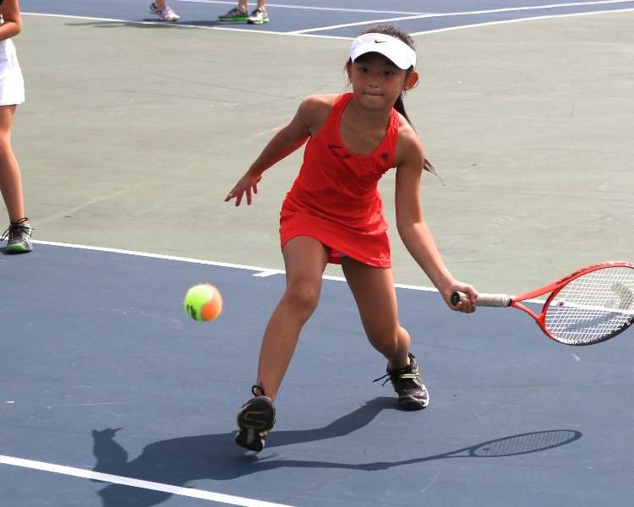

Questions:

StrikeTennis@gmail.com or 770-361-2166

