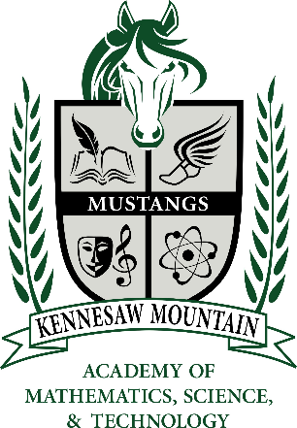
Kennesaw Mountain High School
STEM Magnet Program
Freshmen Magnet Biology
Summer Work 2023

Magnet Biology summer work is due by Friday, August 4th, 2023 by 11:59pm

Welcome to the Magnet program at KMHS! We are so excited that you are here. All freshmen students take magnet biology in the Fall of 2023. Before we begin our semester, it’s imperative that you take time to refresh some skills and begin previewing the material. Please follow the instructions below to complete the required summer work. If you have any questions, please complete the form: https://forms.office.com/r/nqStijfzwC

STEP 1: JOIN OUR ONLINE WIZER CLASS.
- Go to https://app.wizer.me and click on the “Join now” button in the upper righthand corner.
- Click “I’m a Student”.
- IF you were a student at a Cobb County middle school, click on “Connect with Microsoft” to login with your students.cobbk12.org email account. The password would be the same password you use to login to a school computer.
- IF you were NOT a student at a Cobb County middle school, thus do not yet have a student email address, make an account using a personal email address. Be sure to use your full legal name when creating the account profile.
- Join our class using the course code: 6WDebJ
STEP 2: COMPLETE THE WORKSHEETS
- Locate the 4 worksheets that have been assigned within our Wizer class. Complete all four worksheets. Click “turn in work” when done with a worksheet. You do not need to complete them all at the same time. Your work will save if you leave then return.
- You should get a notification for each worksheet that work was successfully submitted.

