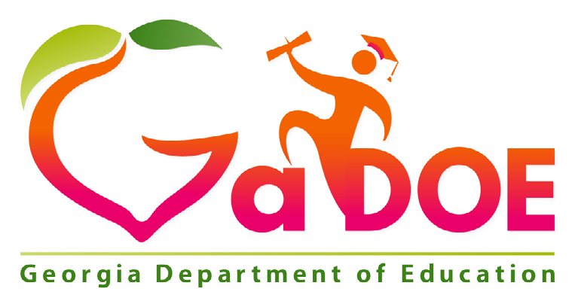

School Improvement Plan
2021-2022
Comprehensive Needs Assessment

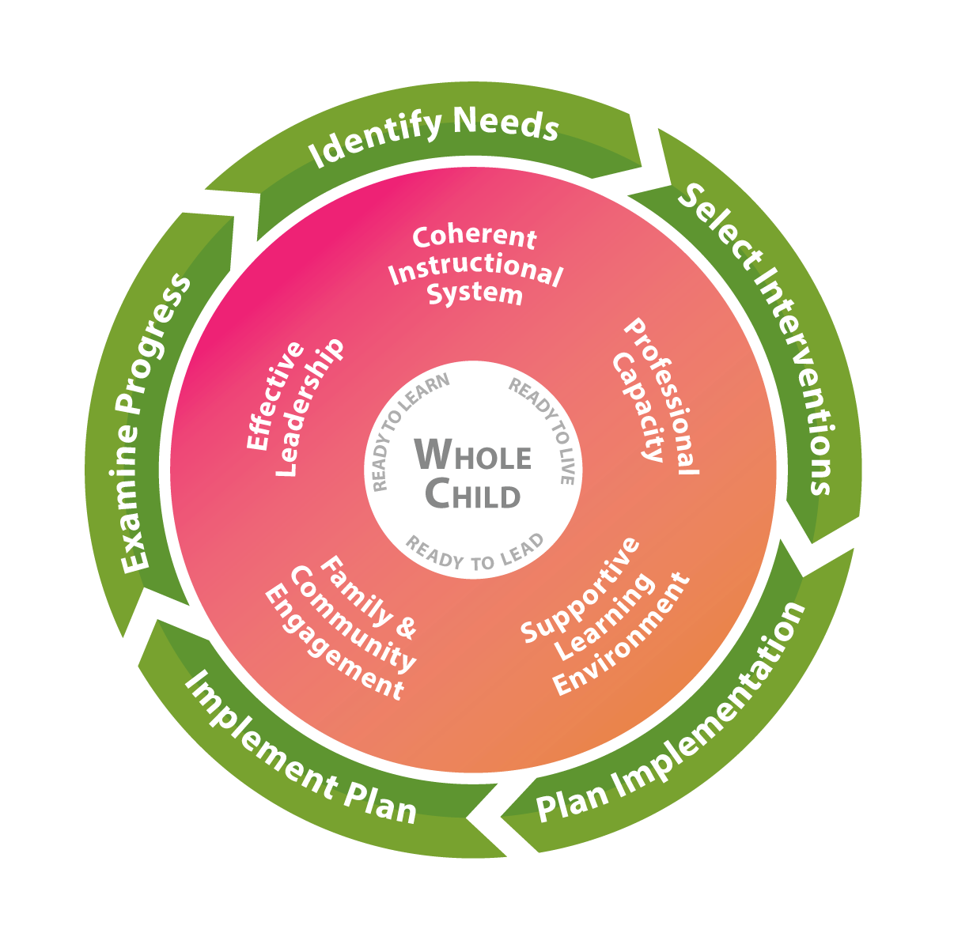

BRUMBY ELEMENTARY SCHOOL
DATE SUBMITTED
6/01/2021

DATE REVISED
6/9/2021

1

GEORGIA’S SYSTEMS OF CONTINUOUS IMPROVEMENT
The Georgia Department of Education’s strategic plan emphasizes transforming the agency into one that provides meaningful support to schools and districts. The agency has developed a common, continuous improvement framework to ensure that these efforts are aligned across all agency divisions, departments, and programs. Georgia’s Systems of Continuous Improvement focuses on the systems and structures (the “what”) that must be in place for sustained improvement in student outcomes. It also utilizes a problem-solving model (the “how”) to provide a clear process for identifying improvement needs, planning for improvement, and implementing, monitoring, and evaluating the improvement efforts.
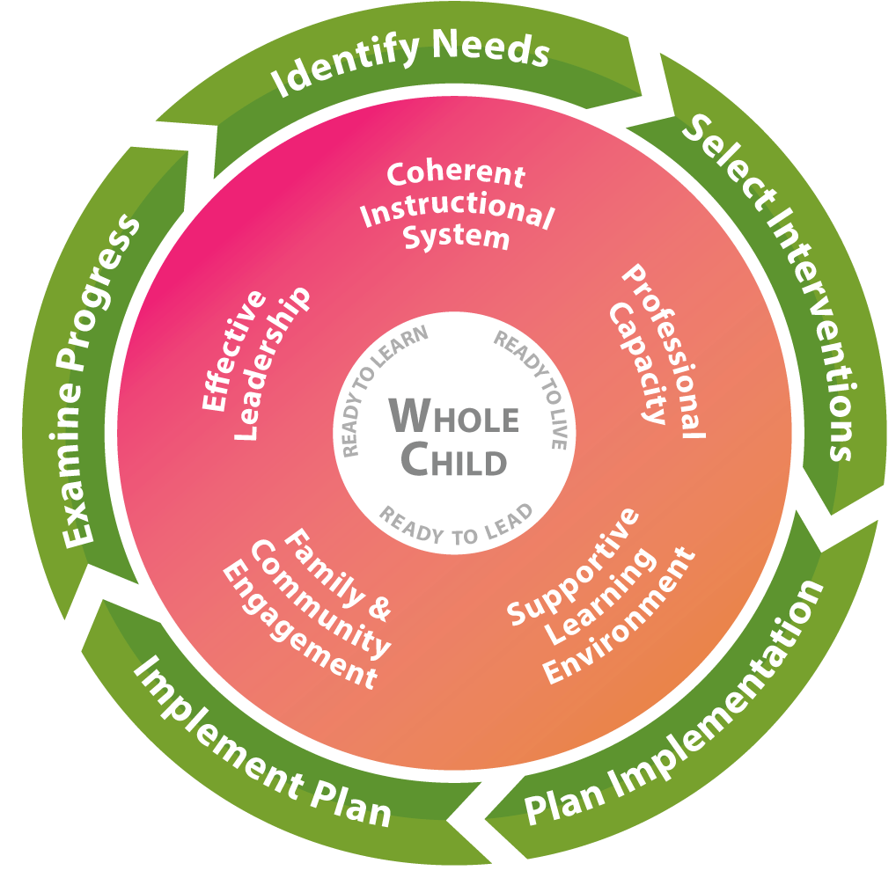
Systems to Improve (What to Improve)
Coherent Instructional System: The major system of the complex school organization that articulates and guides the “what” and “how” of instruction. This comprehensive system includes the processes related to:
- Planning for quality instruction - The structure of the instructional system in which the district defines what the students should “know” and “do”, and determine how their students will show they “know” the content and can “do” a skill or performance task
- Delivering quality instruction - The structure of the instructional system that guides teachers in how they introduce content, practice its use along with the students, and then allow students to use the content on their own while providing students regular standards-based feedback to gain mastery of the content
- Monitoring student progress - The structure of the instructional system that methodically discovers if the students are getting the content, and what to do about it when they are getting it or are not getting it
- Refining the instructional system - The structure of the instructional system that examines how to improve the planning for quality instruction, delivering quality instruction, and monitoring student progress

Georgia’s Systems of Continuous Improvement
Effective Leadership: A major system of the complex school organization that sets the direction for the school, ensures that the school staff and the school leaders are capable of meeting that direction, and makes sure the organization functions according to its mission. This system includes the processes related to:
- Creating and maintaining a climate and culture conducive to learning - the structure of the leadership system that ensures that the school allows both adults and children to put learning at the center of their daily activities
- Cultivating and distributing leadership - the structure of the leadership system that develops others to accomplish the group’s purpose and encourages the development of leadership across the organization
- Ensuring high quality instruction in all classrooms - the structure of the leadership system that reduces the variability in the quality of instruction across all schools and all classrooms
- Managing the district and its resources - the structure of the leadership system that ensures leaders effectively use all the resources at hand so that the district functions according to its mission
- Driving improvement efforts - the structure of the leadership systems that methodically, intentionally, and effectively improves the district’s major systems, structures, and processes
Professional Capacity: A major system of the complex school organization that develops a quality staff to reduce the variance of quality in instruction throughout the school. This system includes the processes related to:
- Attracting staff - the structure of the professional capacity system that is intentional in locating the teachers and leaders that are the best fit for the district and its schools to achieve its mission
- Developing staff - the structure of the professional capacity system that ensures the increasing quality of the school staff’s knowledge and skills
- Retaining staff - the structure of the professional capacity system that ensures the quality staff is working in the context/ position that is most beneficial to student achievement
- Ensuring staff collaboration - the structure of the professional capacity system that reinforces the effective practice of constant collaboration to improve instructional quality in all schools and in all classrooms
Family and Community Engagement: A major system of the complex school organization that develops quality links between school professionals and the parents and community the school is intended to serve. This system includes the processes related to:
- Welcoming all families and the community - The structure of the family and community engagement system that ensures families and the community are active participants in the life of the school, and feel welcomed, valued, and connected to each other, to school staff, and to what students are learning and doing in the school
- Communicating effectively with all families and the community - The structure of the family and community engagement system that ensures families/the community and school staff engage in regular, two-way, meaningful communication about student learning
- Supporting student success - the structure of the family and community engagement system that ensures families, communities, and school staff, continuously collaborate to support students’ learning and healthy development both at home and at school, and have regular opportunities to strengthen their knowledge and skills to do so effectively
- Empowering families - the structure of the family and community engagement system that ensures families are empowered to be advocates for their own and other children, to ensure that students are treated fairly and have access to learning opportunities that will support their success
- Sharing leadership with families and the community - the structure of the family and community engagement system that ensures families/the community and school staff are equal partners in decisions that affect children and families and together inform, influence, and create policies, practices, and programs
- Collaborating with the community - the structure of the family and community engagement system that ensures families and school staff collaborate with community members to connect students, families, and staff to expanded learning opportunities, community services, and civic participation
Georgia’s Systems of Continuous Improvement
Supportive Learning Environment: A major system of the complex school organization that ensures students’ school participation and willingness to expend major effort on classroom learning. This system includes the processes related to:
- Maintaining order and safety - the structure of the supportive learning environment system that ensures that the basic needs of orderliness and safety are met
- Developing and monitoring a system of supports - the structure of the supportive learning environment system that provides comprehensive services to students to meet their unique, whole-child needs
- Ensuring a student learning community - the structure of the supportive learning environment system that ensures compliance with positive and healthy behavioral and academic norms
Process to Improve (How to Improve)
Step 1: Identify Needs: Consult many sources to determine what in the district needs improvement.
- Plan and prepare for the process
- Collect and analyze data
- Identify needs and conduct a root cause analysis
Step 2: Select Interventions: Research many sources to determine the solutions that have a good chance of meeting the identified district needs.
- Consider all the evidence for needed improvements
- Research possible interventions
- Determine if staff has the capacity to implement possible interventions
Step 3: Plan Implementation: Develop a team and plan to implement the solutions that are most promising and can be carried out at the school.
- Identify roles and responsibilities of those implementing the intervention
- Develop a team that will deeply understand the intervention and of best ways to implement it
- Develop the implementation timeline
- Identify resources and supports needed for the implementation of the intervention
- Develop a set of information to be reviewed to track the implementation
Step 4: Implement Plan: Carry out the plan to implement the promising solutions, making real-time adjustments where/ when needed.
- Collect information to monitor the quality of supports being provided for the intervention
- Consider what additional information is needed to determine if intervention is working
- Assess the degree to which the implementation plan is being followed
- Identify ways to break down any barriers
- Build capacity of others to facilitate the improvement process now and in the future
Step 5: Examine Progress: Determine whether the implementation of the promising solutions is meeting the originally identified needs of the school.
- Determine if the staff can formally study the effects of the intervention to share with others in the field
- Monitor implementation and progress against defined goals
- Define reasonable expectations for success
- Identify and track progress and performance
- Develop a plan for how knowledge about the intervention will be shared with others
- Use the evidence to determine whether the intervention should continue as is, be modified, or be discontinued

Georgia’s Systems of Continuous Improvement
Georgia Department of Education
School Improvement Plan
1. GENERAL IMPROVEMENT PLAN INFORMATION
District Name |  |  | Cobb County School District
School Name |  |  | Brumby Elementary School
Team Lead |  |  | Dr. Amanda Richie
Position |  |  | Principal
Email |  |  | Amanda.Richie@cobbk12.org
Phone |  |  | 770-916-7070
Federal Funding Options to Be Employed (SWP Schools) in This Plan
(Select all that apply)
 | X | Traditional funding (all Federal funds budgeted separately)
 |  | Consolidated funds (state/local and federal funds consolidated) - Pilot systems ONLY
 |  | “Fund 400” - Consolidation of Federal funds only
Factor(s) Used by District to Identify Students in Poverty
(Select all that apply)
 | X | Free/Reduced meal applications
 |  | Community Eligibility Program (CEP) - Direct Certification ONLY
 |  | Other (if selected, please describe below)
1. General Improvement Plan Information

2. SCHOOL IMPROVEMENT GOALS

2.1 CREATING IMPROVEMENT GOALS
Effective goals assist schools in attaining collective agreement about what work needs to occur for improvement to take place. Goals should focus and prioritize the efforts and resources of the district/school to the previously identified needs and create a focus for improvement. Setting goals should be a strategic process which aligns the goals within one of the five systems: Coherent Instruction, Effective Leadership, Professional Capacity, Family and Community Engagement, or Supportive Learning Environment.
There are several categories of goals which may be used in school improvement but the one type which focuses on improving results and not just enhancing processes is a SMART goal. SMART is an acronym for:
Specific Measurable Attainable Relevant Time-bound
An example of a SMART goal is:
By the end of the school year 2017-2018, all teachers will have training and be included in a PLC for their content-specific area.

2.1.1 Completing the Improvement Goals Tables
Enter the school’s two to four overarching needs and related root causes, as identified in the Comprehensive Needs Assessment 2017-2018 School Report, into the tables on pages 8, 14, 20, and 26. Determine a goal for each overarching need and include the goal in the last row of each corresponding table. For each overarching need, complete the planning tables covering the five systems from Georgia’s Systems of Continuous Improvement. Use the codes below to list the structures addressed through the goal within each system. For each system, identify one to six action steps that will be taken to address the root causes that have created the overarching need. Finally, identify any supplemental action steps necessary to ensure the necessary supports are in place for the listed subgroups.

Coherent Instructional System
CIS-1 Planning for quality instruction
CIS-2 Delivering quality instruction
CIS-3 Monitoring student progress
CIS-4 Refining the instructional system
Effective Leadership
EL-1 Creating and maintaining a climate and culture conducive to learning
EL-2 Cultivating and distributing leadership
EL-3 Ensuring high quality instruction in all classrooms
EL-4 Managing the district and its resources
EL-5 Driving improvement efforts
Professional Capacity
PC-1 Attracting staff
PC-2 Developing staff
PC-3 Retaining staff
PC-4 Ensuring staff collaboration

2. School Improvement Goals
Family and Community Engagement
FCE-1 Welcoming all families and the community FCE-2 Communicating effectively with all families and
the community
FCE-3 Supporting student success
FCE-4 Empowering families
FCE-5 Sharing leadership with families and the
community
FCE-6 Collaborating with the community
Supportive Learning Environment
SLE-1 Maintaining order and safety
SLE-2 Developing and monitoring a system of supports
SLE-3 Ensuring a student learning community

PLANNING and PREPARATION
Date(s) 5/25/2021

IDENTIFICATION of STAKEHOLDERS

Stakeholders are those individuals with valuable experiences and perspective who will provide the team with important input, feedback, and guidance. Stakeholders must be engaged in the process in order to meet requirements of participating federal programs. Documentation of stakeholder involvement must be maintained by the school

Position/Role | Name
Title I Supervisor | James Milliman
Academic Coach (Title I) | Tracy Boyles
Academic Coach (Title I) | Tami Shields
Technology Coach (Local School) | Sandra Lake
Principal | Amanda Richie
Assistant Principal | Jason Traster
Assistant Principal | Wendy Rice
Parent Facilitator | Luz Landeverde
Staff Representative | Stephen Cosgrove
Parent Representative | Lynnette Wise

Meeting Date(s): 5/28/2021

IDENTIFICATION OF TEAM
The comprehensive needs assessment (CNA) and school improvement team (SIP) team consist of people who are responsible for working collaboratively throughout the needs assessment and plan development process. Ideal team members possess knowledge of programs, the capacity to plan and implement the needs assessment, and the ability to ensure stakeholder involvement. Documentation of team member involvement must be maintained by school.
Position/Role | Printed Name | Signature
Principal | Dr. Amanda Richie | Amanda K. Richie
Assistant Principal | Jason Traster | Jason Traster
Assistant Principal | Wendy Rice | Wendy Rice
SSA | Nelsenia McWhorter | Nelsenia McWhorter
Technology Coach | Sandra Lake
Academic Coach | Tracy Boyles
Academic Coach | Tami Shields
Staff Support | Stephen Cosgrove | St
Kindergarten | Kim Lloyd | Kim Lloyd
First | Kara DePriest | Kara DePriest
Second | Kristin Greene | Kristin Greene
Third | Janet Davis | Janet Davis
Fourth | Heather Hurt | Heather Hurt
Fifth | Sheila Porter | Sheila Porter
ESOL | Sonya Oviedo | Sonya Oviedo
Core-Expansion | Amy Calley | Amy Calley
Parent Facilitator | Luz Landaverde | Luz Landaverde
PTA | Capocein King | Capocein King
Parent Representative | Lynnette Wise | Lynnette Wise
7

IDENTIFICATION of STAKEHOLDERS
References: Schoolwide Checklist 3.b.

Stakeholders are those individuals with valuable experiences and perspective who will provide the team with important input, feedback, and guidance. Stakeholders must be engaged in the process to meet federal program requirements of participating federal programs. Documentation of stakeholder involvement must be maintained by the school

In developing this plan, briefly describe how the school sought and included advice from individuals (teachers, staff, other school leaders, paraprofessionals, specialized instructional support personnel, parents, community partners, and other stakeholders).
References: Schoolwide Checklist 3.b.[Sec. 2103(b)(2)]
Data and input given during Guiding Coalition Meetings in addition to the input given at the end of SY20-21 was used in the adjustment of the Title I Plan for FY21-22. Minutes and input from Brumby PTA, and well as Brumby Foundation members, which include staff, parents, and community members was also utilized in the development of the plan. Opportunities for input were solicited mainly via virtual format, forms and questionnaires due to covid-19 restrictions

8

Comprehensive Needs Assessment (References: Schoolwide Checklist 1.a.)
Comprehensive Needs Assessment Evaluation of Goal(s)
9
Collaborate with your team to complete the questions below regarding the progress the school has made toward each goal in the FY21 School Improvement Plan (SIP).
For the School Year: FY21
Goal 1: By the end of the 2020-2021 school year, increase the percentage of students in the proficient and advanced band combined on the MI assessment by 30%.
- Was the goal met? Not able to assess.

- What data supports the outcome of the goal?
Grade |  | Fall |  |  | Spring |  | Growth
 |  | # | % |  | # | % | # | %
K (below 9 Q) | 88 | 44 | 50% | 136 | 72 | 53% | 28 | 64 %
1 (below 117 Q) | 97 | 57 | 59% | 121 | 61 | 50% | 4 | 7 %
2 (below 217 Q) | 104 | 43 | 41% | 133 | 53 | 40% | 10 | 23 %
3 (below 381 Q) | 137 | 29 | 21% | 149 | 54 | 36% | 25 | 86 %
4 (below 534 Q) | 108 | 15 | 14% | 133 | 35 | 26% | 20 | 133 %
5 (below 645 Q) | 122 | 13 | 11% | 111 | 32 | 29% | 19 | 146 %

- What process/action step/Intervention contributed to the outcome of the goal?
The pandemic and students only received 70% of instruction for the 2020-2021 school year which significantly affected the outcome.

- Reflecting on outcomes:

  - If the goal was not met, what actionable strategies could be implemented to address the area of need? The accuracy and validity of the data is most likely skewed due to the # of students who participated in the assessment virtually and the pandemic. Next year, we will only monitor those students who have both Fall and Spring scores so the number of students taking the assessment during each administration is the same.
  - If the goal was met, what strategies will be implemented to sustain the progress that was made and go to the next level?
  - If the outcomes exceeded the goal, what are the next steps?

Goal 2: By the end of the 2020-2021 school year, increase the percentage of the students in the proficient and advanced band by 30% when compared to fall ’20 RI scores.
- Was the goal met? Unable to determine.

- What data supports the outcome of the goal?

Grade |  | Fall |  |  | Spring |  | Growth
 |  | # | % |  | # | % | # | %
K (score a lexile) | 163 | 10 | 6% | 154 | 18 | 12% | 8 | 80 %
1 (lexile 190+) | 133 | 10 | 7.5% | 147 | 37 | 25% | 27 | 270 %
2 (lexile 420+) | 169 | 32 | 19% | 138 | 67 | 49% | 35 | 109%
3 (lexile 545+) | 141 | 49 | 35% | 168 | 68 | 40% | 19 | 39%
4 (lexile 715+) | 142 | 27 | 19% | 142 | 44 | 31% | 17 | 63%
5 (lexile 785+) | 159 | 57 | 36% | 134 | 63 | 47% | 6 | 11%

- What process/action step/Intervention contributed to the outcome of the goal?
The pandemic and students only received 70% of instruction for the 2020-2021 school year which significantly affected the outcome.

- Reflecting on outcomes:

  - If the goal was not met, what actionable strategies could be implemented to address the area of need? The accuracy and validity of the data is most likely skewed due to the # of students who participated in the assessment virtually and the pandemic. Next year, we will only monitor those students who have both Fall and Spring scores so the number of students taking the assessment during each administration is the same.
  - If the goal was met, what strategies will be implemented to sustain the progress that was made and go to the next level?
  - If the outcomes exceeded the goal, what are the next steps?
______________________________________________________________________________________

Goal 3: By the end of the 2020-2021 school year, increase the percentage of students from non-proficient to proficient by 3 percent in Science.

- Was the goal met? Unable to assess

- What data supports the outcome of the goal?
Data is not available to imply an outcome for this goal.

- What process/action step/Intervention contributed to the outcome of the goal? Additional science focused classes provide problem-based learning experiences and challenges in ways classroom teachers have difficulty carrying out due to time and space for resources.

- Reflecting on outcomes:

- If the goal was not met, what actionable strategies could be implemented to address the area of need? We were not able to provide curricular and instructional support through additional science classes that are specific standard/concept supportive in addition to supporting teachers’ lessons. For the 2021-2022 SY, we will continue to support hands-on science instruction through the utilization of science core-expansion classes for all students K-5.
- If the goal was met, what strategies will be implemented to sustain the progress that was made and go to the next level?
- If the outcomes exceeded the goal, what are the next steps?

Goal 4: By the end of the 2020-2021 school year, increase the school climate survey results for personnel and students by 3%. 2018 personnel climate rate 75% 2018 student climate rate 73%
(parent rate was 97% our goal would be to maintain or improve)

- Was the goal met?
The latest survey from 2019 shows that we exceeded our climate goal for both personnel and students. We did not meet our goal for parent results.

- What data supports the outcome of the goal?
Student responses indicated an increase from 73% to 74%. Personnel survey results increased from 75% to 81%. Our parent survey results decreased significantly from 97% to 83%.

- What process/action step/Intervention contributed to the outcome of the goal? Climate surveys were not required this school year so it is difficult to evaluate whether we would have met this goal for this school year.

- Reflecting on outcomes:

  - If the goal was not met, what actionable strategies could be implemented to address the area of need? The pandemic significantly affected teaching and learning and greatly impacted the social emotional needs of our students, parents, and staff. We will continue making SEL and Trauma Informed practices a priority throughout the 2021-2022 school year as our goal #4.
  - If the goal was met, what strategies will be implemented to sustain the progress that was made and go to the next level?
  - If the outcomes exceeded the goal, what are the next steps?

Comprehensive Needs Assessment (References: Schoolwide Checklist 1.a.)
Comprehensive Needs Assessment Summary of Findings
9
Data Types | Identified Strengths | Identified Challenges | Multiple Data Sources Used
 |  | (Highlight 2-3 as Priority)
Student Achievement Data
ELA | -OG trained staff/Heggerty  -Continued training on Structured Literacy  -Implemented consistent common assessments  -Utilized pacing guides, scope and sequence to stay on track.  -Read 180/System 44 (intermediate grades)  -Novel studies (intermediate grades)  -Imagine Learning (ESOL)  -Headsprouts/Reading A-Z | -Inconsistent participation of virtual students  -Hybrid teaching/learning impacted student progress and made small group instruction difficult  -Difficult to differentiate instruction due to wide gaps in learning levels.  -Students struggled with comprehension/fluency/Organization of writing  -Scheduling constraints limited collaboration time between ESOL & grade levels | FRA, RI, Common Formative Assessments, DRAs, Running Records, Writing rubrics, teacher generated probes, data reports
Math | -Utilized pacing guides  -Incorporated real-life scenarios into instruction  -Implemented Nearpod and Dreambox  -Good grasp of number sense (primary grades) | -Difficult to manage small group instruction due to severe learning gaps and balancing a hybrid learning environment  -Struggled with word problems, fractions, vocabulary, math fact fluency  -Unable to incorporate hands-on learning and use of manipulatives with remote learners | MI, rubrics, common formative assessments, explicit modeling, scaffolding, CTLS/Touchstone assessments
Science | -Mystery Science and virtual LOF were effective teaching tools  -Participated in STEM  Virtual labs when available | -Unable to participate in many STEM activities and project-based learning due to Covid and online students not having access to supplies.  -Lacked knowledge of key science vocabulary  -Challenge to cover standards due to hybrid model | Classroom assessments, observations
Social Studies | -GA Weekly Studies and LFO were effective resources for content area standards  -Participated in virtual field trips to support standards | -Unable to carve out time to cover standards.  -Hard to integrate content into reading and writing.  -Trouble with engaging students in interactive lessons | Classroom assessments, observations
Other  Attendance (Staff, students, virtual learners) | -Committed students very involved  -Parents showed flexibility  -F2F students had better attendance overall  -Overall good staff attendance unless quarantined | -Students switched back and forth between remote and F2F.  -Remote student- inconsistent participation  -Teachers lacked clear expectations on virtual learning attendance (cameras on)  -Virtual students showed up late to class for only for a short time. | -Staff and student attendance records  -Documentation of 5 absences and referrals to SSW  -Missing assignments/grades/report cards
Discipline / School Climate Data | -Developed relationships  -Built classroom community  -Whole staff participated in CRP and SEL quarterly training  -Waiting room and mute options were utilized for disruptive online learners  -Smaller class sizes F2F reduced behaviors | -Parents created distractions and did not monitor behaviors of virtual learners  -Lacked consistency with school-wide behavior plans/ consequences/expectations  -Repetitive negative behaviors  -Behaviors increased as more students returned to F2F instruction. | -School-wide communication  -CTLS Parent  -Behavior referrals (classroom and admin)  -Counselor referrals/involvement
Perception Data | -Walkthroughs (virtual and F2F)  -Parent Communication via CTLS  -Media coverage during fundraiser | -Lacked time to brand school via social Media Posts | -Observation Notes  -Communication Records  -Local news station airing of fundraiser
Process Data | -Weekly CCCs  -Grade level collaboration  -PL-SEL/Trauma Informed Practices | -Lacked technology integration and access due to disbursement for online learners.  --Limited parent involvement | -Meeting Notes  -Attendance Survey  -Technology disbursement records/documents

Prioritized Need #1

Based on our student achievement data, local School Math Data, and MI data, we have determined that our students need remediation and acceleration in math.
Root Cause #1 | Difficulty understanding math vocabulary
Root Cause #2 | Lack of knowledge of math facts
Root Cause #3 | Inconsistent implementation of Guided Math/Small group instruction/Number Talks
Root Cause #4 | Lack of teacher training and strategies to support student instructional needs

Root Cause #5
GOAL | Increase quantile scores from one band to the next by 5% on the MI from Fall administration 2021 to Spring administration 2022.

10

Prioritized Need #2

Based on our student achievement data, local data, and RI data, we have determined that our students need remediation and acceleration in the area of ELA.
Root Cause #1 | Difficult to effectively differentiate instruction due to wide gaps in learning levels
Root Cause #2 | Inconsistent implementation of structured literacy/OG across teams and grade levels
Root Cause #3 | Inconsistent implementation of Guided Reading/Writing Workshop
Root Cause #4 | Lack of integrating reading and writing with other content areas
Root Cause #5 | Lack of time/scheduling for ESOL teachers to collaborate with grade levels
GOAL | Increase 2nd through 5th grade Lexile scores from one band to the next by 5% on the RI from Fall administration 2021 to Spring administration 2022.  Increase Kindergarten FRA scores by 5%  Increase percentage of 1st graders moving from FRA to RI by 5%

11

Prioritized Need #3

Based on our student achievement data and local Science data, we have determined that our students need remediation and acceleration in Science.
Root Cause #1 | Lack of implementation of interactive and project-based/STEM activities.
Root Cause #2 | Lack of knowledge of key science vocabulary

Root Cause #3

Root Cause #4

Root Cause #5
GOAL | Increase percentage of students scoring proficient on STEM rubric by 5% from pre to post tests.

Prioritized Need #4

Based on our attendance and discipline data, we determined that our students need social/emotional support and interventions.
Root Cause #1 | Lack of strategies to self-regulate, reflect, and repair relationships impacted by behaviors
Root Cause #2 | Lack of strategies and interventions that encourage positive behaviors
Root Cause #3 | Lack of strategies to address problem behaviors and reduce occurrences
Root Cause #4 | Lack of strategies and interventions of trauma informed practices

Root Cause #5
GOAL | Reduce the number of absences greater than 10 by 5%. Reduce the number of administrative referrals for physical incidences by 5%.
12

