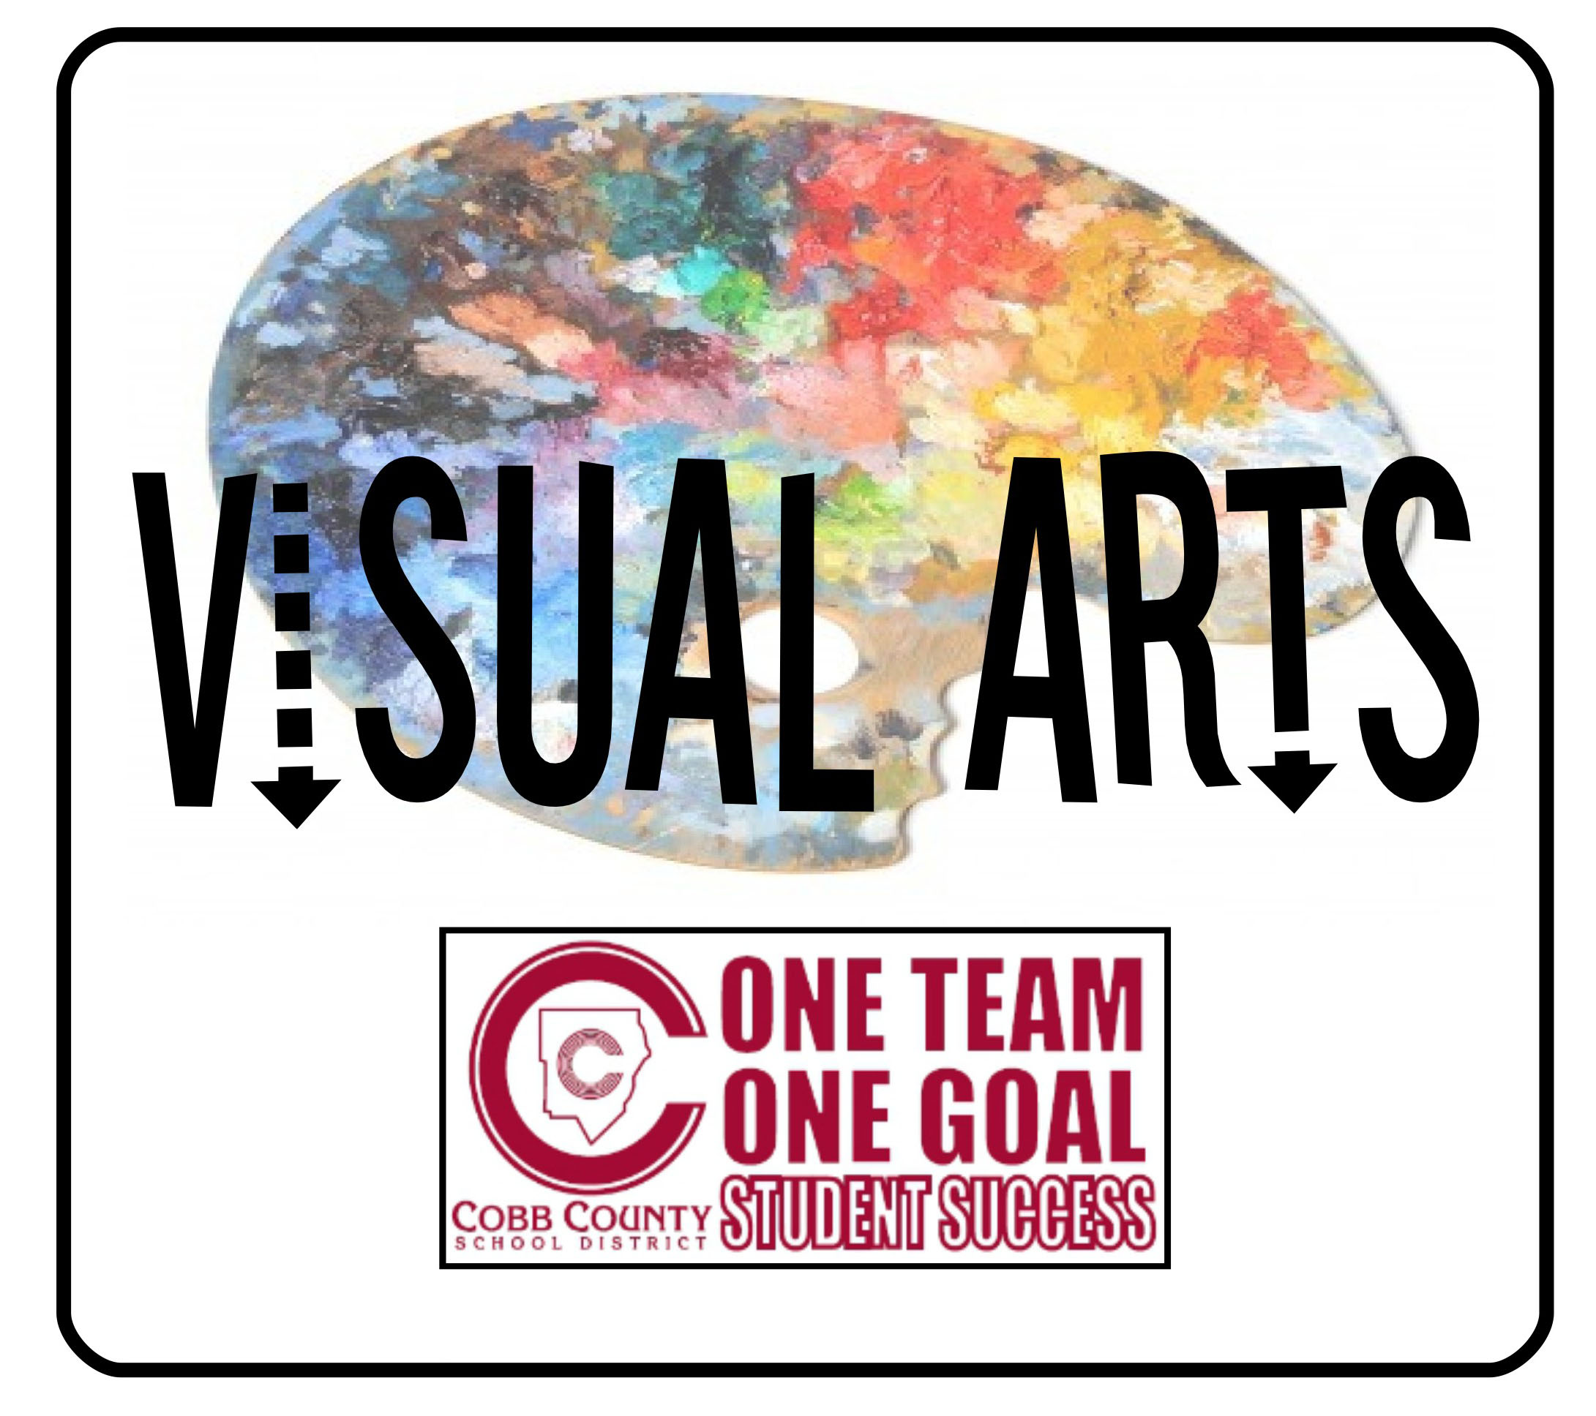
8th Grade Visual Arts Comprehensive Program for HS Credit

Feb 2022

Dear Parents and Students:
The Cobb County School District allows a one-year visual arts comprehensive course to be offered to talented visual arts students entering eighth grade. Your student has shown interest in this program and is invited to participate during the next school year. This course will be taught during one of your child’s current connections class periods. Students who successfully complete the year of high school art in middle school may begin studio art courses in high school. Upon completion, one high school credit will be awarded. A numerical grade will be recorded each semester on the middle school report card.
The opportunity to study visual arts at the high school level in middle school is exciting! This course adds to your child’s workload and requires daily application, a sketchbook and a digital portfolio maintained in and out of school. Students without access to a home computer will be given access to school computers to complete online assignments. Successful students need to be highly motivated in the visual arts, know how to plan their time efficiently, and stay the course.

Eligibility:
A Visual Arts teacher can recommend a student at the end of the 7th grade year based on the following criteria:

- Self-motivated, works outside the classroom and beyond scheduled periods on artwork

-High expectations are evident in work and conduct
-Demonstrates leadership and responsibility in the art studio
-Demonstrates a true passion for Visual Arts
-Completes all classwork, projects and homework assignments in a timely manner

Enrollment: Please complete the attached interest form and indicate your preference for next school year. You will attach a work of art to the interest form and submit both. This application is NOT a guarantee for placement in the course.

The interest form, with attached artwork, should be returned to Mrs. Waller by MARCH 25th. NO late forms will be accepted.

Sincerely,

Kerri Waller
Art Teacher
Simpson Middle School
Kerri.waller@cobbk12.org

This form, with attached artwork is due back to Mrs. Waller or Mrs. Booe-Fell by Friday, March 25th. NO late interest forms will be accepted.

8th Grade Visual Arts Comprehensive Program for HS Credit

Student name:__________________________________

Homeroom:_____________________________________

Music class (if any):_______________________________

Please remember that this is a yearlong commitment and no student will be allowed to drop the class due to high school add/drop rules. Please note that turning in this letter of interest is not a guarantee placement in the course.

Please initial and return to Mrs. Waller:

________My child would be interested in taking the year long 8th grade Visual Arts Comprehensive Program for high school credit during the 2018-19 school year. I understand that this is a yearlong class. I understand that there will be homework and it will add to my student's workload.

Parent name: ____________________________________

Parent signature: ________________________________

Date: __________________________

Parent e-mail: ___________________________________

Please email kerri.waller@cobbk12.org with any questions
Please use this page (or a piece of white drawing paper) to create a work of art to submit with your application by Friday, March 25th. You must create a new artwork. Do not turn in a drawing you have done in the past. Do not trace a drawing.

