Wheeler High School
Student Handbook 2022-2023

A Collaborative Community For Student Success

375 Holt Road
Marietta, GA 30068
Main Office: 770-578-3266
FAX: 770-578-3268
Counseling: 770-578-3269
Web-Site: www.wheelerhigh.com

Wheeler Fight Song

Fight on you cats. We’ll win tonight
A victory is near. We’ll show the ______ we can fight,
Let’s give our mighty cheer - - GO CATS!!!

The Wheeler cats will never fail. They are the very best.
The blue and gold will win tonight. Fight on for WHS!

SCHOOL INFORMATION

Wildcats: Focusing on People

Dear Students and Families:

We are so excited about what the 2022-23 school year will bring for the Wildcat Family as we continue to build strong collaborative teams helping our students become successful. Success looks different for every student but for all our students the ultimate goal is graduation. We consciously work to meet the needs of ALL of our students so they can reach success in the classroom, on the stages, in the athletic arenas and fields, in the clubs and organizations, as well as their social settings.

This handbook is designed primarily for the students. However, I encourage families to browse through the handbook and become familiar with the contents as well. You will notice the handbook covers rules/regulations/procedures, academic planning, activities and clubs to get involved with, some behavior policies and consequences for inappropriate behavior, and other general information. It is impossible to include all of the information and knowledge about Wheeler in a small handbook. If you come across something that is not covered in the handbook, please ask questions so that you can get the answer. Making good decisions will yield outstanding results.

Student learning is the chief priority of the school. Wheeler pledges its resources to the development of the whole student, engaging the community through relevance and rigor, emphasizing citizenship, and celebrating diversity. The Wheeler staff is committed to continuous improvement and will challenge you to be a self-directed lifelong learner. To develop those skills, you must plan for success. Use this handbook as a resource as you navigate your way through the school year.

The last bit of advice is to enjoy your high school career. The high school years are full of friendships, activities, trips, and experiences that you will remember for a lifetime. The more you put into your experience, the more you will get out. The entire Wheeler staff is committed to providing the environment needed for an outstanding high school education. When you graduate with a Wheeler High School diploma, the world is yours for the taking!

GO CATS!!
Paul Gillihan, Ed.S
Principal

The Wheeler Student Handbook is designed to be an information source for students and parents. Students are responsible for knowing the contents of this handbook. All information contained is subject to change or modification with regard to policy and procedures adopted by the Cobb County Board of Education or the Wheeler High School staff. During the first week of school, students will receive Cobb County School System policies. Students are also responsible for any additional information related to local or district policies throughout the school year and for communicating this information to their parents/guardians. For additional information on district policies, please go to www.cobbk12.org. For more information related to Wheeler High School, please visit https://www.cobbk12.org/Wheeler.

Staff to Know
Administrators
Mr. Paul Gillihan Principal
Mr. Ken Ealy Assistant Principal
Ms. Marranda Edwards Assistant Principal
Ms. Brittny Jones Assistant Principal-Athletic Director
Mr. Kendrick Kirkland Assistant Principal
Ms. Pamela McCabe Assistant Principal
Ms. Tanya Robson Assistant Principal
Mr. Chris Walstead Magnet Coordinator
Ms. Phyllis Joyner SSA
Department Leaders
Ms. Valerie Bolen Career Technology
Ms. Taisa Turner Counseling
Mr. Brian Clements English
Dr. Dwayne Wasson Fine Arts
Mr. Cameron Ward Foreign Language
Ms. Kamisha Polk ESOL
Mr. Bjorn Thornton Mathematics
Mr. Bryan Love Physical Education
Ms. Ashley Deason Science
Ms. Alissa Jean Social Studies
Ms. Rosie Leyva Special Services

Counseling Department
Ms. Susan Acedo Counseling Clerk
Ms. Megan Fanoe Records Clerk
Ms. Valerie Bullock Students with last name Ch - F
Mr. Stephen Chung Students with last name G – J
Ms. Jackie Edwards Students with last name A - Ce
Ms. Michaela Hall Students with last name R - S
Ms. Kara Mills Students with last name Mi - Q
Ms. Holly Nelson Students with last name K - Me
Ms. Taisa Turner (DL) Students with last name T - Z
Mr. Mark Collins Graduation Coach

Magnet Program Advisor
Ms. Sarah Kietzman Johnson

Media Specialists
Ms. Renee Tehrani
Nurse
Ms. Patti Hough

Office Personnel
Ms. Karina Meijas Ortiz School Secretary
Ms. Judy Collins Front Desk
Ms. Janeen Denhaese Bookkeeper
Ms. Kathleen Corrao Pupil Personnel Clerk
Ms. Emily Nixon Synergy Clerk
Ms. Maureen Klinkmueller Magnet Clerk
Social Worker
Ms. Hannah Jones

Parent Liasion
Vani Arguari

Campus Police Officers
Officer Curley Sparks
Officer Jamie Brinkley

2022-2023 WHEELER HIGH SCHOOL BELL SCHEDULES
REGULAR BELL SCHEDULE
Class Schedule |  |  |  | Lunch Schedule
1st Block | 8:20-10:03 | 102 minutes |  | A Lunch | 11:42-12:12
2nd Block | 10:09-11:36 | 87 minutes |  | B Lunch | 12:17-12:47
3rd Block | 11:42-1:57 | 135 minutes |  | C Lunch | 12:52-1:22
4th Block | 2:03-3:30 | 87 minutes |  | D Lunch | 1:27-1:57

HOMEROOM BELL SCHEDULE
Class Schedule |  |  |  | Lunch Schedule
1st Block | 8:20-9:45 | 85 minutes |  | A Lunch | 11:43-12:13
Advisement | 9:51-10:06 | 15 minutes |  | B Lunch | 12:18—12:48
2nd Block | 10:12-11:37 | 85 minutes |  | C Lunch | 12:53—1:23
3rd Block | 11:43-1:58 | 135 minutes |  | D Lunch | 1:28—1:58
4th Block | 2:04-3:30 | 86 minutes

INTERVENTION BLOCK SCHEDULE
Monday | Social Studies
Tuesday | Math
Wednesday | Science
Thursday | English
Friday | Electives

‘
EARLY RELEASE BELL SCHEDULE
1st Block | 8:20-9:03 | 43 minutes
2nd Block | 9:09-9:52 | 43 minutes
3rd Block | 9:58-10:41 | 43 minutes
4th Block | 10:47-11:30 | 43 minutes

ATTENDANCE

The School Day
The building will be open by 7:15 A.M. for students who need to arrive early and students should be in class at the 8:20 A.M bell. However, the school day officially begins for a student upon arrival to campus. If a student arrives early for any reason (detention, make-up work, extra help), they are expected to remain on campus at all times until the school day ends at 3:30 P.M. or administrative permission has been granted for early dismissal. Students will be required to leave the building by 3:45 unless under the direct supervision of a faculty member.

Student Absences
When a student has been absent, a statement should be written the next day from a parent or guardian stating the reason for the absence. This statement should be brought to the Attendance Office and exchanged for an “Absence Slip” which should be shown to all the student’s teachers. If a statement is not brought, the absence is recorded as unexcused. The student has three school days to clear an absence. If a student has a court appearance, court documentation should be provided for an excused absence.

The GA Board of Ed. states that students may be excused from school for the following reasons:
- Personal illness or when attendance in school endangers the student’s health or the health of others.
- A serious illness or death in a student’s immediate family necessitating absence from school.
- A court order or an order by a government agency, including pre-induction physical examinations for service in the armed forces, mandating absence from school.
- The observation of religious holidays, necessitating absence from school.
- Conditions rendering attendance impossible or hazardous to student health or safety.
- Registering to vote or voting in a public election, which shall not exceed one day.
- A student whose parent or legal guardian is in military service in the armed forces of the United States or the National Guard, and such parent or legal guardian has been called to duty for or is on leave from overseas deployment to a combat zone or combat support posting, shall be granted excused absences, up to a maximum of five school days per school year, for the day or days missed from school to visit with his or her parent or legal guardian prior to such parent’s or legal guardian’s deployment or during such parent’s or legal guardian’s leave. Nothing in this Code section shall be construed to require a local school system to revise any policies relating to maximum number of excused and unexcused absences for any purposes.
- Any other absence not explicitly defined herein but deemed by the local school board of education to have merit based on circumstances.

We strongly encourage students to attend school daily. Although makeup work may be completed after a student’s return from an absence, there is no substitute for actual classroom instruction. Parents are encouraged to check their student’s daily attendance, grades, and attendance history by accessing ParentVue on the county’s website, https://parentvue.cobbk12.org/PXP2_Login.aspx. Please note, that ParentVue rolls up with students from one grade to the other. When a new student enrolls, the parent creates a ParentVue account in order to register. If a parent forgets their password, they can reset it themselves on the ParentVue login site.

Early Dismissals
In order for a student to be dismissed from school early, the parent or guardian must either come to school in person, send a written note, or send an email. Please see details below:

For a parent or guardian picking up a student in person:
- A person on the student’s emergency contact/check out list must show ID at the attendance office
or
For a student driver to be dismissed without a parent/guardian present:
- A written note from the enrolling adult in ParentVue can be submitted to the Attendance Office prior to start of school.
- The note must have a phone number where that person can be reached and it must match the one in ParentVue. If the adult cannot be reached, the student MAY NOT LEAVE.
or
- An email, from the enrolling adult’s email address in ParentVue, can be submitted to Kathleen Corrao at Kathleen.Corrao@cobbk12.org.
  - A request for Early Dismissal/Checkout needs to be emailed the night before OR no later than 8:45 am the day of the dismissal.
  - In the subject line make sure to put EARLY DISMISSAL and your Child's Name.
  - The time of check out must be included in the note.
  - The email must have a phone number where adult can be reached and it must match the number in ParentVue. If the adult cannot be reached, the student MAY NOT LEAVE.
  - Please do not send emails regarding early dismissal days in advance.

After the early dismissal request has been verified in Attendance, a dismissal slip will be prepared and the student will be notified to pick it up during class changes. If a student leaves without a dismissal slip, disciplinary action will be taken.
***Please be sure to update your child’s contact list for check out purposes. The Enrolling Adult is the only person who can make these changes in PARENTVUE.***
Late Arrivals/Tardies
Any student not in their classroom by the 8:20 tardy bell will be marked absent by his/her teacher. All students who arrive to school after the 8:20 tardy bell, must report directly to the attendance office to obtain a tardy pass to class. To be excused for being tardy to school, a student must present a doctor's official appointment verification, a note regarding student illness, or a document for a court ordered appearance at the time the student signs in to school. Tardies due to missing the bus, traffic, oversleeping, car trouble, etc. are unexcused. If the student does not have a written, confirmable note from a parent or guardian, the tardy will be considered unexcused. Students will be marked as excused or unexcused tardy according to the previous stated absence policy.

Continual tardiness will result in disciplinary action. The consequences for unexcused tardies (these are cumulative) will be the following:

- 8th-- Admin Detention
- 11th—Saturday School
- 14th-- 1 Day ISS
- 17th-- 2 Days ISS
- 20th – 3 Days ISS
- 23, 26, etc.-- 2 days OSS (Insubordination)

Upon the eight unexcused tardy to school, a student’s parking privilege may be revoked.

Certificate of School Enrollment

Students must obtain a Certificate of School Enrollment (form DS-1) from their school to apply for a Learner’s Permit or Driver’s License. Certificates are issued through the Guidance Office with a 48- hour turn around. There is a $2.00 processing fee.

Students must provide a birth certificate or other government issued ID (Passport, ID card) to prove age. The student must come in person to request the form.

College Visits
Seniors are allowed two official college visits per academic year. To be considered an official college visit, the student must turn in documentation to the Attendance Office within 3 days of the absence from the college or university that includes the student’s name and date of visit.
Withdrawals
Any student withdrawing from school for any reason is to report to the attendance office to complete the proper forms. The withdrawal form must be signed by the enrolling adult with picture ID. This should be done no later than the last day the student will be in school. All books and any technology must be returned and fines or fees paid in order to clear the records.

Hall Passes
Students who leave a class for any reason are responsible for asking their teacher for a pass. The pass should include the name, date, time, and destination, as well as the teacher’s signature. Students who wish to leave the cafeteria during lunch to make up work or work in the media center must obtain a pass to present to the teacher on lunch duty. Semester long passes are available in the library. If a teacher grants permission for a student to leave the cafeteria, the teacher must provide the pass to the student. Students in the hall without a pass will be escorted back to class and may be referred for skipping class.

ACADEMICS/INSTRUCTION

Textbooks
Students are responsible for returning textbooks in the same condition as they are issued. If a book is not returned or is damaged beyond use, the student will be charged the cost of the book. Minor damage will be assessed at 25% of book cost and major damages at 50% of book cost. No books will be issued until the fine(s) is paid. It is the student’s responsibility to clear all fines. Textbooks should not be left in classrooms or given to other students.
Many textbooks are now available online. Here is the LINK for High School textbooks that are available online. Codes to access the available textbooks will be given to students from their classroom teachers.

Wheeler Media Center
Many resources are available 24/7 at www.wheelerlibrary.com. We hope that you will make the Wheeler Media Center your headquarters for research and reading.

Hours: Weekdays, 7:45 a.m. – 3:45 p.m.

You don’t need a card to check out a book, just your number or name! Books can be checked out for a three-week period, and you can always renew them for longer. Magazines can be checked out for overnight use, but they must be returned the next school day. Newspapers must stay in the media center, but you can always make a free photocopy of any article you like. Students are responsible for any lost or damaged materials. The media center does not charge fines for overdue books.

Media center computers are available for your school assignments. Individual students may use the computers any time during media center hours, except when they are reserved for use by a class. Of course, you must abide by the media center computer rules and the school district's policies and regulations regarding the use of technology.

Grade Reports & Home/School Communication
Cobb County School District Administrative Rule IHAC recognizes that effective communication between the school and the home is essential to the success of students. The Board further recognizes that the delivery of information to the home is a responsibility that must be shared by school personnel and students. Parents should provide valid daytime phone numbers and update information online via ParentVue when addresses or phone numbers change. Information on how to do this can be found HERE. Students in grades 9-12 are expected to transmit written notes, messages, deficiencies, report cards and other documents between the school and their parents. School personnel shall be responsible for making reasonable efforts in the communication processes, including e-mail, written, and telephone messages and for providing particular attention to situations where the educational welfare of students may be jeopardized. However, school personnel shall not be held responsible for student problems that develop from the refusal of students to transmit messages from the school to the home.

Grading Period Dates:

End of 1st Six Weeks | September 9, 2022
End of 1st Quarter | October 7^{th,} 2022
End of 2nd Six Weeks | October 28, 2022
End of 3rd Six Weeks, End of 2nd Quarter, End of 1st Semester | December 16, 2022
End of 4th Six Weeks | February 17,, 2023
End of 3rd Quarter | March 15, 2023
End of 5th Six Weeks | April 12, 2023
End of 6th Six Weeks, End of 4th Quarter, End of 2nd Semester | May 24, 2023

We strongly encourage students and parents to communicate their concerns to teachers as soon as a problem becomes evident. If a student has a concern or a problem in a class, the student should follow these steps to resolve the issue:
- The student should schedule a meeting with the teacher.
- If the issue is not resolved, the student and parent should make an appointment with the teacher.
- If the problem persists, the parent/teacher should make an appointment with the appropriate counselor/administrator.
At any time, parents/guardians may access their student’s grade through ParentVue. As a reminder, ParentVue rolls up with students from one grade to the other. When a new student enrolls, the parent creates a ParentVue account in order to register. If a parent forgets their password, they can reset it themselves on the ParentVue login site.

Course Registration/Drop-Add
After registration, students may request a schedule change only if credit has already been received for the class scheduled or if a mistake was made in registering for the course. If a course is dropped after the first ten days of the semester, a grade of 10 will be given for that course, and no credit will be awarded.

Grading System
Cobb County high schools observe the following grading system:
A - 90 – 100 B - 80 – 89 C - 74 - 79
D - 70 – 73 F - below 70

Students should work with their teachers to complete all assignments missed. Additionally, conduct grades will be given. Proper citizenship development of students is as important as their academic training. The following is a guide to conduct grading:
- Satisfactory - Needs no correction
- Needs Improvement - Needs some correction
- Unsatisfactory - Needs immediate correction

Quality Points for Accelerated/Honor Classes
Courses that earn a full quality point (A=5.0, B=4.0, C=3.0):
All AP courses, all language courses level IV and higher, Chemical Engineering, Organic Chemistry, Advanced Physics/Robotics, Advanced DNA/Genetics, Advanced Scientific Internship, Advanced Scientific Research

Courses that earn a half quality point (A=4.5, B=3.5, C=2.5):
All Honors courses

Testing Days
A student should have no more than two (2) major tests in one day. It is the student’s responsibility to discuss conflicts with each of his or her teachers before the test.

Make-Up Work
Students are expected to make up all work missed during an absence. It is the student’s responsibility to find out what work was missed and to turn it in to his/her teachers. Students will be allowed one day for each day of absence plus one additional day to make up work missed during absences. For example, if a student is absent for two days, he/she will be allowed three days to make up work that was missed. Students should check with individual teachers for policies regarding make-up tests. Work missed due to skipping class or removal from ISS may not be made up for credit.

Final Exams/End-Of-Course Tests
Comprehensive final exams are given at the end of each course in every class and count 10% of the final course grade. Students may NOT take a final exam early. In the case of illness, students may be tested after the scheduled testing period. It is the responsibility of the student to make arrangements with their teachers to make up final exams. ***Algebra I, American Literature, US History, and Biology have state-mandated End-of-Course Tests that count 20% of the final course grade. Courses with an EOC, will not have a Final Exam given on final exam days at the end of the semester.
The EOC testing windows set forth by the State of Georgia is posted below, along with other testing dates. Please avoid scheduling appointments during these times if at all possible.
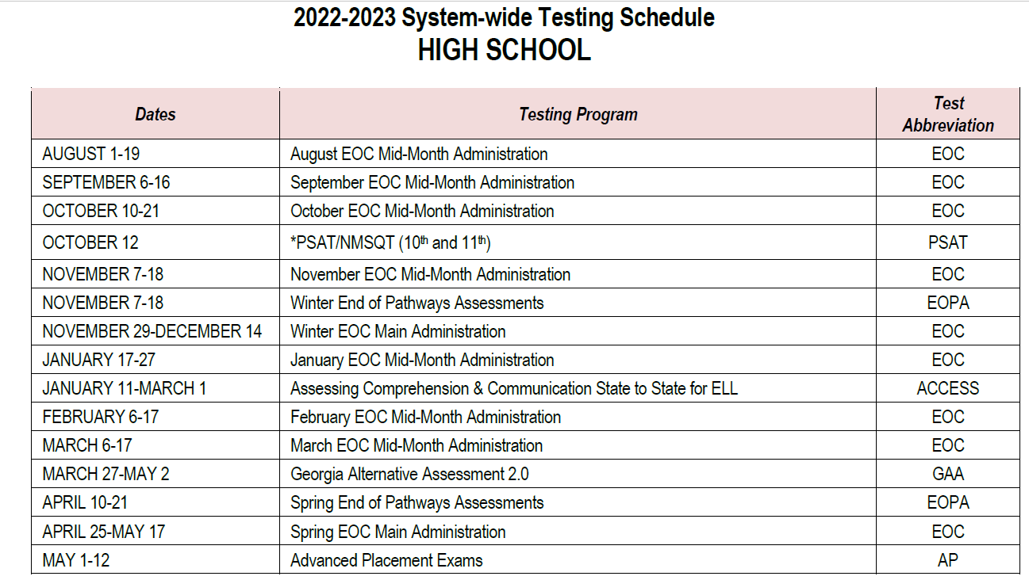

Advanced Placement Exam Schedule for Spring 2023
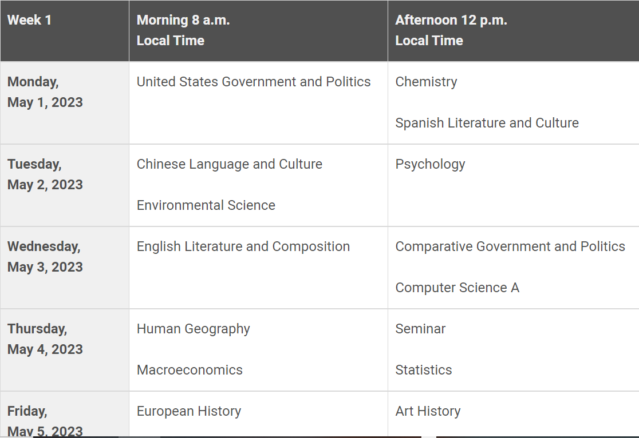
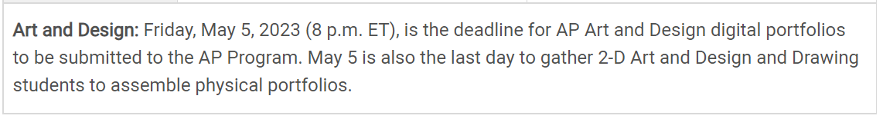

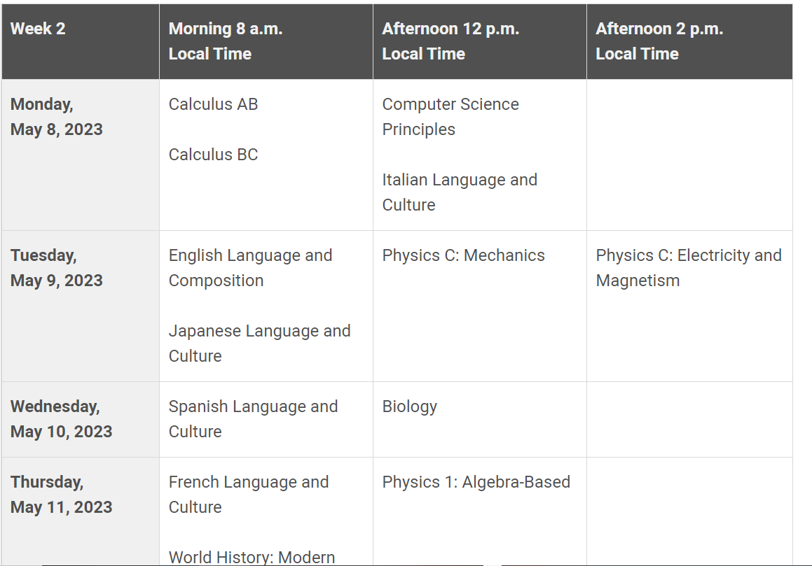
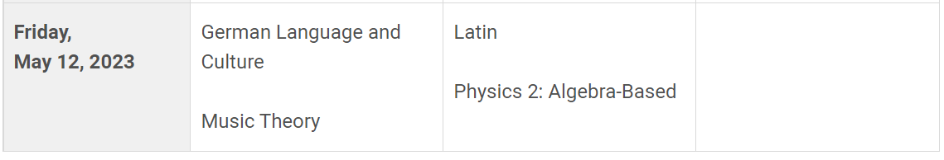
Student Mentorship Class
Career technical mentorship is a class offered for juniors and seniors on track for graduation. Students must have a 3.0 minimum GPA and good attendance. Students must also have a good discipline record. Students may only mentor twice in their high school career, and the credits do not count for the technical diploma. Mentoring is a privilege. Those students who take this class should be dedicated to the office in which they serve and represent Wheeler well.

Senior Minimum Day (Offered Spring Semester Only)
Students classified as seniors and carrying sufficient credits to provide for one unit above the total needed for high school graduation may schedule a minimum of three blocks (in consecutive order. Students participating in the mentoring program may not take minimum day. These seniors must have passed or be enrolled in all specified courses for graduation with the exception of courses limited to seniors. Seniors who choose minimum day must be off campus no later than five minutes after their last class or be under the direct supervision of a faculty member. Failure to comply will result in administrative action or enrollment in a class during their “off” period.

College Entrance Examinations
The PSAT (Preliminary Scholastic Aptitude Test) is an examination of interest to college-bound students and is given to all sophmores. Juniors wanting to qualify as a National Merit Scholar will be eligible to take the PSAT/NMSQT. The test will be on Oct 12, 2022. More information to come for Juniors needing to register for the PSAT?NMSQT.

Students should consult the website of the college of their choice for the appropriate entrance exam to take. Application forms and study guides for the tests are available in the Counseling Suite. Check with a Counselor for specifics; but expect to pay $55 for the SAT and for the ACT $63 (no writing) and $88 (with writing).

2022-2023 SAT Test Dates, Registration Deadlines & Score Releases

Click HERE for dates and links to register for the SAT.

2022-2023 ACT Test Dates & Registration Deadlines
Click HERE for dates and how to register for the ACT.

GRADUATION REQUIREMENTS
English | 4 Units Including:  *1 Unit 9th Grade Literature/Composition  *1 Unit American Literature/Composition  2 additional English units
Mathematics* | 4 Units Including:  *Algebra I OR Accelerated Algebra/Geometry A  *Geometry OR Accelerated Geometry B/Algebra II  *Algebra II OR Accelerated Pre-Calculus  *1 additional math unit
Science | 4 Units Including:  *1 Unit Biology  *1 Unit Physics  *1 Unit Chemistry OR Earth Systems OR Environmental Science  *1 additional science unit
Social Studies | 3 Units including:  *1 Unit World History  *1 Unit United States History  * ½ Unit American Government/Civics AND ½ Unit Economics
Health & Physical Ed. | 1 Unit Including:  *½ Unit Health AND ½ Unit Personal Fitness
CTAE and/or Modern Language/Latin and/or Fine Arts | 3 Units from any of these areas  Though there is no foreign language requirement for the Georgia High School diploma, students planning to enroll in ANY post-secondary institution are strongly encouraged to earn two units of credit in the same modern language/Latin.  NOTE: Students planning to enter or transfer into a University System of Georgia institution MUST take two units of the same modern language/Latin.  Students may earn three units of credit in a coherent sequence of CTAE course through a self-selected pathway leading to college readiness and a career readiness certificate endorsed by related industries.
Electives | 4 units
Total Units Required Minimum | 23 units

*Unit credit may be awarded for courses offered in the middle grades that meet 9-12 requirements.
*No course credit may be awarded for courses in which instruction is for grades K-8.
*Completion of diploma requirements does not necessarily qualify student for the HOPE Scholarship Program.

Financial Aid
Information concerning scholarships, grants, and loans is available through the Counseling Office https://sites.google.com/view/wheelercounseling/meet-the-counseling-staff. Information is regularly updated. Financial aid meetings will be held to offer help for students and parents. Students interested in obtaining aid are advised to complete paperwork early. Financial aid information is often obtained from income tax records, so it is advised that the student and their parents gather this information for early filing.

Transcripts
- Transcripts of a student’s record can be obtained by completing a transcript request in Counseling Office.
- Transcripts are NOT released without a student’s written consent.
- All transcripts are. $2.00.
- Official transcripts must be mailed by Counseling.
- If transcripts are given to a student in an envelope, they will be marked unofficial.
- The main reasons for sending transcripts are college entrance, scholarship or financial aid requests, and prospective employment.
- No transcripts will be sent until all fines/fees are cleared.

College Applications
Obtain college information and an application online. Some of these are available in the Counseling Office. If the application that you need is not available, you may obtain the websites and addresses of all colleges from your counselor. Take the completed application to the Counseling Office with a check for the appropriate application fee. Sign the card releasing your transcript and SAT scores. Counseling will mail the application for you. Applications need to be turned in three weeks before the college deadline to allow time for processing. Counseling will not do any overnight or express mailing.

Early Graduates
Seniors desiring to graduate at the end of the first semester should schedule an appointment with their counselor ASAP. It should be noted that December early graduates, will not be allowed to participate in spring senior activities such as prom and Gradbash. They will be able to walk in May at graduation.

Grade Level Promotion
Promotion to the next grade level is based on number of credits a student has earned. The following units are required for promotion:
- To 10th grade: 5 units (9th Lit, 9th level math, 9th level science)
- To 11th grade: 10 units (10th Lit, 10th grade math, World History, 10th grade science)
- To 12th grade: 16 units (11th grade Lit, 11th grade math, Physics, US History)

GENERAL INFORMATION

Lockers
- Students will be assigned lockers during the first week of school if a student requests one for the year. Students should NOT share their combination.
- The right is reserved to search a school locker when there is reason to believe a violation of school regulations has occurred and at the end of each semester. All lockers are subject to inspection and search by school officials as provided by law. There may be random locker searches.
- Students should not go to their lockers during any class period or during lunch period without a written pass signed by a faculty member.
- The school is not responsible for items taken from a locker. If students have a problem with their lockers, they should report the problem to the appropriate administrator.
- PE lockers are provided for student use during PE classes. These lockers can be secured with a lock provided by the student. Be sure to secure all your possessions before you leave the locker room. Students must remove personal locks from P.E. lockers at the end of each period.
- No obscene or illegal substance-oriented pictures, slogans, etc. may be placed inside lockers or on the doors. A student will be held responsible for any extraordinary measures needed to clean his locker at the end of the year.

Beverages and Snacks
Vending machines available for student use during class changes and during their lunches. The machines are located throughout the school. Students should dispose of all trash in an appropriate manner. FOOD OR BEVERAGES ARE ALLOWED IN CLASSROOMS ONLY WITH THE TEACHER’S PERMISSION.

Student Phone Use
OFFICE PHONES CAN BE USED FOR EMERGENCIES AND WITH THE PERMISSION OF ADULT OFFICE PERSONNEL ONLY. Students may use cell phones during lunch. Students should report to a teacher, an administrator, a counselor, or the nurse for emergencies that require a phone.

Lost and Found
Lost and Found is located in Admin I. If students do not find their lost items there, they can report the missing item to Ms. Collins in Admin. I.

School Social Worker
Wheeler’s social worker addresses issues including but not limited to: drug abuse, teen pregnancy, depression, and attendance problems. The school social worker works in conjunction with community agencies, the family, and the school to help all function together in the best interest of the student. Hannah Jones can be reached via phone at 770-578-3266, ext 055 or via email at Hannah.Jones@cobbk12.org.

Emergency Drills
Fire drills will be held monthly. The warning is a continuous ringing of the fire alarm. Students are to quietly file out of the building to a designated area. Severe Weather Drills as well as Emergency Situational Drills will be conducted periodically. Students must remain quiet and comply with their teacher’s directions.

Insurance
School accident insurance is available to all students at the beginning of the school year. Information is included in the Cobb County School District folder which will be available digitally this year.

Visitors
Parents/guardians or community resource visitors are welcome to visit our school but are required to sign in at Admin. I and obtain a Visitor Pass. Students are asked not to bring visitors to school. If visiting a teacher, an appointment must be made, and visitors will be escorted to and from their destination by a staff member or student volunteer.

TRANSPORTATION

Student Parking
Each student who chooses to park a vehicle at a Cobb County public school must purchase a parking permit, which consists of a decal sticker (that must be affixed to the FRONT windshield), and the student will be assigned a parking area. Due to limited parking, only seniors without unpaid fines will be assigned parking spaces. If seniors do not utilize all available spots, then the spaces will be opened up to juniors.

Student parking permits for available parking areas will be issued upon application and payment of a parking fee. No refund will be made for any days the student does not attend school in the current semester.

A exert of the rules and regulations are listed below, which is used to register vehicles parked on campus. All students must have a current Georgia driver’s license (Class D), proper insurance, and a Georgia license tag.

1. For minor violations, fine imposed must be paid the next day of school or imposed fine is increased $1.00 per day.
2. Suspension of parking on campus (No refund will be made)
3. Removal of parking decal (No refund will be made)
4. Impounding of vehicle per County Ordinance or Georgia State Law
5. For serious violations, State Court Traffic Ticket may be issued
6. Failure to respond to a citation issued by a Campus Police Officer shall be grounds for cancelling the parking decal or permit, and the vehicle may be impounded at the discretion of the principal or his/her designee
7. No decal or permit may be bought for or transferred to another student for any reason. Decals are to be issued to students who qualify for parking privileges as determined by the principal.

NOTE: Failure to respond to a citation is grounds for canceling a permit. If parked illegally, cars will be impounded without warning. Please note that impoundment fees are set by the wrecker service. All tickets must be paid before a car will be released from impoundment. Parking tickets will increase by $10.00 each time a vehicle is impounded..
Parking and traffic violations on campus subject to above discipline shall be, but not be limited to, the following:
1. Parking an unregistered vehicle on campus.
2. Parking in reserved places.
3. Parking at yellow curb or in "No Parking" or "Fire Lane" areas.
4. Parking in service roads, driveways and walkways.
5. Parking in unpaved areas.
6. Parking in entrance or exits of parking lots.
7. Parking at an angle or in a manner so as to utilize two parking spaces.
8. Failing to stop for "Stop" signs.
9. Failing to vacate vehicle on arrival at school.
10. Failing to leave school campus upon entering vehicle.
11. Giving false information and/or falsely registering a vehicle.
12. Operating a vehicle without valid driver's license (learner's permit not acceptable).
13. Reproducing, altering, defacing, or improperly displaying a parking decal.
14. Unauthorized parking in handicap parking spaces.
15. Driving too fast for conditions.
16. Reckless conduct with vehicle.
17. Parking in another student's parking space.
18. Speed shall not exceed 15 mph on campus.
19. All applicable State Law, Traffic Laws and Local Ordinances.
20. Valid Georgia License Plate, meeting State Requirements.

Students who fail to clear financial obligations will not be allowed to purchase a parking decal. A student’s parking privileges will be revoked after eight (8) unexcused tardies to school. Parking permits may be suspended for a period of not less than 45 school days. A student must reapply for another parking space, and if none are available, the student must place his/her name on the waiting list. The period of suspension may, in some cases, extend into the next semester.

The driver/owner of any vehicle will be responsible for the use of his vehicle while on campus and, subsequently, for a violation of the rules and regulations by persons other than himself if the offense is committed with or in his vehicle. Vehicle owners who utilize the school parking facility agree to maintain adequate liability insurance and must have proof of insurance available at all times. The Cobb County Board of Education shall not be responsible for any losses or damages to the property of users of its facilities, including loss due to bodily injury.

STUDENTS MAY GO TO THEIR CARS DURING THE SCHOOL DAY WITH A PASS FROM AN ADMINISTRATOR.

The right is reserved to search an automobile when there is reason to believe a violation of school regulations has occurred. If a student’s vehicle is vandalized or if student’s have articles stolen from their vehicles, a report to the campus officer should be made immediately. A stolen property report should also be filled out. A report will be filed with the Cobb County Police Department for follow up.

See below for Steps to follow in order to obtain a parking decal:

Step 1- Send Email to: Kathleen.Corrao@cobbk12.org
- Email Subject: Fall PARKING- STUDENT NAME and STUDENT ID#
Step 2- Email Parking Application (3 pages)
- Cobb County Parking Permit Application/Vehicle Registration -Page 1
- Rules and Regulations with Signature(s) and Date- Page 2
- Truancy and Tardy Rule with Signature(s) and Date – Page 3

Click Parking Application to access (Scroll to Student Decal Parking Decal Requirements and download the Excel document).
Click Truancy Form to access (Scroll to Student Decal Parking Decal Requirements)
Step 3- Email Kathleen.Corrao@cobbk12.org the following documentation with your application (3 attachments)
- Current GA Driver’s License – Class D
- Current Car Insurance Card for vehicle listed on the application
Is my car insurance current? _________ (school starts 08/01/2022) check the expiration date. You cannot park on campus with expired car insurance
- Copy of GA Tag Registration
Is my car registration current? _______ (must be a GA Tag No exceptions) Do not submit renewal notices; we must have current dates. We must see the expiration date- you must provide proof.
Step 4- Students will be notified by email within 3 days if their application has been approved. Applications will be reviewed in the order received. Once you receive the approval email, log onto MyPaymentsPlus and pay for parking. Students should bring the confirmation from MyPaymentsPlus when they arrive to pick up their parking pass from attendance.
FIRST SEMESTER PRICE OF DECAL
(Decals sold between)
- August 1 – September 23
  - Cost $50
- October 1 – October 31
  - Cost $45
- November 1 – November 18
  - Cost $40
- November 28 – December 16
  - Cost $30
SECOND SEMESTER PRICE OF DECAL
(Decals sold between)
- January 5 – February 17
  - Cost $50
- February 27 – March 31
  - Cost $4
- April 10 – April 28
  - Cost $40
- May 1 – May 24
  - Cost $30

EMERGENCY ONE DAY PARKING PERMITS
Emergency one-day parking permits cost of $1.00
PARKING FINES
$1.00 PER DAY SHOULD BE ADDED TO FINE FOR EACH DAY PAID LATE.
NON-MOVING VIOLATION
  - 1ST OFFENSE
      - $15 + $1 PER DAY
  - 2ND OFFENSE
      - $30 + $1 PER DAY
  - THIRD & SUBSEQUENT VIOLATIONS
      - $30 + $1 PER DAY
MOVING VIOLATION
- 1ST OFFENSE
    - $30 + $1 PER DAY
- 2ND OFFENSE
    - $35 + 1 PER DAY
Driver’s License
Georgia law requires both license and permit applicants to provide proof of school enrollment (attendance). License applicants must also provide the ADAP certificate.

Driving Privilege
In accordance with O.C.G.A. 40-5-22, Cobb County Schools are required to report to the Department of Driver Services any student who has dropped out of school without graduating and has remained out of school for ten consecutive school days; has more than ten school days of unexcused absences in any semester or combination of two consecutive quarters; or has been suspended from school for threatening, striking, or causing bodily harm to a teacher or other school personnel; possession of or sale of drugs or alcohol on school property; possession of or use of a weapon on school property, any sexual offense prohibited under Chapter 6 of Title 16; or causing substantial physical or visible bodily harm to or seriously disfiguring another person, including another student. Upon receipt of such report, the Department of Driver Services shall notify (by certified mail or statutory overnight delivery) any minor (between the ages of 14 and 18) who has been issued an instruction permit or driver’s license that such minor’s instruction permit or driver’s license is suspended for one year or until the minor’s eighteenth birthday, whichever comes first.

Driver’s Education
The Marietta/Cobb Driver’s Education program is a combined program of the Marietta City and Cobb County school systems and operated through Marietta Community School. The program consists of 30 hours of classroom and 6 hours of behind-the wheel instruction designed to teach new drivers fundamental skills and basic knowledge about driving a motor vehicle. The program curriculum and instructors are approved and licensed by the Department of Driver Services.
Classes are taught year-round at Marietta High School and various Cobb County high schools. Exact dates, locations, cost, and registration information may be obtained at https://mariettacommunityschool.ce.eleyo.com/.

Bus Conduct and Bus Passes
Maintaining proper conduct while on the school bus shall be the responsibility of the student. Students will observe the same code of conduct on the bus as they would on the school campus. Serious or continued misconduct will result in disciplinary action which may include suspension from the bus. Students must board the bus at their assigned stop. DO NOT CROSS SEVERAL LANES OF TRAFFIC as a short-cut to another bus stop.

IF YOUR BUS IS LATE TO SCHOOL, you must enter through the doors of the front lobby in order to obtain a LATE BUS PASS from Admin I. Your tardy will be counted as an unexcused tardy to class if you do not present a late bus pass to your teacher in a timely manner.

In accordance with Cobb County policy, students may be transported from and returned to their residences only. Students who need to ride a bus other than their assigned bus must bring a note from a parent with a phone number to Attendance before 11:30 A.M. on the day the change is needed. In addition to the phone number of the parent, include the following information in the note:
- student’s name and student ID
- date of change
- bus number the student will be riding
- name of the student where the rider will be a guest
- name and phone number of the parent of the student where the rider will be a guest

If parent cannot be reached, student may NOT change buses. NO PASSES will be issued at dismissal. Bus changes will only be granted for childcare or academic purposes. Students may not ride a middle school or elementary school bus to or from school.

No bus passes will be issued on Final Exam days.

Late bus passes will be given to students if their bus arrives at Wheeler after 8:15. Students with late bus passes are expected to get breakfast and report directly to class.

EXTRACURRICULAR ACTIVITIES
Students are encouraged to take an active part in student clubs and organizations. Wheeler High School offers a wide variety of clubs and activities that are as diverse as the interests of our students. Only clubs and organizations that do not discriminate based on race, color, national origin, and religious affiliation will be chartered by the Principal. All approved organizations must be registered with the appropriate administrator and have a faculty sponsor. A staff member must be present at all meetings and activities. All club activities, including fundraisers, must be scheduled with the administrator at least two weeks prior to the event. Fundraisers must be approved. A list of clubs and activities can be found here and on Wheeler’s website at https://www.cobbk12.org/Wheeler.

Fundraising
Policies JKA and JKB govern fundraising activities. Commitment to raise funds cannot and must not be made to students, parents, vendors, etc. until approval has been received from an administrator in charge. All fundraising activities must be requested in writing on the appropriate form and approved by the administrator in charge of fundraising/clubs. No sales may take place during class time. At such events such as dances, students may be requested to show identification. School regulations and disciplinary actions apply to all extracurricular functions. All special events must be approved and scheduled at least two weeks in advance.

Participation in Extracurricular Activities
State Board Policy and Cobb County Board of Education Policy require that students who participate in extracurricular activities meet certain eligibility requirements.

To be eligible for participation, a student must:
- pass three subjects the semester preceding participation
- be enrolled in at least 3 classes which offer at least 3 credits toward graduation
- be on-track for graduation as follows:
  - earned 5 units at the beginning of the 2nd year
  - earned 10 units at the beginning of the 3rd year
  - earned 16 units at the beginning of the 4th year
- if student enrolls in 3 classes (minimum day), all 3 classes must be passed to continue extracurricular participation
Additionally, students who participate in extracurricular activities are expected to display exemplary behavior. Chronic and/or severe discipline problems will result in students being ineligible for class office or to serve as an officer in an extracurricular club.
A student who uses or possesses illegal drugs or alcohol on or off school property shall be suspended from interscholastic/extracurricular activities in compliance with Cobb County School Administrative Rule JJICA. A student who is arrested for, or charged with, a misdemeanor involving moral turpitude, or a felony shall be automatically suspended from interscholastic/extracurricular activities. The student shall remain suspended from these activities until such time as the matter is resolved in favor of the student.

The Cobb County Board of Education recognizes the significance of extracurricular activities at the high school level. In order to assure that students’ participation in these activities is in line with their progress toward high school graduation, the following standards shall be observed for student participation in all high school extracurricular activities. (For the purpose of this policy, extracurricular activities include athletic and competitive teams sanctioned by the Georgia High School Association at the 9th, JV, & V levels and groups defined by the Georgia High School Association including cheerleading, debate, and one-act play.)
- Students must meet all academic eligibility requirements as outlined under “Guidelines for Participation in Extracurricular Activities.”
- Students who wish to participate on an athletic team must have a physical exam performed by a licensed physician prior to participation. This exam must be dated after April 1 of the preceding school year. Students must also submit proof of adequate insurance coverage.
- Students are not eligible to participate in a GHSA-sanctioned activity after their eighth semester in high school.

Drug/Alcohol Policy Governing Extracurricular Activities
In order to provide consistency and fairness in dealing with students involved in extracurricular activities who violate the drug and alcohol policy, we will follow the Cobb County School Administrative Rule JJICA. Students participating in any athletic program may be dismissed by their coach if they have been involved in substance use.

National Honor Society
NHS recognizes and encourages academic achievement while striving for ideals in leadership, character, honor, and service. Students are selected for membership in the spring of their junior year on the basis of GPA, character, and participation in extracurricular activities. The GPA requirement is a 4.00. Certain disciplinary offenses, occurring at any time during a student’s high school career, may exclude him or her from consideration. These include, but are not limited to: academic dishonesty, insubordination, skipping/truancy, fighting, forgery, and other inappropriate actions leading to ISS or OSS.

Wheeler Community Service
Community service has become an integral part of the Wheeler culture; however, it is not a requirement for graduation. Many students take advantage of this opportunity to help others and make a difference at school and in the community. These opportunities provide our students an avenue to meet others and develop leadership and life skills, which often make a difference in earning a scholarship, being accepted into college of their choice, and obtaining a job or internship.
- How to Earn a Letter: You must earn a total of 45 documented volunteer hours that are from a Wheeler related event. While in years past we have only recognized hours that were logged in direct service to Wheeler High School, we are now allowing students to log volunteer hours performed outside of school.
Students will be notified of their award which will be handed out at an announced ceremony during the fall semester. To obtain the Wheeler Service Letter students must pay dues in the amount of $10 through MyPaymentsPlus.
- How to Earn a Service Medallion: Students who have logged a total of 180 hours or more of community service by the end of their senior year are eligible to receive the Service Medallion which may be worn at graduation. Medallions will be awarded in early May.

Conduct at Athletic Events
Good sportsmanship is important to Wheeler’s athletic program. Student fans represent Wheeler as much as the athletes do and are responsible for much of the school’s reputation. Support your team enthusiastically but consider the other team’s players and fans. Applaud fine play and good sportsmanship by both teams. Remember, extracurricular activities are an extension of the school day, and students must comply with all school behavior policies. We take much pride in our tradition of excelling on all fields of competition and in showing good sportsmanship. Let’s continue this fine tradition.

LUNCH AND BREAKFAST
Student meals will no longer be provided at no charge to all students. The cost for breakfast and lunch are outlined below.

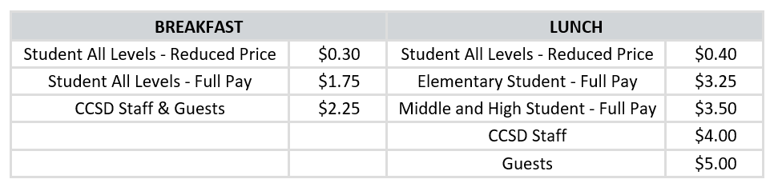
APPLYING FOR FREE OR REDUCED-PRICE MEAL BENEFITS
- Families eligible for free or reduced-price meals must complete an application to receive them – all other students must pay full price for their meals.
- Food and Nutrition Services strongly encourages all families who believe they may be eligible for meal benefits to apply before the start of the school year.
- Families must pay for school meals until their application is processed and approved.
- The Online Family Meal Application can be found on the FNS on Family Meal Application Information webpage.
- Families that apply and are eligible could receive free breakfast & lunch or at a reduced-price (Breakfast for $0.30 and Lunch for $0.40) during the school year depending on the current federal eligibility guidelines.
- Eligible families can also use their notification letter as proof of eligibility in the meal program for discounts on testing, services, camps, and various application fees.
For full details about the CCSD Food and Nutrition Services Program including information about menus, please visit the Food and Nutrition Services website.
Wheeler uses a computer system in the cafeteria that allows parents to pay in advance either by contacting 1-866-535-1707 or MyPaymentsPlus.com or via the MyPaymentsPlus app. Students or parents may put money in their accounts at any time. Students must memorize their 6- or 7-digit Cobb County ID number (not the student’s Social Security Number) and should NOT SHARE THEIR ID NUMBERS WITH ANY OTHER STUDENT.

During lunch, students must stay in the cafeteria or courtyards unless they have written permission to leave. FOOD MAY NOT BE TAKEN OUT OF THESE AREAS.

CLINIC
Students needing minor attention should report to the nurse in the Clinic with a pass from their teacher.

Medications and Health Care at School
- Does the school provide medications?
No, the school does not provide medication. Medication must be brought to the front office or school clinic by the parent/guardian. An “Authorization to Administer” medication form must be completed.
- May the parent/guardian bring and give medications to their student?
Yes, a parent/guardian may come to school and give her or his child medication. Appropriate visitor sign-in procedures should be followed.
- Where can I find authorization forms?
Authorization forms are found in the front office, school clinic, or online. Forms are available online at https://web.cobbk12.org/page/6380/section-j Find Administrative Rule JGCD-R, click on JGCD-2, Authorization to Give Medication Form. These completed forms should be submitted to the clinic.
- Why do I need a doctor's note for adult strength over-the-counter medication when my doctor has told me this is appropriate for my student’s weight (or condition)?
The school nurse wants to protect your child and must follow guidelines for dosage recommended by the manufacturer.
- Why do medications have to be in the original container?
The original container provides information from the manufacturer about over-the-counter medications, including the name of the medication, the proper dose, how the medication should be given, how often the medication can be given, possible side effects, and when the medication is no longer effective (an expiration date).
The original prescription container includes the name of the medication, the patient’s name, the prescribing doctor, the proper dose, how and when it should be given, how long the medication should be given, when the medication expires, and the pharmacy where the medication was purchased. All of this information is necessary for the school nurse to administer medication in a safe manner.
6. What if my child’s medication or dosage changes?
Parents/guardians must inform the school nurse of any medication changes. New medication or different doses will not be given unless the parent completes a new medication form. The information on the prescription bottle label must match the new consent form.
7. Can my child take herbal medication at school?
No. Over-the-counter diet pills, vitamins, dietary supplements, including minerals or herbs will not be given.
8. May my child carry cough drops at school?
All students may carry cough drops and throat lozenges as long as an “Over-The-Counter Medication Permission” form is completed (can be found by going to Section "J" (cobbk12.org) . Then click on JGCD-7; Authorization to Carry Over -the- Counter Medication. Submit this to the school nurse and they will keep the original completed form on file. The student should carry a copy of the form with the medication too. The medication must be kept in the original container.
9. May my child carry over-the-counter medication at school?
Middle and high school students (grades 6-12) may carry certain over-the counter medications: ibuprofen (i.e.: Advil, Motrin, Midol), acetaminophen (Tylenol), aspirin, antacids, cough drops and throat lozenges with a completed “Over-the-Counter Medication Permission Form” on file in the clinic (see link above under #8). The student should carry a copy of the form with the medication. The medication must be kept in the original container.
10. Can my child carry his asthma inhaler at school?
Yes, students may carry inhalers, Epi-pens or insulin with a completed “Authorization for Student to Carry a Prescription Inhaler, Epi-pen or Insulin” form on file in the clinic. To get form, go to Section "J" (cobbk12.org) and find form JGCD-10
11. Why is there a place for the health care provider to sign the authorization form for my child to carry their inhaler at school?
The health care provider’s signature indicates that your child has been instructed on the proper use of their inhaler and that your child is responsible for administering it to himself/herself without supervision. The form can be faxed to the doctor and then faxed back to the individual school nurse.
12. Why do I have to have a prescription label on the inhaler?
The prescription on the inhaler includes the child’s name, how often it is to be used and what dose is appropriate for your child. It is difficult to keep the label directly on the inhaler. You can write your child’s name on the inhaler and bring the labeled prescription box to the school nurse.
13. If my child is sick, why can't I bring the medicine and send her or him back to class?
You can, unless your child has a fever, vomiting, two episodes of diarrhea, a rash that may be contagious, or any other condition that the school nurse or administrator believe may be contagious or disruptive to the class or teacher.
14. If I give my child Tylenol for a fever, can I still send them to school?
If the fever is more than 100.9 degrees F before you give her or him Tylenol, then your child cannot come to school. Your child may return to school when his/her temperature is below 101 degrees F without Tylenol or any other fever reducing medication for 24 hours, if s/he feels well and is not showing any signs of illness.
15. If I give my child Tylenol for aches and pains, can I still send her or him to school?
Your child is welcome at school while taking Tylenol and any other over-the-counter medication for an injury, dental work, etc. However, if the medication is for a sore throat, earache or flu-like symptoms, please keep her/him at home.
16. Why can’t I put medicine in my child’s lunch box if he/she has to take medicine at lunch?
Medication in a lunch box could be lost or taken by another child. If a staff member found the medication it could be considered an illegal drug with consequences according to the Code of Conduct. Medications must be brought to the front office or school clinic by parents/guardians the original and properly labeled container.
17. If I treat my child for lice can I send them back to school the same day?
Yes. Please bring your child back to the school nurse to be rechecked.
18. Why do I have to bring in a box top to verify lice treatment?
A box top from the product provides the school nurse with the type of treatment that was used and confirms that treatment was provided for the child since a prescription is not necessary for treatment of head lice.
19. How much time do I have to get to the school if the nurse calls me to pick up my child because he's sick?
You or a person you designate should arrive within one hour of being called. Most school clinics have an area where your child can rest for a short period of time. You or a person you designate, must arrive within 15 minutes if your child has a fever of 104 degrees F or higher. Otherwise, 911 will be called.

20. How long will my child’s over-the-counter medication be given at school?
Over-the-counter medication may be given with parent/guardian permission as needed throughout the school year. A doctor’s note is required for over-the-counter medication that is given for more than 10 consecutive school days.
21. What happens to my child’s medication at the end of the school year?
All medications not picked-up by parents by the last day of school will be destroyed.

STUDENT BEHAVIOR AND CONSEQUENCES
The faculty and students of Wheeler are a community of people working together. In order to accomplish our goals, we must treat each other with mutual respect and adhere to established expectations of behavior.

Wheeler High School’s Academic Integrity
Wheeler High School students are expected to display Academic Integrity at all times and within all classes in which they are enrolled. Students can accomplish this by following Clemson University’s 5 fundamental values*, which are:
- Honesty
- Trust
- Fairness
- Respect
- Responsibility
These values can be exhibited by following the guidelines set forth by CVA**. “This means that all work submitted is created by the student and is original work. Therefore, students should not copy or plagiarize others work or share theirs with others as well.” More specifically, the School for Ethical Education*** defines academic integrity as honest academic work where”:

- The ideas and the writing of others are properly cited; and
- Students submit their own work for tests and assignments without unauthorized assistance; and
- Students do not provide unauthorized assistance to others; and
- Students report their research or accomplishments accurately (for example, honestly listing accomplishments on a resume).

Wheeler High School’s Statement of Integrity
I certify the work I am submitting is my original work.
I have not shared, nor exchanged information or materials with anyone, nor will I do so in the future.

Students will be asked to document the Wheeler High School Statement of Integrity when submitting all graded assignments. If one is found in violation of Academic Integrity, discipline will be administered.

 | Consequence
1st Infraction | - Parent notified  - Student receives a 0 on original assignment  - Student can do an optional assignment for maximum of a 70%
2nd Infraction | - Parent notified  - Student receives a 0% on original assignment
* https://www.academicintegrity.org/wp-content/uploads/2017/12/Fundamental-Values-2014.pdf
** http://www.cobbk12.org/schools/cobbvirtualacademy/integrity.aspx
***The School for Ethical Education is a non-profit organization founded in 1995 to support ethical behavior in all human interactions. (www.ethicsed.org)
Dress Code
Students should maintain the level of personal hygiene and safety necessary to ensure a healthy school environment and should not wear anything that might distract from classroom instruction or contribute to the disruption of the normal function of the school. Wheeler complies with the CCSD dress code policies.

The following types of clothing are considered inappropriate at Wheeler:
    - Shorts and skirts that are too short. Bottoms should be completely covered.
    - The outer layer of pants must be worn so as to cover ALL undergarments and or other layers of clothing.
    - Bandannas should NOT be worn on the bus in the mornings, as well as in the building from the time a student enters the building until 3:30 PM. This applies to both males and females.
    - Pajamas (unless on spirit days), boxer shorts, cut-off sweat pants, slippers, or going without shoes.
    - Shirts or blouses that expose the midriff, chest, or “see-through” garments.
    - Clothing which advertises alcohol or substances illegal for minors or which displays suggestive phrases, designs, markings, or profanities.
    - Shirts or blouses with elongated arm opening or opened in the front or sides without an undershirt.
    - Exposed under garments; chains attached to pants, belts, or wallets; excessively long or heavy neck chains (see Weapons policy).
    - Clothing that displays weapons, drugs, violence, gang affiliations, or other logos that cause dissension.
** The interpretation of acceptable dress will be made by school officials.

Missed classes for dress code infractions will be unexcused. Repeat offenses will result in disciplinary action.

Cell Phones and Electronic Devices
Students shall not use cell phones, ear buds, or any electronic devices during instructional time unless specifically authorized by individual teachers for instructional purposes during the school day. Otherwise, communication and electronic devices must be off during instructional time. Students are allowed to listen to music inside the cafeteria during their assigned lunch periods with headphones only.

The district offers laptops to all students. Parents must complete the authorization form to “opt in” via ParentVue to obtain a device. Go to Parentvue.cobbk12.org, click on student device liability and again for a second time, click on read agreement, click on the “agree to conditions above box”, click submit agreement, click the “opt in box”, you will then see a green message “You have successfully opted -in this student”. Students will be able to go to the media center immediately following this process to get their computer. Therefore, teachers will assign activities, assignments and assessments that will require the use of a computer during class. If students do not obtain a school issued laptop, then they should provide their own.

Wheeler High School is NOT responsible for lost or stolen items.

Behavior in the Classroom

Students are expected to arrive for each class on time and remain attentive, respectful, and on-task throughout the entire class period. Only by following the simple rules listed below, can we ensure that the classroom atmosphere remains conducive to learning.
- Show respect for your teachers and other students:
  - Be on time for school and class.
  - Do not interrupt instruction (beating on desks, humming, singing, blurting out, talking to others during instruction, or making other inappropriate noises or gestures.)
  - Ask permission to leave your seat.
  - Keep your head up during instruction and remaining attentive. Do not sleep in class.
  - Leave the personal belongings of others alone.
  - Respect the opinions of others by avoiding inappropriate personal attacks.
- Show respect for school property and the classroom environment:
- Dress appropriately for school (see “Dress Code”).
- Keep cell phones, headphones and any other electronic device in your bag or at home.
- Do not deface desks, bulletin boards, or walls.
- DO NOT BRING FOOD OR DRINK INTO ANY CLASSROOM WITHOUT THE TEACHER’S PERMISSION.
- Follow all classroom rules outlined by your teacher.

Cheating Policy
The following are considered scholastic dishonesty in schoolwork and will be disciplined:
- Taking information of any form into a test situation for the purpose of responding to test items
- Plagiarism – Using the ideas or words of others without proper documentation
- Copying the work of others when the copied material will count as part of the semester grade.
- Communicating test information to others in or out of class
- Taking test questions (complete test, answer key, teacher’s edition) to provide assistance in later test situations
- Selling, buying, or using papers written by another party
- Providing or receiving work
- Talking, communicating, or utilizing a cell phone or any other electronic device (if it’s out during an assessment, you’ve broken the policy) during testing
See Student Code of Conduct for disciplinary actions that will be taken if the Cheating Policy is broken.

National Honor Society and other organizations do not allow membership by students who have cheated. Incidents of cheating are cumulative over the student’s high school enrollment.

Computer Related Discipline Consequences
A student who uses a computer to violate a discipline rule will FIRST receive the normal consequences for that violation. For example, students who are insubordinate in their use of a computer will receive the consequence for insubordination. Students will ALSO lose their computer privileges for a time:
1st violation – minor: two weeks; major: two semesters
2nd violation – minor: one month; major: permanent loss of privileges
3rd violation – minor: remainder of school year

Behavior in the Cafeteria
Students are expected to display appropriate behavior in the cafeteria. Lunch is a class that students must attend in the cafeteria or on the patio. These guidelines should be followed:
  - Do not cut in line.
  - Dispose of trash in garbage cans.
  - Do not take food or drinks outside the cafeteria and lunch area.
  - Students MAY NOT leave the campus during lunch OR order food to be delivered
  - No outside food is allowed
Student Searches
Cobb County School Administrative Rule JCAB-R
The Cobb County School System endeavors to provide a safe and secure environment for all students. The Board authorizes reasonable searches of students directed to that end by authorized school officials. Searches based on reasonable suspicion may proceed without hindrance or delay, but they shall be conducted in a manner that ensures that students are not arbitrarily stripped of personal privacy. The principal of each school or his authorized representative possesses the authority to conduct inspection of students’ lockers, articles carried upon their persons, and vehicles. Such search shall be based on a reasonable suspicion of the presence of deleterious items but not limited to bombs, handguns, or other dangerous weapons, contraband drugs, alcohol, tobacco, stink/smoke bombs, hidden noisemakers, and water guns. In the event the search of a student’s person, his personal possessions, his locker, or vehicle reveals the student is concealing material, the possession of which is prohibited by federal, state or local law, local law enforcement authorities shall be notified so they may take appropriate action, in addition to administrative response.

Teacher Detention
During the first days of a semester, each student will receive oral or written orientation procedures from his teachers regarding detention policies. Each teacher may have his own guidelines, and it is the student’s responsibility to abide by detention rules. Failure to serve a teacher detention will result in referral to an administrator and consequences will be given to the student who fails to serve a teacher given detention.

In-School Suspension (ISS)
In-School Suspension has been established as a measure to keep students in school while they are being disciplined for serious offenses. Strict state and county policies govern the ISS program, and the student is made aware of these prior to his reporting to ISS.

Students are given the opportunity to obtain all class assignments before entering the ISS program, and that work must be returned to the teachers on the first day the student is back in class, or no credit will be granted. Students cannot participate in school activities such as, but not limited to: athletic events, club competitions, drama, band, chorus, or orchestra performances until the ISS assignment ends.

A student will be removed from ISS after receiving 3 penalty demerits and subsequently suspended from ISS. Removal/suspension from ISS will result in Out-of-School suspension for the remainder of the ISS suspension plus 1 additional day and the loss of opportunity to make up classwork.

To receive a full day’s credit in ISS, the student must remain in ISS for the entire school day regardless of student schedule. If a minimum day student receives ISS, he or she will be considered “Full Day” if they serve the entire 3 blocks.

In accordance with Cobb County policy, ISS CANNOT be assigned in place of suspension for the following:
- Weapons
- Tobacco
- Bomb threat
- Alcohol/Drug Use
- Fighting
- False fire alarms

Out-of-School Suspensions (OSS)
Suspension is a very serious disciplinary action. It is the strongest statement the local school makes in expressing its displeasure with misbehavior. Suspended students (except those suspended from ISS) will be permitted to make up their work. All work will be due the day the student returns from suspension. Suspended students are not permitted on Wheeler campus or on any other Cobb County campus during their suspension. They are also not permitted to participate in or attend any extra-curricular activities. Additionally, students who accumulate 10 days of OSS in a semester may not be allowed to attend after school functions/events such as, but not limited to, athletic games and dances during that semester. Also, if a student gets into a fight at an after school activity, they may not be allowed to attend such after school events during that semester or possibly the school year.

Please refer to the Wheeler High School Disciplinary Progression Policy below. All parents and students should be familiar with the various infractions and consequences, as students will be held accountable should a violation to the Student Code of Conduct occur.

Please click HERE to review Cobb County’s Student Code of Conduct for the explanation of the various levels of discipline, which correlates with Wheeler High Schools Disciplinary Progression Policy.

